BEFORE THE
WASHINGTON UTILITIES AND TRANSPORTATION COMMISSION

FOCAL COMMUNICATIONS )
CORPORATION OF WASHINGTON, )
)
Petitioner, ) Docket No. UT-013019
)
v. ) VERIZON’S OPPOSITION TO
) FOCAL’S MOTION TO STRIKE
VERIZON NORTHWEST INC., ) PORTIONS OF VERIZON’S
) COMPLIANCE FILING
Respondent. )
___________________________________ )

The Commission should deny the Motion to Strike Portion’s of Verizon’s Compliance Filing, lodged by Focal Communications Corporation of Washington’s (“Focal”). Focal’s objections are not substantive, and Verizon’s Compliance Filing is entirely appropriate for three reasons.
First, Paragraph 72 of the Commission’s Second Supplemental Order in this docket ordered Verizon to make available to Focal the entire interconnection agreement between Verizon and Time Warner in North Carolina, except for state-specific rates and performance measures. Verizon fully complied by filing within 10 days of that Order a revised Supplemental Agreement replacing North Carolina-specific rates with Washington-specific prices, including relevant Washington-specific performance measures, and changing the names of, and contact information for, the parties, the Commission, and the state. See Second Supplemental Order at ¶ 73.
Second, Focal objects to the fact that the Supplement Agreement recites that each party “reserves the right to update the Verizon North Carolina Terms to incorporate intervening changes in law to the extent permitted by the Verizon North Carolina Terms . . ..” Verizon Supplement Agreement ¶ 4. This “reservation of rights” provision adds no new terms to the agreement; it simply makes it clear that existing rights are preserved. Verizon included this language because, after the approval of the North Carolina agreement, but before the Commission’s Second Supplemental Order, at least one important change in law had occurred, the Federal Communications Commission’s Order on Remand, dealing with Internet-bound traffic and reciprocal compensation. The North Carolina agreement contains a change of law provision dealing with this very issue, but the agreement has not yet been modified to reflect the FCC’s decision. So, out of an abundance of caution, Verizon included the language at issue simply to preserve its rights.
Last Friday, the United States Court of Appeals for the District of Columbia Circuit found that the FCC’s statutory rationale for the Order on Remand was flawed, and it remanded the matter to the FCC to develop a different rationale. In the meantime, however, the Order on Remand remains in effect, and Verizon is entitled to preserve its rights with regard to the Order.
Third, Focal objects to the fact that, in connection with the adoption of the North Carolina agreement, Verizon sent Focal a standard adoption letter that Verizon routinely sends to CLECs that adopt one of Verizon’s agreements with another carrier. Focal has executed Verizon’s standard adoption letter in California, Washington D.C., Massachusetts, New York, Pennsylvania, Texas, and Virginia. In addition, aside from party names and dates, the letter Verizon sent to Focal is indistinguishable from adoption letters Verizon has historically filed with this Commission. Like the “reservation of rights” provision in the Interconnection Agreement, the adoption letter merely preserves each party’s rights. It was therefore entirely appropriate for Verizon to send that letter here.
For the reasons stated, the Commission should deny Focal’s Motion to Strike and adopt Verizon’s proposed language.
Respectfully submitted,
VERIZON NORTHWEST INC.

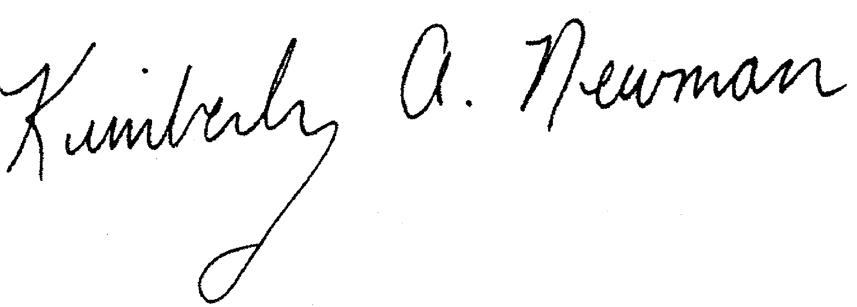
___________________________
Charles H. Carrathers III  Vice President and General Counsel  Verizon (HQE03B62)  600 Hidden Ridge  Irving, TX 75038  (972) 718-2415  chuck.carrathers@verizon.com | Kimberly A. Newman  Thomas M. Finan  Hunton & Williams  1900 K Street, N.W., Suite 1200  Washington, D.C. 20006  (202) 955-1500  (202) 778-2201 (fax)  knewman@hunton.com  tfinan@hunton.com
Dalene Florez
Legal Department
Verizon (HQE03J36)
600 Hidden Ridge
Irving, TX 75038
(972) 718-6362
dalene.florez@verizon.com

May 8, 2002 Attorneys for Verizon Northwest Inc.

CERTIFICATE OF SERVICE
I hereby certify that I have served Verizon Northwest Inc.’s Opposition to Focal’s Motion to Strike Portions of Verizon’s Compliance Filing upon Ms. Carole J. Washburn, Washington Utilities & Transportation Commission, 1300 S. Evergreen Park Drive SW, Olympia, WA 98504-7250 and Gregory J. Kopta, Davis Wright Tremaine LLP, 2600 Century Square, 1501 Fourth Avenue, Seattle, WA 98101-1688, via overnight delivery and electronic mail on May 8, 2002.
____________________________
Kimberly A. Newman
Attorney for Verizon Northwest Inc.

56423.001708 WASHINGTON 286118v3

Verizon has discovered that the rate sheet utilized in the compliance filing contained incorrect reciprocal compensation rates. Accordingly, Verizon is planning to make a filing with the Commission to substitute the correct rate sheet.
Implementation of the Local Competition Provision in the Telecommunications Act of 1996 and Inter-Carrier Compensation for ISP-Bound Traffic, Order on Remand and Report and Order, CC Docket Nos. 96-98 and 99-68, 16 FCC Rcd 9151 (2001) (“Order on Remand”).
Section V, ¶ 3.1 of the North Carolina Agreement acknowledges the controversy about whether reciprocal compensation is payable for Internet-bound traffic, and provides for the adjustment of the agreement in the event of an FCC decision resolving the matter. The Order on Remand did just that.
Other state commissions have recognized that interconnection agreements with appropriate change of law provisions should incorporate the terms of the Order on Remand. See Petition of Verizon Pennsylvania Inc. for Resolution of Dispute with WorldCom, Inc. Pursuant to the Abbreviated Dispute Process, Docket No. A-310752F700, Public Meeting, (Pa. P.U.C. April 11, 2002); Complaint of Global NAPs, Inc. Against Bell Atlantic-Rhode Island Regarding Reciprocal Compensation, Docket No. 2967, Report and Order, at 5 (R.I. PUC, Jan. 29, 2002).
WorldCom, Inc. v. F.C.C., 2002 WL 832541 (C.A.D.C., May 3, 2002).
In the Matter of the Local Competition Provisions in the Telecommunications Act of 1996; Intercarrier Compensation for ISP-Bound Traffic, CC Docket Nos. 96-98, 99-68, Order on Remand and Report and Order, 16 FCC Rcd. 9151 (2001) (“ISP Remand Order”).
Verizon has filed such adoption letters with the Commission for agreements adopted by Verizon and NCIData.com, Inc. (filed June 28, 2001 and approved 7/25/01), Verizon and Allegiance Telecom of Washington, Inc. (filed May 18, 2001 and approved 10/10/01), and Verizon and Winstar Communications, Inc. (filed 4/17/02 and pending approval). See Attached Exhibit 1.

