CenturyLink

931 14th Street, Suite 1230

Denver, Colorado 80202

303-992-5832

April 6, 2017

Steven King
Executive Director and Secretary
1300 S. Evergreen Park Dr. S.W.
P.O. Box 47250
Olympia, Washington 98504-7250

Re: Advice No. WA 17-04A for CenturyTel of Washington, Inc., CenturyTel of InterIsland, Inc., and CenturyTel of Cowiche, Inc. d/b/a CenturyLink

Dear Mr. King:

CenturyTel of Washington, Inc., CenturyTel of InterIsland, Inc., and CenturyTel of Cowiche, Inc. d/b/a CenturyLink is forwarding for filing the sheets listed on Attachment A.

In this filing CenturyLink is removing Uniform Service Order Codes (USOCs) from the tariff. These codes are being removed as part of the consolidation and alignment of CenturyLink’s billing system. No rates, terms or conditions will be impacted by the removal of these codes.

CenturyLink is also revising terms associated with cancellation of customer orders contained in this tariff. Current language is not clear as to what happens to the customer’s order when the customer fails to respond to company inquiries within 30 days after the original service date. Company processes differ by legacy company on when billing begins and when the orders should be cancelled and there is a strong desire to have standard company processes. Accordingly, Service date Change Language is being revised to a standardized format and language surrounding the number of days the existing service orders can be delayed is being set at 60 days.

CenturyLink respectfully requests that these proposed rate changes become effective on May 6, 2017.
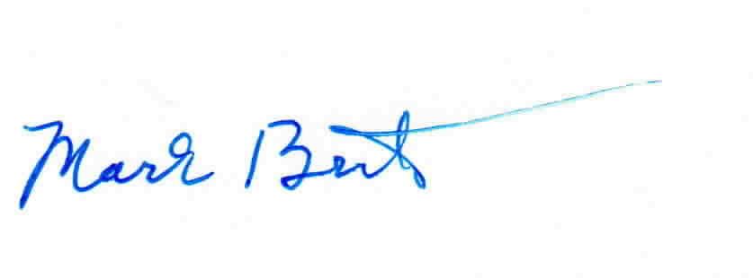
Sincerely,

Mark Brinton
Manager Regulatory Operations
Office: (303) 992-5832
e-mail: Mark.Brinton@CenturyLink.com

Attachment A

Attachment A
Advice No. WA 17-04A

ACCESS SERVICE
Tariff WN U-12

SECTION | SHEET | REVISION
1 | 1-13 | 1st
1 | 1-15 | 1st
5 | 5-6 | 2nd
5 | 5-9 | 2nd
6 | 6-23 | 1st
6 | 6-24 | 1st
6 | 6-25 | 1st
6 | 6-97 | 1st
6 | 6-98 | 1st
6 | 6-99 | 1st
6 | 6-100 | 1st
6 | 6-101 | 1st
6 | 6-102 | 1st
6 | 6-103 | 1st
16 | 16-4 | 2nd
16 | 16-5 | 1st
16 | 16-6 | 1st
16 | 16-7 | 1st
16 | 16-8 | 1st
16 | 16-9 | 1st
16 | 16-10 | 2nd
16 | 16-12 | 5th
16 | 16-13 | 1st
16 | 16-14 | 1st
16 | 16-15 | 1st
16 | 16-16 | 2nd
17 | 17-4 | 2nd
17 | 17-5 | 1st
17 | 17-6 | 1st
17 | 17-7 | 1st
17 | 17-8 | 1st
17 | 17-9 | 1st
17 | 17-10 | 2nd
17 | 17-12 | 5th
17 | 17-13 | 1st
17 | 17-14 | 1st
17 | 17-15 | 1st
17 | 17-16 | 2nd

