CenturyLink

931 14th Street, Suite 1230

Denver, Colorado 80202

303-992-5832

April 6, 2017

Advice No. 3720T

Steven King
Executive Director and Secretary
1300 S. Evergreen Park Dr. S.W.
P.O. Box 47250
Olympia, Washington 98504-7250

Dear Mr. King:

Qwest Corporation d/b/a CenturyLink QC is forwarding for filing the sheets listed on Attachment A.

In this filing CenturyLink is removing Uniform Service Order Codes (USOCs) and Field Identifier Codes (FIDs) from the tariff. These codes are being removed as part of the consolidation and alignment of CenturyLink’s billing system. No rates, terms or conditions will be impacted by the removal of these codes.

CenturyLink is also revising terms associated with cancellation of customer orders contained in this tariff. Current language is not clear as to what happens to the customer’s order when the customer fails to respond to company inquiries within 30 days after the original service date. Company processes differ by legacy company on when billing begins and when the orders should be cancelled and there is a strong desire to have standard company processes. Accordingly, Service date Change Language is being revised to a standardized format and language surrounding the number of days the existing service orders can be delayed is being set at 60 days.

CenturyLink QC respectfully requests that these proposed rate changes become effective on May 6, 2017.

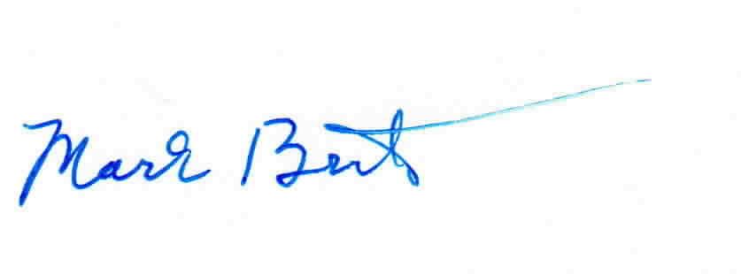
Sincerely,

Mark Brinton
Manager Regulatory Operations
Office: (303) 992-5832
e-mail: Mark.Brinton@CenturyLink.com

Attachments

Attachment A
Advice No. 3720T

ACCESS SERVICE
WN U-48

SECTION | SHEET | REVISION
1 | 2 | 1st
1 | 24 | 1st
1 | 29 | 1st
2 | 71 | 1st
2 | 85 | 1st
5 | 14 | 2nd
5 | 18 | 1st
6 | 137 | 2nd
6 | 138 | 2nd
6 | 138.1 | 1st
6 | 139 | 2nd
6 | 140 | 2nd
6 | 141 | 2nd
6 | 142 | 2nd
6 | 143 | 2nd
6 | 143.1 | 1st
6 | 144 | 2nd
6 | 145 | 2nd
6 | 145.1 | 1st
6 | 146 | 6th
6 | 147 | 2nd
6 | 148 | 1st
6 | 149 | 1st
6 | 150 | 1st
6 | 151 | 2nd
6 | 152 | 1st
6 | 153 | 1st
6 | 154 | 1st
11 | 3 | 1st
13 | 1 | 1st
13 | 2 | 1st
13 | 3 | 1st
13 | 5 | 1st
13 | 10 | 1st
13 | 14 | 1st
13 | 16 | 1st
13 | 17 | 1st
13 | 18 | 1st
13 | 19 | 1st
13 | 24 | 1st
13 | 25 | 1st
13 | 26 | 1st
13 | 27 | 1st
13 | 28 | 1st
13 | 29 | 1st
13 | 30 | 1st
Attachment A
Advice No. 3720T

ACCESS SERVICE
WN U-48

13 | 31 | 1st
13 | 32 | 1st
13 | 33 | 1st
13 | 35 | 2nd
13 | 36 | 1st
13 | 37 | 1st
13 | 38 | 1st
15 | 12 | 1st
15 | 13 | 5th

