CenturyLink

1801 California Street, 10th Floor

Denver, Colorado 80202

303-992-5832

May 26, 2016

Steven King
Executive Director and Secretary
1300 S. Evergreen Park Dr. S.W.
P.O. Box 47250
Olympia, Washington 98504-7250

Re: Advice No. WA 16-02A for United Telephone Company of the Northwest

Dear Mr. King:

United Telephone of the Northwest d/b/a CenturyLink is forwarding for filing the sheets listed on Attachment A.

As described in the attached narrative (“Description of Methodology”), this filing is the fifth step in implementing the “Transitional Intrastate Access Service” reductions mandated by the Federal Communications Commission's November 18, 2011 Report and Order and Further Notice of Proposed Rulemaking in WC Docket Nos. 10-90, etc. (FCC 11-161). Also enclosed is CenturyLink’s certification that the company is not seeking duplicative recovery in the state jurisdiction for any Eligible Recovery subject to the recovery mechanism established by the Transformation Order. The calculations supporting these rate changes are being filed as confidential.

As part of this filing CenturyLink is also updating obsolete billing language.

CenturyLink respectfully requests that these proposed rate changes become effective on July 1, 2016.

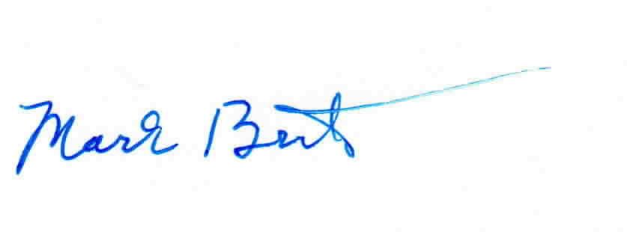
Sincerely,

Mark Brinton
Manager Regulatory Operations
Office: (303) 992-5832
e-mail: Mark.Brinton@CenturyLink.com

Attachment A

Attachment A
Advice No. WA 16-02A

ACCESS SERVICE
Tariff WN U-11

SECTION | SHEET | REVISION
5 | 5-9 | 1st
5 | 5-9.1 | Original
5 | 5-11 | 1st
6 | 6-144 | 4th
6 | 6-145 | 1st
13 | 13-15 | 1st
15 | 15-6 | 1st

