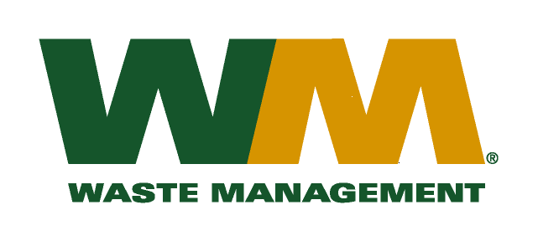
July 30, 2026
Washington Utilities and Transportation Commission
Chandler Plaza Building
1300 S. Evergreen Park Drive SW
P.O. Box 47250
Olympia, WA 98504-7250

Subject: Waste Management of Skagit County, a division of Waste Management of Washington, Inc. (G-237); Tariff # 18
Enclosed are the revised pages 2, 21, 22 and 23 to the above-referenced tariff. The purpose of these tariff revisions is to reflect the change in the commodity credit for residential customers receiving subscription recycling collection services. These tariff revisions reflect a change in the current recycling credit from <$2.18> to a credit of <$1.06> per month for residential customers.
This change is jointly due to the change in commodity values, tonnages and materials composition since the commodity credit adjustment on July 1, 2015. We are requesting that the proposed effective date of these tariff revisions be July 1, 2016.
Enclosed for your review are our accounting work papers. Customers will be notified of the change in their recycling credit adjustment on their next regularly scheduled billing after approval by the Commission. In addition, the counties have been notified of these proposed tariff changes.
If you have any questions or need additional information, please contact or me at (425) 814-7840.
Very truly yours,

Michael A. Weinstein
Senior Pricing Manager, Pacific Northwest Market Area

cc: Carlton Paulmier
Jeff McMahon
Clerks of the Board, Island, Skagit and Snohomish County Chairs

