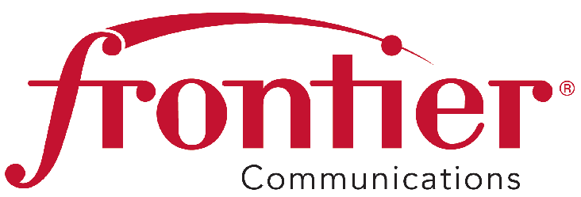
August 25, 2015

Frontier Communications Northwest Inc.

1800 – 41st Street
Suite N-100
Everett, WA 98203
Fax: 425-261-5262

Advice No. 3350

Mr. Steven King, Executive Director and Secretary
Washington Utilities and Transportation Commission
P. O. Box 47250
1300 S. Evergreen Park Drive SW
Olympia, WA 98504-7250

Dear Mr. King:

Frontier Communications Northwest Inc. submits Advice No. 3350, a tariff filing in the General and Local Exchange Tariff, WN U-17, Section 1 and 4.

The purpose of this filing is to remove Anonymous Call block, *69, Call Block and Call Trace from the tariff and relocate these services to the General and Local Exchange Service Catalog, Section 4.

Frontier requests an effective date of October 9, 2015 for this tariff filing.

Pursuant to WAC 480-80-103(4) and WAC 480-80-104(8), I certify that I am authorized to make this filing on behalf of the company. If you have questions regarding this filing, please contact Cathy Dahlquist at (425) 261-6380.

Sincerely,
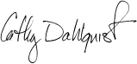
Cathy Dahlquist
Manager, Government & External Affairs

CD: lms
Enclosures

W.U.T.C.
August 25, 2015
Advice No. 3350

Attachment A

General and Local Exchange Tariff, WN U-17

Section 1

1st Revised Table of Contents Sheet 1
1st Revised Table of Contents Sheet 3

Section 4

1st Revised Table of Contents Sheet 1
1st Revised Sheet 1
1st Revised Sheet 2
1st Revised Sheet 3
1st Revised Sheet 4
1st Revised Sheet 5

FRONTIER COMMUNICATIONS NORTHWEST INC.
EVERETT, WASHINGTON

N O T I C E

Frontier Communications Northwest Inc. submits Advice No. 3350, a tariff filing in the General and Local Exchange Tariff, WN U-17, Section 1 and 4.

The purpose of this filing is to remove Anonymous Call block, *69, Call Block and Call Trace from the tariff and relocate these services to the General and Local Exchange Service Catalog, Section 4.

The effective date for this tariff filing is October 9, 2015.

A copy of this tariff is available for public inspection at the following Frontier Plus store locations:

1402 SE Everett Mall Way 18700 33rd Ave. West, Suite D 4916 W. Clearwater
Everett Lynnwood Kennewick
Everett Frontier Plus Alderwood Frontier Plus Kennewick Frontier Plus

Posted at __________________________
__________________________
by __________________________

Post in above store location.

