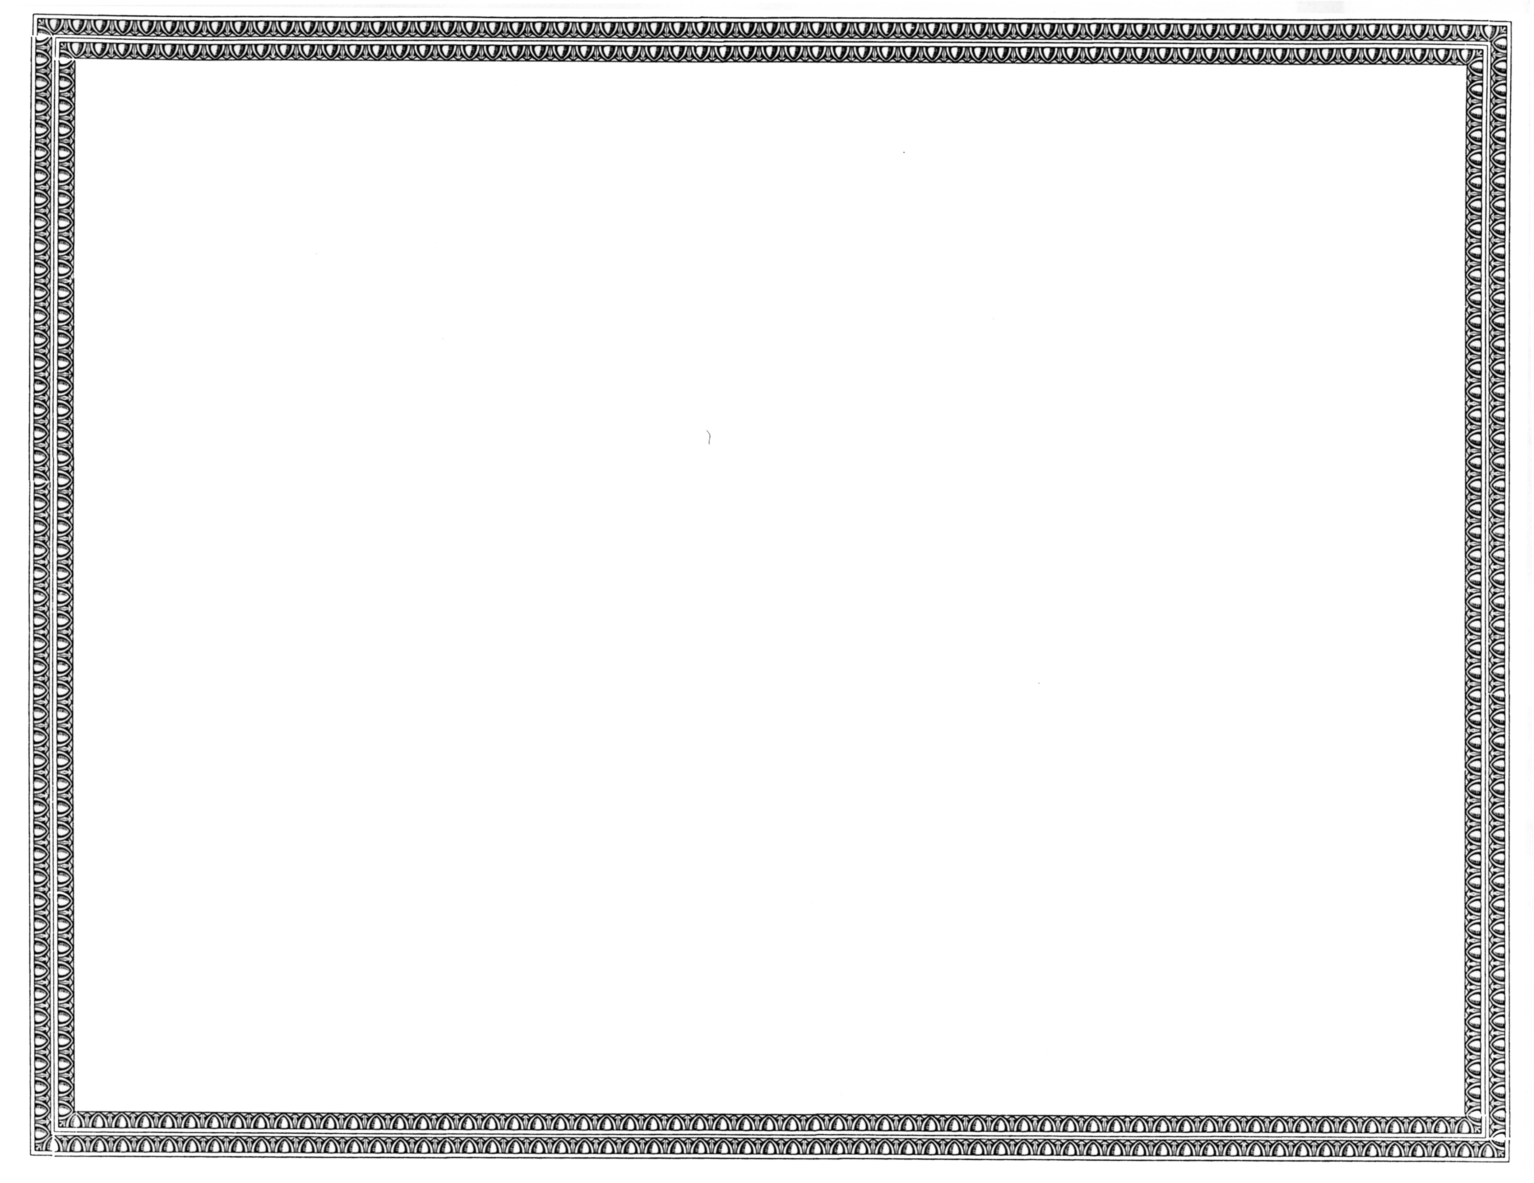



REGISTRATION
OF

CSS Integration, Inc., d/b/a CSS Communications

AS A COMPETITIVE
TELECOMMUNICATIONS COMPANY

Docket Number UT-150621 May 14, 2015
Effective Date

STEVEN V. KING

Executive Director and Secretary

CERTIFICATE IS NOT TRANSFERABLE

