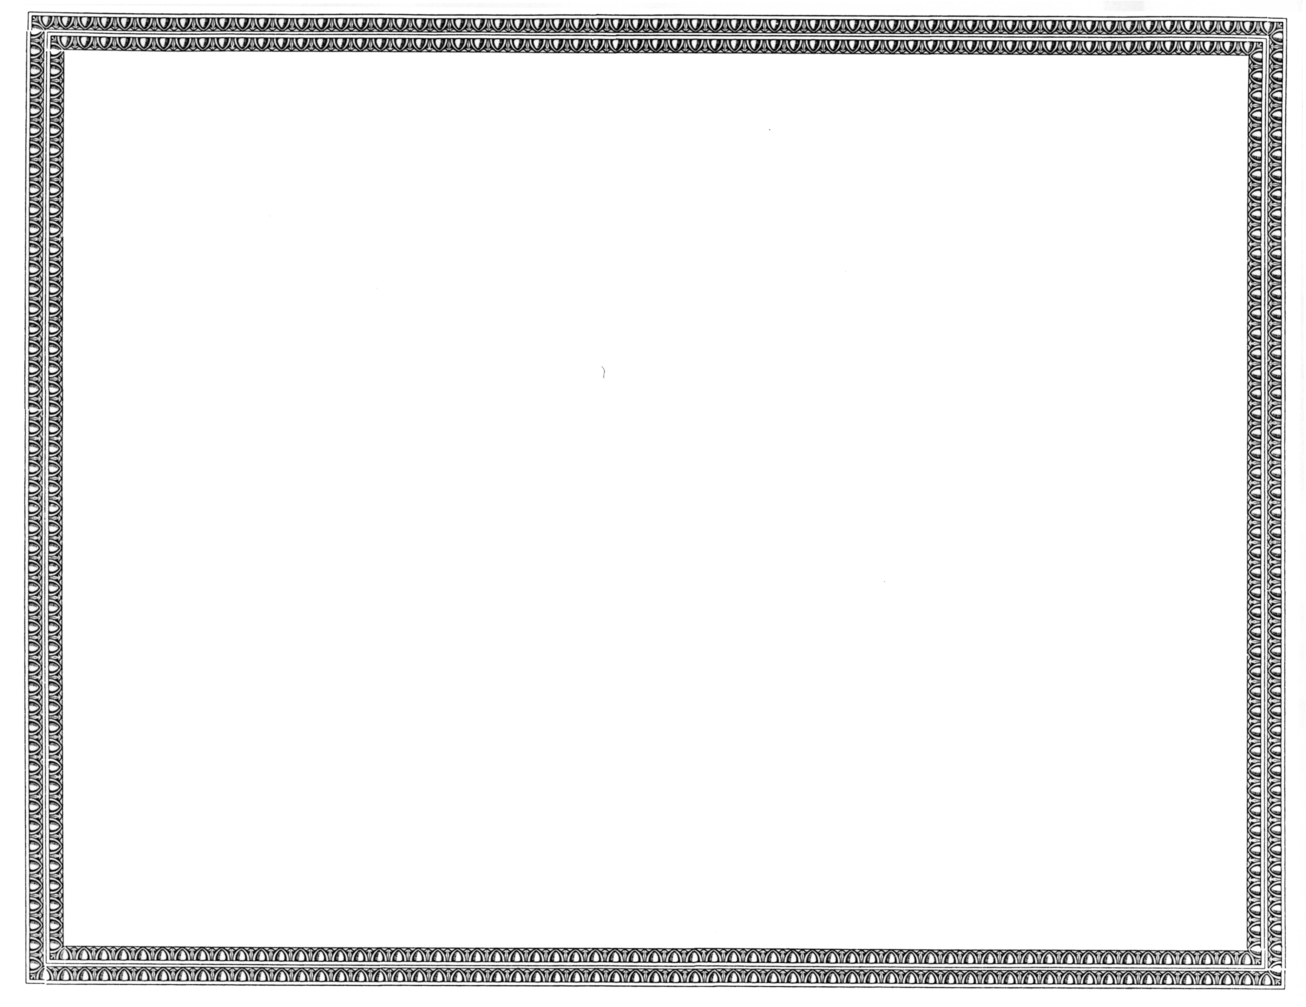



REGISTRATION
OF

Time Warner Cable Business LLC, d/b/a Time Warner Cable

AS A COMPETITIVE
TELECOMMUNICATIONS COMPANY

Docket Number UT-130361 April 11, 2013
Effective Date

STEVEN V. KING

Acting Executive Director and Secretary

CERTIFICATE IS NOT TRANSFERABLE

