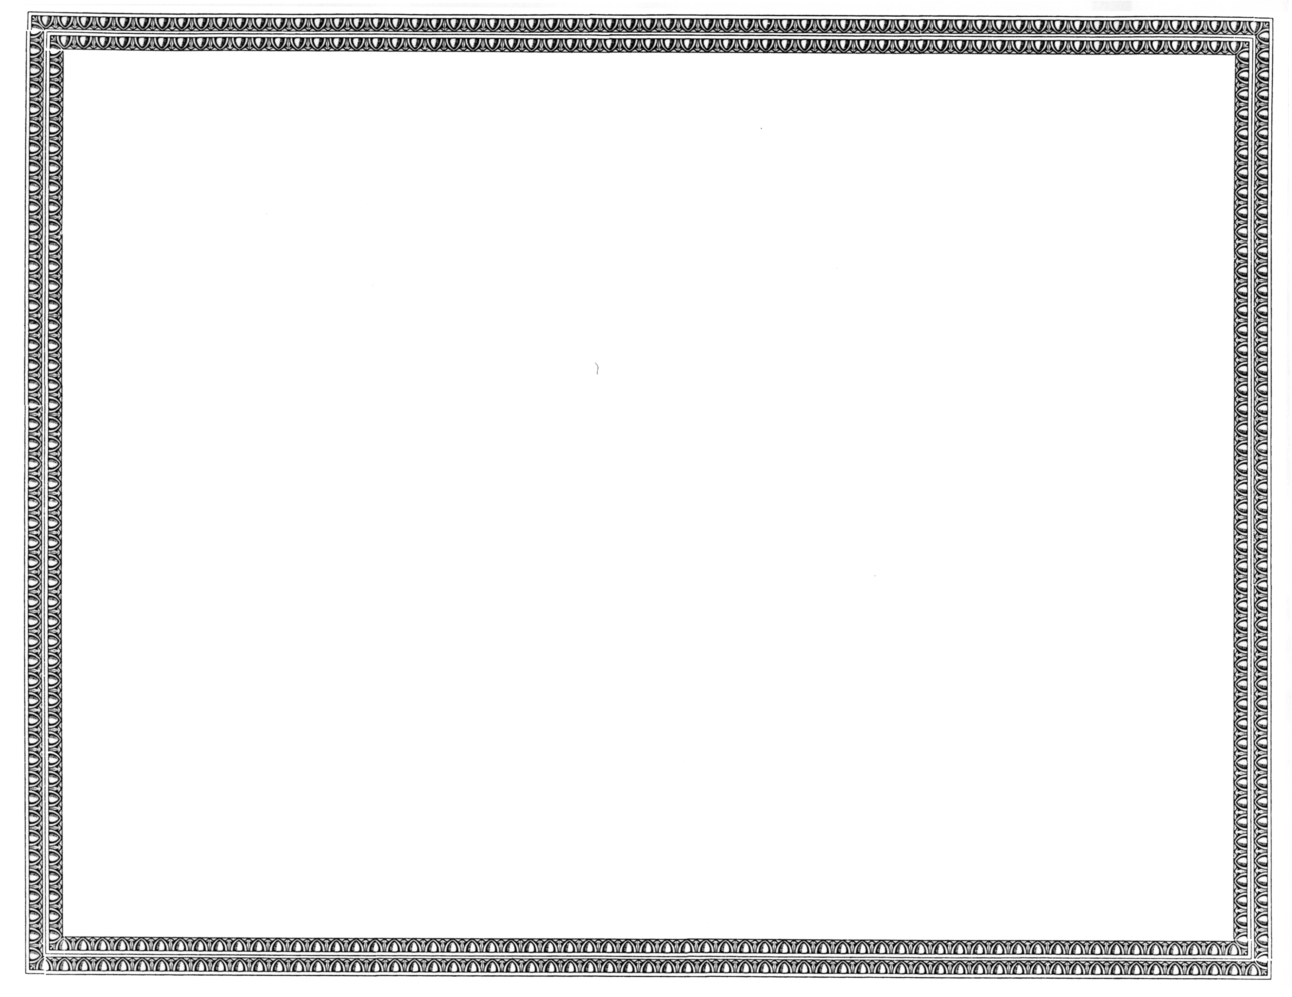



REGISTRATION
OF

Collier Technologies, LLC

AS A COMPETITIVE
TELECOMMUNICATIONS COMPANY

Docket Number UT-101462 September 26, 2010
Effective Date

DAVID W. DANNER

Executive Director and Secretary

CERTIFICATE IS NOT TRANSFERABLE

