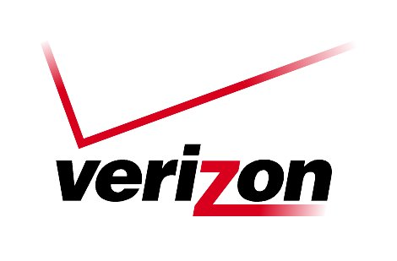 Verizon Northwest Inc.

1800 – 41st Street, WA0105RA
P. O. Box 1003
Everett, WA 98206-1003
Fax: 425-261-5262

May 18, 2006

Ms. Carole J. Washburn, Executive Secretary
Washington Utilities and
Transportation Commission
Chandler Plaza Building
1300 S. Evergreen Park Drive SW
P. O. Box 47250
Olympia, Washington 98504

Dear Ms. Washburn:

Subject: CONTRACT NO. 1321ICB

Verizon Northwest Inc. submits for filing Contract No. 1321ICB, a renewal of a customer specific agreement that provides Emergency Alerting and Conferencing Service on a month to month basis for a period not to exceed three (3) years. The current agreement was filed under Contract No. 1249ICB, effective April 23, 2003 in Docket No. UT-980233. The rate to provide this service has not changed. The company provides this service under contract because the service is not available under tariff.

Verizon submits the documentation required by WAC 480-80-142. Verizon considers the contract and cost support confidential and protected under the provisions of WAC 480-07-160. A redacted copy of the contract is included with this filing. The cost support pages are marked “Confidential per WAC 480-07-160”. The company, for commercial reasons, may be harmed if this information is not considered confidential.

The Company requests an effective date of June 21, 2006. Please contact Lin Fogg at (425) 261-6380, if you have questions.

Very truly yours,
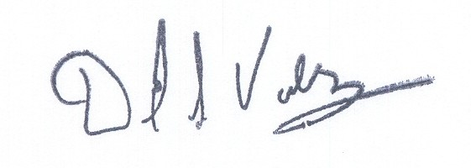

David S. Valdez

Senior Vice President – West

Public Policy, Affairs and Communications

DSV/LF/lf

Attachments
(2005-354623)

ESSENTIAL TERMS AND CONDITIONS
PER WAC 480-80-142

Contract No. 1321ICB New ______ Renewal ___X___ Amendment ______

Effective Date: June 21, 2006

Expiration Date: June 21, 2009

Duration of Contract: Month to month for a period not to exceed three (3) years.

Renewal Options: If the Customer indicates to Verizon in writing that it desires to negotiate a new contract to continue the Services provided, this Agreement shall automatically be extended for a period not to exceed sixty (60) days from the end of the initial term to allow the parties to finalize a new agreement. Written notice must be provided by Customer at least thirty (30) days prior to the end of the original termination date.

Description of Service: Emergency Alerting and Conferencing Service provides the Customer the ability to instantly alert all parties connected to the conferencing bridge and to accommodate quality voice teleconferencing to those parties participating in the wide area bridge conference. The system is designed to allow any conference member to initiate a conference by simply going off hook, at which time all other entities on the system will be alerted. Once answered, the other parities are automatically linked into the conference bridge.

Termination Charges: Not applicable.

Number of Units: 1

Monthly Recurring Charge(s) per unit: $190.97

Non-Recurring Charge(s): Not Applicable

Locations: Kennewick, Pasco, Richland

Contract No. 1321ICB New _____ Renewal __X___ Amendment _ ___

WAC 480-80-142:

7(iii) Demonstrate, at a minimum, that the contract charges cover the company’s cost of providing the service. Costs will be determined under a long-run incremental cost analysis, including as part of the incremental cost, the price charged by the offering company to other telecommunications companies for any essential function used to provide the service, or any other commission-approved cost method. (iv) Summarize the basis of the charge(s) proposed in the contract and explain the derivation of the proposed charge(s) including all cost computations involved.

Verizon Northwest includes as an attachment to this contract filing the documentation and explanations required by WAC 480-80-142. The cost support has been labeled confidential and is protected pursuant to the provisions of WAC 480-07-160 for commercial reasons.

Contract No. 1321ICB New ______ Renewal __X___ Amendment _____

WAC 480-80-142:

7 (v) Indicate the basis for using a contract rather than a filed tariff for the specific service involved. If the basis for using a contract is the availability of an alternative service provider, identify that provider.

Service is provided under a contract because it is not available under the tariff.

Contract No. 1321ICB New _____ Renewal __X____ Amendment _____

WAC 480-80-142:

(2) Duration of contract. All contracts shall be for a stated time period.

The term shall be on a month to month basis for a period not to exceed three (3) years.

