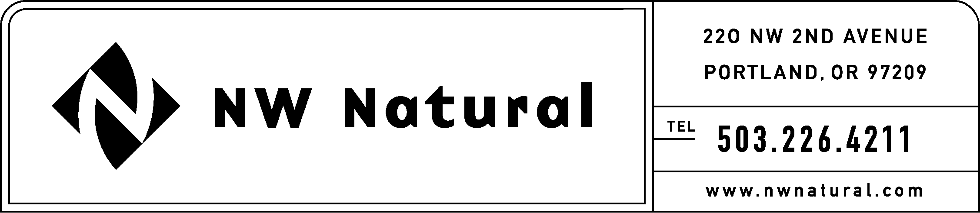

Rates and Regulatory Affairs
Facsimile: 503.721.2532

November 7, 2005 NWN Advice No. WUTC 05-8

VIA ELECTRONIC FILING

Ms. Carole J. Washburn, Executive Secretary
Washington Utilities and Transportation
Commission
1300 Evergreen Park Drive, S.W.
P. O. Box 47250
Olympia, Washington 98504-7250

Re: Housekeeping Filing: Revision to Schedule T: Service Election

Northwest Natural Gas Company, dba NW Natural (NW Natural or Company), files herewith the following tariff sheet proposed to become effective with less than required notice on November 8, 2005:

Fourth Revision of Sheet T.2,
Schedule T,
“Customer-Owned Natural Gas Transportation Service.”

The purpose of this filing is to extend the date by which Customers must submit a Withdrawal of Election form to the Company when taking a one-time opportunity to withdraw from taking Sales Service from November 8, 2005, to November 10, 2005, in accordance with the Addendum Special Contract filed with the Commission under NW Natural Advice No. WUTC 05-7A, dated November 7, 2005.

The requested effective date of this tariff filling is November 8, 2005. The Company respectfully requests that the Commission consider this the Company’s application for approval on less than required notice.

Copies of this letter and the attached filing are available in the company’s offices in Vancouver, Washington and The Dalles, Oregon.

As required by WAC 480-80-103(4)(a), I certify that I have authority to issue tariff revisions on behalf of NW Natural.

Please address correspondence on this matter to me with copies to the following:

Kelley Miller
Staff Assistant
Rates & Regulatory Affairs
220 NW Second Avenue
Portland, Oregon 97209
Telecopier: (503) 721-2532
Telephone: (503) 226-4211, ext. 3589
E-mail: kelley.miller@nwnatural.com

Please call if you have questions.

Sincerely,

Onita R. King, Manager
Tariffs & Regulatory Compliance

ORK/cmt
enclosures

