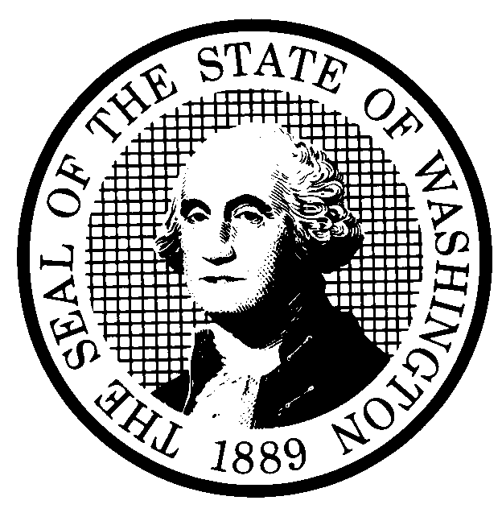 | PREPROPOSAL STATEMENT OF INQUIRY |  | CR-101 (June 2004)  (Implements RCW 34.05.310)  Do NOT use for expedited rule making
Agency: Washington Utilities and Transportation Commission

Subject of possible rule making: Consider processes to implement the Grade Crossing Protective Fund grant program.
Docket No. TR-051060
Statutes authorizing the agency to adopt rules on this subject: RCW 80.01.040, RCW 81.04.160, and RCW 81.53.281.
Reasons why rules on this subject may be needed and what they might accomplish: In 2003, the legislature enacted statutory changes that form the basis for this preproposal inquiry. The Washington Utilities and Transportation Commission issued an Interpretive and Policy Statement on November 26, 2003, in Docket No. TR-031384 to implement the changes for the biennium ending on June 30, 2005. Through the process of developing and implementing the Interpretive and Policy Statement, the Commission has decided that it is now appropriate to consider formalizing the program in a rule as encouraged by RCW 34.05.230.
Identify other federal and state agencies that regulate this subject and the process coordinating the rule with these agencies: The Washington Stated Department of Transportation administers several federal funding programs that involve railroad signals and other railroad safety improvements. Those programs involve major projects that are usually very costly. The projects generally envisioned for the Washington Utilities and Transportation Commission program are smaller in scope, and often involve smaller communities and short line railroads. Such projects would not be able to compete with the larger projects envisioned in the WSDOT programs even though they are important to public safety. Commission Staff work closely with WSDOT Staff on all such projects so that potential overlap is avoided and coordination is maximized.
Process for developing new rule (check all that apply):
Negotiated rule making
Pilot rule making
Agency study
Other (describe)
The Policy and Interpretive Statement will form the basis for discussion and comment. A request for written comments on the need for rules and what might be included in a proposed rule will be made to participants in the 2003 workshop on the subject, and to all others on the Commission railroad interested persons list.
How interested parties can participate in the decision to adopt the new rule and formulation of the proposed rule before publication:
(List names, addresses, telephone, fax numbers, and e-mail of persons to contact; describe meetings, other exchanges of information, etc.)
Interested persons may contact the Secretary, Washington Utilities and Transportation Commission, P.O. Box 47250, 1300 S. Evergreen Park Drive, S.W., Olympia, Washington, 98504-7250; Telephone (360) 664-1174; Facsimile (360) 586-1150.

For specific information regarding opportunities for written comment, and to ensure receipt of further information concerning this rulemaking, please see the attachment to this form.

DATE |  | CODE REVISER USE ONLY
NAME (TYPE OR PRINT)
Carole J. Washburn

SIGNATURE
TITLE
Executive Secretary

WASHINGTON UTILITIES AND TRANSPORTATION COMMISSION
CR-101 - ATTACHMENT
DOCKET NO. _TR-051060

The Commission issued an Interpretive and Policy Statement on November 26, 2003, in Docket No. TR-031384. The Grade Crossing Protective Fund grant program was administered according to that document for the biennium ending June 30, 2005. It forms the basis for considering a rule encompassing the same subject matter, and can be found on the Commission’s web site at: www.wutc.wa.gov/051060.

Interested persons may contact the Secretary, Washington Utilities and Transportation Commission, P. O. Box 47250, Olympia, Washington, 98504-7250, 360-664-1174
(Fax: 360-586-1150).

WRITTEN COMMENTS

Written comments may be submitted to the Commission at the address given above and should be filed with the Commission no later than September 19, 2005, for consideration in the Commission study.
Electronic copies. The Commission requests that comments be provided in electronic format to enhance public access, for ease of providing comments, to reduce the need for paper copies, and to facilitate quotations from the comments. Comments may be submitted by electronic mail to the Commission’s Records Center at records@wutc.wa.gov. Please include:

- The docket number of this proceeding (TR-051060)
- The commenting party’s name
- The title and date of the comment or comments

An alternative method for submitting comments may be by mailing/delivering an electronic copy on a 3 ½ inch, IBM-formatted, high-density disk, in .pdf Adobe Acrobat format or in Word 97 or later. Include all of the information requested above. The Commission will post on the Commission’s web site all comments that are provided in electronic format. The web site is located at http://www.wutc.wa.gov/051060. If you are unable to file your comments electronically or to submit them on a disk, the Commission will always accept a paper document.

Opportunity for further comment is anticipated. Information about the schedule and other aspects of the rulemaking, including comments, will be posted on the Commission’s web site as it becomes available. If you wish to receive further information on this rulemaking you may (1) call the Commission’s Records Center at 360-664-1234, (2) e-mail the Commission at <records@wutc.wa.gov>, or (3) mail written comments to the address above to the attention of Carole J. Washburn, Secretary. When contacting the Commission, please refer to Docket No. TR-051060 to ensure that you are placed on the appropriate service list. Questions may be addressed to Mike Rowswell (360) 664-1265 or e-mail at mrowswel@wutc.wa.gov.

Address: Mike Rowswell
Washington Utilities and Transportation Commission
P.O. Box 47250
Olympia, WA 98504-7250

FAX: 360-586-1150
NOTICE

TO CONTINUE RECEIVING NOTICES AND INFORMATION ABOUT THIS RULEMAKING -- The Commission wants to ensure its mailings are sent to persons who are interested in the topic and want to receive that information. ANY PERSON WHO COMMENTS will continue to receive notices and information. If you do not submit comments but wish to remain on the mailing list for this rulemaking, please advise the Records Center by any one of the following methods: (1) send a note with your name, address (or a copy of your mailing label), and telephone and fax numbers referencing Docket No. TR-051060, and the words "Please keep me on the mailing list"; or (2) E-mail your name, address, telephone and fax numbers, referencing Docket No. TR-051060, and the words "Please keep me on the mailing list" to <records@wutc.wa.gov>. Please note that all information in the mailings will be accessible through the Commission's Internet web site at <http://www.wutc.wa.gov/051060>. THOSE PARTIES WHO DO NOT RESPOND MAY NOT RECEIVE FURTHER MAILINGS OR INFORMATION ON THE RULEMAKING.

