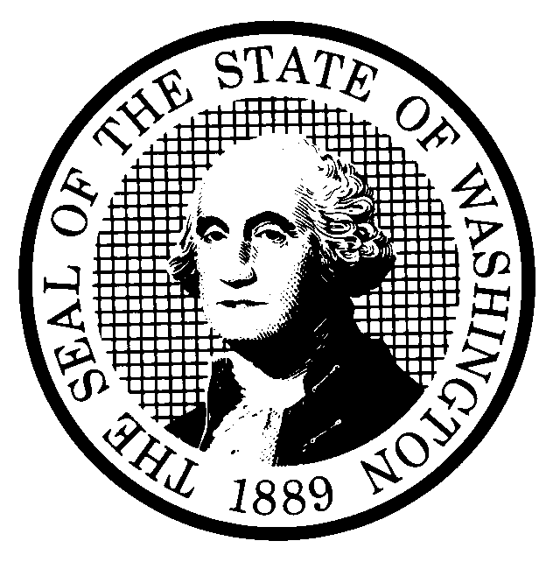 | PROPOSED RULE MAKING |  |  |  |  | CR-102 (June 2004)  (Implements RCW 34.05.320)  Do NOT use for expedited rule making
Agency: Washington Utilities and Transportation Commission
Preproposal Statement of Inquiry was filed as WSR 04-05-103; or  Expedited Rule Making--Proposed notice was filed as WSR or  Proposal is exempt under RCW 34.05.310(4). |  |  |  |  |  |  | Original Notice  Supplemental Notice to WSR  Continuance of WSR
Title of rule and other identifying information: WAC 480-62-218, Point Protection. WUTC Docket No. TR-040151.

The proposal would add to rules governing railroad operations a rule addressing point protection. The proposed rule requires railroads to protect the leading end of train movements to add safety for employees that might be present on the tracks ahead of the movement, vehicles using road crossings, and trains on connected tracks.
Hearing location(s):  Commission Hearing Room 206  Second Floor, Chandler Plaza Building  1300 S. Evergreen Park Drive S.W.  Olympia, WA 98504 |  |  |  | Submit written comments to:  Name: Carole J. Washburn, Secretary  Address: P.O. Box 47250, Olympia, WA 98504-7250  e-mail records@wutc.wa.gov  fax (360) 586-1150 by August 11, 2004  Please include Docket No. TR-040151 in your communication.
Assistance for persons with disabilities: Contact
Mary DeYoung by September 27, 2004
TTY (360)-586-8203 or (360) 664-1133
Date of intended adoption: September 29, 2004, 9:30 a.m.
(Note: This is NOT the effective date)
Purpose of the proposal and its anticipated effects, including any changes in existing rules: Point protection requires that a train crewmember who controls a locomotive, or who can provide information to the person who does, is able to see ahead of the direction in which the train is moving to make sure the way is clear. Railroads have operating rules that require employees to provide point protection. These rules, however, are not enforceable by the Federal Railroad Administration (FRA) or the Commission. The proposed rule requires railroads to follow procedures modeled after railroad operating rules to ensure that people, vehicles, and other trains are less likely to be struck by trains.

When a locomotive is shoving a train, the engineer in the cab cannot perform point protection. In those circumstances and when safety generally requires it, the proposed rule would require that a crewmember be in a position to see ahead of the train. This requirement is always necessary when the train will occupy a highway crossing at grade. Additionally, the crewmember must be in a position to warn vehicular traffic at crossings unless he or she confirms that crossing gates are in a fully lowered position, or that no traffic is approaching or stopped at the crossing.

When a locomotive is pulling forward, the engineer in the cab performs the lookout function, so a rule is unnecessary. However, when the locomotive is moved by remote control and no one is in the cab, the dangers presented by a pulling movement are the same as in a shoving movement. Accordingly, the rules for shoving movements are made applicable to pulling movements in remote control operations.

When railroads establish zones that no one can enter other than a remote control operator, a point protection rule is unnecessary. Therefore, the proposed rule includes an exception to point protection to allow this type of operation. However, in order to ensure clarity about how these zones should operate, point protection remains required at highway crossings at grade and where a train can enter mainline tracks except under certain circumstances.

Reasons supporting proposal: As the FRA stated in a recent report, failure to provide point protection is the leading cause of train accidents in conventional switching operations, as well as a contributing factor in accidents in remote control operations. The proposed rule will allow the Commission to enforce existing, but currently unenforceable, railroad safety procedures concerning point protection. Additional inspections and enforcement are expected to reduce safety violations and decrease the hazards of rail operations for railroad employees and the public.
Statutory authority for adoption: RCW 80.01.040,  RCW 81.04.160 |  |  |  | Statute being implemented: N/A
Is rule necessary because of a:  Federal Law?  Federal Court Decision?  State Court Decision?  If yes, CITATION: |  | Yes  Yes  Yes | No  No  No |  | CODE REVISER USE ONLY  Filed with the Code Reviser's Office  July 21, 2004, 9:12 a.m.  WSR 04-15-140
DATE
JULY 21, 2004
NAME
CAROLE J. WASHBURN
SIGNATURE

TITLE
EXECUTIVE SECRETARY
(COMPLETE REVERSE SIDE)
Agency comments or recommendations, if any, as to statutory language, implementation, enforcement, and fiscal matters:
None

Name of proponent: Washington Utilities and Transportation Commission |  |  | Private  Public  Governmental
Name of agency personnel responsible for:
 | Name | Office Location | Phone
Drafting.......... Mike Rowswell, Rail Safety Manager |  | 1300 S. Evergreen Park Drive S.W., Olympia WA 98504 | (360) 664-1265
Implementation....Carole J. Washburn, Executive Secretary |  | 1300 S. Evergreen Park Drive S.W., Olympia WA 98504 | (360) 664-1174
Enforcement........Carole J. Washburn, Executive Secretary |  | 1300 S. Evergreen Park Drive S.W., Olympia WA 98504 | (360) 664-1174
Has a small business economic impact statement been prepared under chapter 19.85 RCW?
Yes. Attach copy of small business economic impact statement.

A copy of the statement may be obtained by contacting:
Name:
Address:

phone ( )
fax ( )
e-mail
No. Explain why no statement was prepared.

The proposed rule will not result in or impose an increase in costs for any businesses in the railroad industry. Because there will not be any increase in costs resulting from the proposed rule, an SBEIS is not required under RCW 19.85.030(1).

Is a cost-benefit analysis required under RCW 34.05.328?

Yes A preliminary cost-benefit analysis may be obtained by contacting:
Name:
Address:

phone ( )
fax ( )
e-mail

No: Please explain:

The Commission is not an agency to which RCW 34.05.328 applies. The proposed rule is not a significant legislative rule of the sort referenced in RCW 34.05.328(5).

