 |  |  |  |  |  |  | Commission Docket No. |  |  |  |  |  |  |  | UT-041835
 |  |  |  |  |  |  | Agenda Date Assigned
BEFORE THE WASHINGTON UTILITIES AND TRANSPORTATION COMMISSION

LESS THAN REQUIRED NOTICE REQUESTED BY:

Verizon Northwest Inc. 313-013-420
(Utility Name) |  |  |  |  |  |  |  |  |  |  |  |  | (Utility UBI Number)
Utility proposes |  | Amendment No. 8 To The Service Agreement for Enhanced Dedicated SONET Ring (EDSR) Service Between Corporation and Verizon Northwest Inc. |  |  |  |  |  |  |  |  |  |  | Number: |  | Contract No. 1365ICB
(Contract Title)
Indicate below, or attach, an explanation of the reason the company requests permission to file the proposed provisions with less than required notice.

Verizon Northwest respectfully requests this ICB contract amendment become effective September 20, 2008. The customer’s current agreement expires on September 19, 2008, and the customer has not executed a renewal agreement. If no effective contract is in place when the current agreement expires, the Company must disconnect service, as there is no tariff under which to continue providing the service. The Amendment extends the term for six months to allow additional time for the parties to negotiate a renewal agreement.

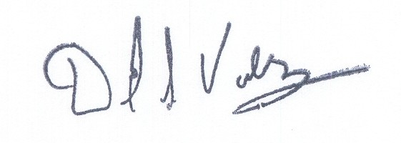  David S. Valdez-Sr. VP West, Public Affairs, Policy and Communications |  |  | is authorized to make filings on behalf of |  |  |  |  |  |  |  |  |  |  | Verizon Northwest Inc.
Signature and Title of Company Officer
I request these provisions become effective on |  |  |  | September 20, 2008
 |  |  |  |  |  |  |  |  | (Date)
 |  |  |  |  |  |  |  |  | Senior Vice President-West, Public Affairs, Policy and Communications
(Signature of Authorized Agent) |  |  |  |  |  |  |  |  | (Title)
David S. Valdez
(Print Name)
( 425 ) 261-5691 |  |  |  |  | (425 ) 261-5262 |  |  |  |  |  |  | David.s.valdez@verizon.com
(Telephone Number) |  |  |  |  | (Fax Number) |  |  |  |  |  |  | (E-Mail Address)
1800 41st St. MC: WA0105RA |  |  |  |  | Everett |  |  |  |  |  |  | WA |  |  |  | 98201
(Mailing Address) |  |  |  |  | (City) |  |  |  |  |  |  | (State) |  |  |  | (Zip Code)
WASHINGTON UTILITIES AND TRANSPORTATION COMMISSION

O R D E R
The Commissioners, having determined this order is consistent with the public interest, directed the Secretary to enter this order granting the provisions requested above.
DATED and signed at Olympia, Washington, this |  |  |  |  |  |  |  | Day of
 |  |  |  |  |  |  |  |  | (Month and Year)
 |  |  |  |  |  |  |  |  | Secretary
Util LRN Form 05/16/05

