July 22, 2010

Via UTC Web Portal

Mr. David W. Danner
Executive Director and Secretary
Washington Utilities and Transportation Commission
1300 S. Evergreen Park Drive S.W.
Olympia, Washington 98504-7250
Subject: Inquiry on Regulatory Treatment of Renewable Energy Resources
Docket UE-100849
Dear Mr. Danner:
Enclosed, for filing, are Comments filed on behalf of the Northwest & Intermountain Power Producers Coalition ("NIPPC") in the above-referenced docket.
If you have any questions, please do not hesitate to contact me.
Very truly yours,
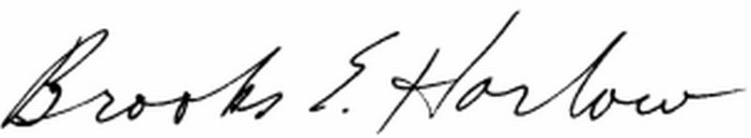
Brooks E. Harlow, P.C.

cc: Mr. Robert D. Kahn

