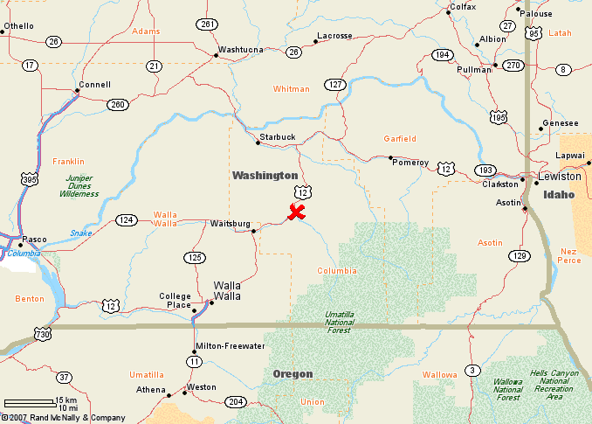
Marengo Wind Plant
140.4 MW
78 Vestas 1.8 MW turbines

