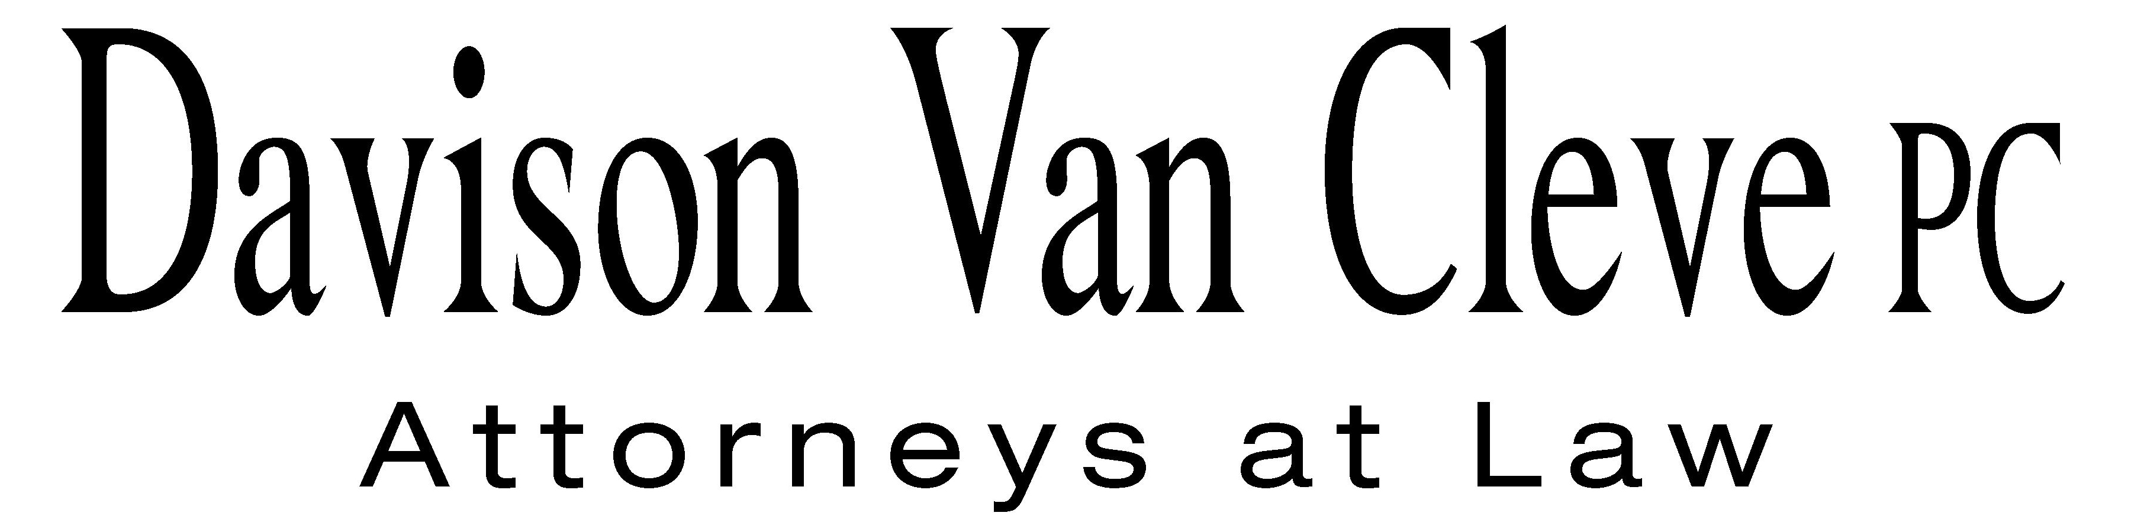
TEL (503) 241-7242 ● FAX (503) 241-8160 ● mail@dvclaw.com
Suite 400
333 SW Taylor
Portland, OR 97204

February 4, 2013

Via Email and Federal Express

Mr. David E. Danner
Washington Utilities and Transportation Commission
PO Box 47250
1300 S Evergreen Park Drive SW
Olympia, WA 98504-7250

Re: In the Matter of PUGET SOUND ENERGY’S Petition for Approval of a Power Purchase Agreement for Acquisition of Coal Transition Power, as Defined in RCW 80.80.010, and the Recovery of Related Acquisition Costs
Docket No. UE 121373

Dear Mr. Danner:

Enclosed please find an original and ten (10) copies of the Response in Opposition to Staff’s Motion for a 30-Day Extension of Time on behalf of the Industrial Customers of Northwest Utilities.

Thank you for your assistance.

Sincerely yours,

/s/ Sarah A. Kohler
Sarah A. Kohler
Enclosures

cc: Service List

CERTIFICATE OF SERVICE

I hereby certify that I have this day served the foregoing Response in Opposition to Staff upon all parties of record in this proceeding by mailing a copy thereof in a sealed, first-class postage prepaid envelope to each individual’s last-known address, as listed below.
DATED this 4th day of February, 2013.
Davison Van Cleve, P.C.

/s/ Sarah A. Kohler
Sarah A. Kohler

PUGET SOUND ENERGY  KEN JOHNSON  PO BOX 97034 PSE-08N  BELLEVUE WA 98009-9734  ken.s.johnson@pse.com | PERKINS COIE  SHEREE CARSON  Donna Barnett  JASON KUZMA  10885 N.E. FOURTH STREET STE 700 BELLEVUE WA 98004-5579  scarson@perkinscoie.com  dbarnett@perkinscoie.com  jkuzma@perkinscoie.com
WASHINGTON UTILITIES & TRANSPORTATION COMMISSION  GREG TRAUTMAN  PO BOX 40128  OLYMPIA, WA 98504  gtrautma@utc.wa.gov | PUBLIC COUNSEL  SIMON FFITCH  LISA GAFKEN  800 FIFTH AVENUE STE 2000  SEATTLE, WA 98104-3188  simonf@atg.wa.gov  lisa.gafken@atg.wa.gov
NW ENERGY COALITION
NANCY HIRSH
DANIELLE DIXON
811 1st Ave # 305
Seattle, WA 98104-2599
nancy@nwenergy.org
danielle@nwenergy.org

