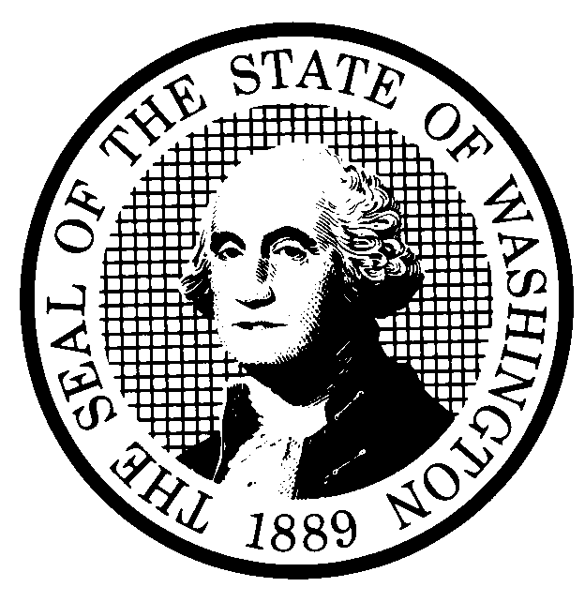 | PROPOSED RULE MAKING  (RCW 34.05.320) |  |  |  |  |  |  |  |  | CR-102 (7/22/01)  Do NOT use for expedited  rule making
Agency: Washington Utilities & Transportation Commission |  |  |  |  |  |  |  |  |  | x Original Notice
x Preproposal Statement of Inquiry was filed as WSR 99-19-086 ; or  Expedited Rule Making -- Proposed notice was filed as WSR ; or  Proposal is exempt under RCW 34.05.310(4). |  |  |  |  |  |  |  |  |  | Supplemental Notice  to WSR  Continuance of WSR
(a) Title of rule: (Describe Subject)
Chapter 480-80 WAC Commission General – Tariffs, Price Lists, and Contracts;
Chapter 480-90 WAC Natural Gas Utilities, Chapter 480-100 WAC Electric Utilities, Chapter 480-120 WAC Telecommunications Companies, Notice to public of tariff changes; and WAC 480-121-065 Customer notice requirements, Petition for competitive classification of a service, Docket U-991301.

Purpose: The purpose of the proposed rules and rule amendments is to streamline the tariff filing process for gas, electric, telecommunications, and water companies, and to clarify requirements for customer notice, consistent with the requirements of the Governor’s Executive Order 97-02.

Other identifying information: Docket No. U-991301

(b) Statutory authority for adoption: RCW 80.01.040 and RCW 80.04.180 |  |  |  |  |  |  |  |  | Statute being implemented: Title 80 Public Utilities
(c) Summary: The proposed rules would streamline filing and format requirements, codify current procedures and best-practice options, use clear language, offer regulated companies greater flexibility to enable them to take advantage of further efficiencies on a case-by-case basis, and eliminate unnecessary requirements. The proposed rules would also clarify requirements for customer notice.

Reasons supporting proposal: The proposed rules are drafted to reflect the effect of legislation regarding price lists. Other proposed rules reflect technological changes, emerging competition, and changes in market structure.

(d) Name of Agency Personnel Responsible for: |  |  |  |  |  | Office Location |  |  |  |  | Telephone
1. Drafting............... Kim Dobyns, 1300 S. Evergreen Park Drive S.W., Olympia, WA 98504 360-664-1242

2. Implementation....Carole J. Washburn, Secretary, 1300 S. Evergreen Park Drive S.W., Olympia, WA 98504 360-664-1174

3. Enforcement........Carole J. Washburn, Secretary, 1300 S. Evergreen Park Drive S.W., Olympia, WA 98504 360-664-1174

(e) Name of proponent (person or organization):  Washington Utilities and Transportation Commission |  |  |  |  |  |  |  |  |  |  | Private  Public  x Governmental
(f) Agency comments or recommendations, if any, as to statutory language, implementation, enforcement and fiscal matters:
None

(g) Is rule necessary because of:  Federal Law?  Federal Court Decision?  State Court Decision? |  | Yes  Yes  Yes |  |  | x No  x No  x No |  | If yes, ATTACH COPY OF TEXT  Citation:
(h) HEARING LOCATION: |  |  |  |  |  |  |  | Submit written comments to:
Commission Hearing Room  Second Floor, Chandler Plaza Building  1300 S. Evergreen Park Drive S.W.  Olympia, WA 98504 |  |  |  |  |  |  |  | Carole J. Washburn, Secretary, P. O. Box 47250, Olympia, WA 98504 or  E-mail to <records@wutc.wa.gov>. Please include Docket No. U-991301 in your communication  FAX (360) 586-1150 By December 27, 2001
Date: January 9, 2002 Time: 1:30 PM |  |  |  |  |  |  |  | DATE OF INTENDED ADOPTION: January 9, 2002
Assistance for persons with disabilities: Contact  Mary DeYoung by Monday, January 7, 2002 |  |  |  |  |  |  |  | CODE REVISER USE ONLY
TDD (360) 586-8203 or (360) 664-1133
NAME (TYPE OR PRINT)
CAROLE J. WASHBURN
SIGNATURE

TITLE  SECRETARY |  |  | DATE  12/5/01
(COMPLETE REVERSE SIDE)
(j) Short explanation of rule, its purpose, and anticipated effects:
The proposed rules effect the administration of tariffs, price lists, and contracts, and posting and publication requirements for regulated investor-owned electric, gas, telephone, and water companies.

See Section (c) for anticipated effects.

Does proposal change existing rules? | x YES NO | If yes, describe changes:
The proposed rules would reduce and reorganize Chapter 480-80 WAC, and clarify and streamline Commission oversight of tariffs, price lists, and contracts.

The proposed rules for customer notice have been incorporated into each industry’s rules for ease of use and to accommodate unique characteristics of each industry. The affected chapters are :
Chapter 480-90 WAC Natural Gas Utilities
Chapter 480-100 WAC Electric Utilities
Chapter 480-120 WAC Telecommunications Companies, and
WAC 480-121-065 Customer notice requirements, Petition for competitive classification of a service.

See the attached chart (Attachment A) for a detailed listing of the proposed changes.
(k) Has a small business economic impact statement been prepared under chapter 19.85 RCW?
Yes. Attach copy of small business economic impact statement.
A copy of the statement may be obtained by writing to:

telephoning: ( )
faxing: ( )
x No. Explain why no statement was prepared
Staff performed a cost analysis on information provided by stakeholders and determined that overall compliance with the proposed rules will not result in an increase in costs for companies and may result in a savings due to cost-efficiencies permitted by the proposed rules.

(l) Does RCW 34.05.328 apply to this rule adoption? Yes x No
Please explain:
The Commission is not an agency to which RCW 34.05.328 applies. The proposed rules are not significant legislative rules of the sort referenced in RCW 34.05.328(5).

