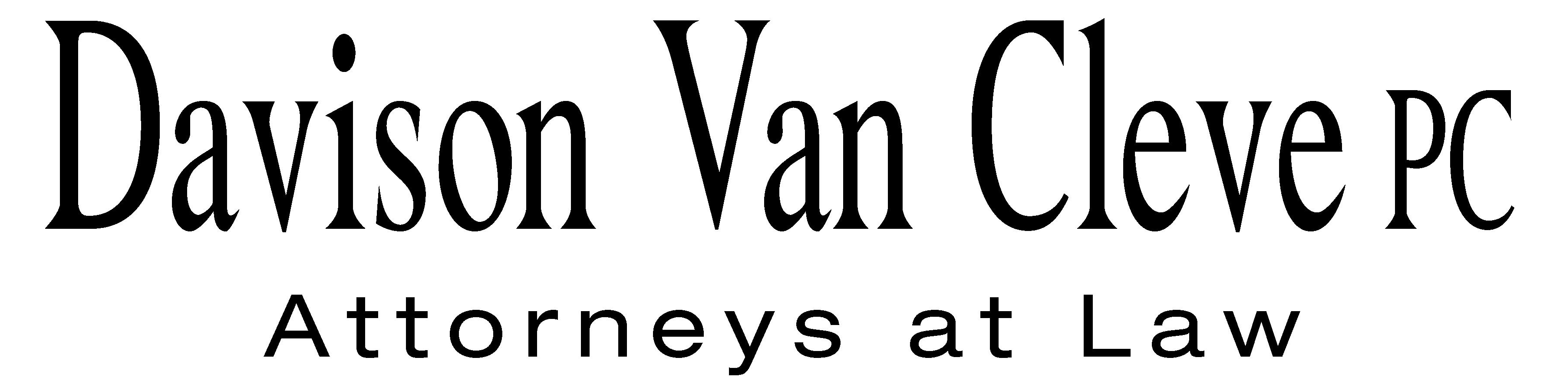
TEL (503) 241-7242 ● FAX (503) 241-8160 ● mail@dvclaw.com
Suite 400
333 SW Taylor
Portland, OR 97204

February 24, 2012

Via Federal Express and Electronic Mail

Mr. David E. Danner
Executive Director
Washington Utilities & Transportation Commission
1300 S. Evergreen Park Drive S.W.
Olympia, WA 98504

Re: In the Matter of WUTC v. Avista Corporation

Docket Nos. UE-110876/UG-110877 (consolidated)

Dear Mr. Danner:

Enclosed please find an original and sixteen (16) copies of the Responsive Testimony and Exhibits of Michael Deen on behalf of the Industrial Customers of Northwest Utilities in the above-referenced matter.

Thank you for your assistance. If you have any questions, please do not hesitate to give me a call.
Sincerely yours,

/s/ Sarah A. Kohler
Sarah A. Kohler

Enclosures
cc: Service List
CERTIFICATE OF SERVICE

I hereby certify that I have this day served a copy of the Responsive Testimony and Exhibits on behalf of the Industrial Customers of Northwest Utilities upon the parties, shown below, listed on the official service list in Docket Nos. UE-110876/UG-110877 by causing the same to be mailed, postage-prepaid, via U.S. Mail.
DATED at Portland, Oregon, this 24th day of February, 2012.
Davison Van Cleve, P.C.

/s/ Sarah A. Kohler
Sarah A. Kohler

Chad M Stokes  Cable Huston Benedick Haagensen & Lloyd, LLP  1001 SW 5th Avenue STE 2000  Portland, OR 97204  cstokes@cablehuston.com | Don Trotter  Assistant Attorney General  WUTC  PO Box 40128  Olympia, WA 98504-0128  dtrotter@utc.wa.gov
Tommy A Brooks  Cable Huston Benedick Haagensen & Lloyd, LLP  1001 SW 5th Avenue STE 2000  Portland, OR 97204-1136  tbrooks@cablehuston.com | David Meyer  Avista Corporation, d/b/a Avista Utilities  PO BOX 3727  Spokane, WA 99220-3727  dmeyer@avistacorp.com
Simon ffitch  Office of the Attorney General  800 5th Ave STE 2000  Seattle, WA 98104-3188  simonf@atg.wa.gov | Ronald L Roseman  Attorney At Law  2011 - 14th Avenue East  Seattle, WA 98112  ronaldroseman@comcast.net

