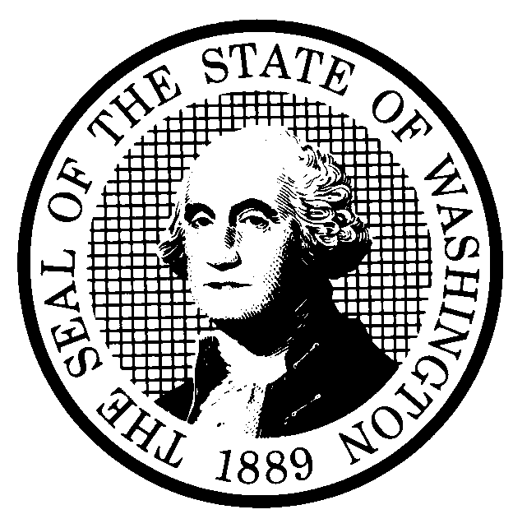 | PROPOSED RULE MAKING |  |  |  |  | CR-102 (June 2004)  (Implements RCW 34.05.320)  Do NOT use for expedited rule making
Agency: Washington Utilities and Transportation Commission
Preproposal Statement of Inquiry was filed as WSR #05-17-083 ; or  Expedited Rule Making--Proposed notice was filed as WSR ; or  Proposal is exempt under RCW 34.05.310(4). |  |  |  |  |  |  | Original Notice  Supplemental Notice to WSR  Continuance of WSR
Title of rule and other identifying information: New Chapter 480-108 WAC Electric companies – interconnection with electric generators with a generating capacity of not more than 25 kilowatts.

The proposed rule would establish standards for interconnection of consumer-owned power generation facilities up to 25 kW capacity to electric utility delivery systems. These regulations include standards for applications for interconnection, processing of such applications, technical and engineering standards for interconnections, safety standards, insurance and liability provisions, and other provisions. Docket No. UE-051106
Hearing location(s):  Commission Hearing Room  Second Floor, Chandler Plaza,  1300 S. Evergreen Park Drive SW  Olympia, WA 98504-7250 |  |  |  | Name: Carole Washburn,  Address: Washington Utilities and Transportation Commission  PO Box 47250  Olympia, WA 98504-7250  e-mail: records@wutc.wa.gov. Please, include: “Docket No. UE-051106” in your comments.  Fax: (360) 586-1150 by (date) February 8, 2006
Date: February 22, 2006 Time: 2:30 P.M. |  |  |  | Assistance for persons with disabilities: Contact  Mary De Young by February 17, 2006  TTY (360) 586-8203 or (360) 664-1133
Date of intended adoption: February 22, 2006
(Note: This is NOT the effective date)
Purpose of the proposal and its anticipated effects, including any changes in existing rules: RCW 80.28.025 establishes a state policy to encourage electric power resources from renewable sources through use of incentives.

Substitute Senate Bill (SSB) 5101, Chapter 300, Laws of 2005, states that “the legislature intends to provide incentives for the greater use of locally created renewable energy technologies.” SSB 5101 also provides that utilities, in return for a credit against the public utility excise tax, may supply an incentive payment to consumers for consumer-generated electricity from renewable energy systems. However, the incentive payments created by SSB 5101 are only available to customers connected to the distribution system of a light and power business if “uniform standards for interconnection to the electric distribution system” are in effect for light and power businesses serving eighty percent of total customer load in the state.

Establishing standards for interconnection of customer-owned power generation facilities to the delivery systems of the investor-owned utilities would constitute substantial progress toward meeting the threshold condition established by SSB 5101 for customer incentive payments. In addition, a rule would establish uniformity among the investor-owned utilities regarding technical and process standards as well as safety and liability standards for such interconnections.

In addition, recently enacted amendments to Section 111(d) of the Public Utility Regulatory Policies Act of 1978 (16 U.S.C. 2621(d)) require the Commission to consider and determine whether to establish standards for interconnection.

Reasons supporting proposal: See above.
Statutory authority for adoption:  RCW 80.01.040 and RCW 80.04.160 |  |  |  | Statute being implemented: N/A
Is rule necessary because of a:  Federal Law?  Federal Court Decision?  State Court Decision?  If yes, CITATION: |  | Yes  Yes  Yes | No  No  No |  | CODE REVISER USE ONLY  Filed with the Code Reviser’s Office  January 18, 2006, 10:05 a.m.  WSR 06-03-126
DATE
January 18, 2006
NAME (type or print)
Carole J. Washburn
SIGNATURE
TITLE Executive Secretary

(COMPLETE REVERSE SIDE)
Agency comments or recommendations, if any, as to statutory language, implementation, enforcement, and fiscal matters:
The rule for interconnection of facilities up to 25kW is the first work produced under the proposal statement of inquiry referenced above. The inquiry will continue to consider rules for interconnection of facilities larger than 25kW.

Name of proponent: (person or organization) Washington Utilities and Transportation Commission |  |  | Private  Public  Governmental
Name of agency personnel responsible for:
 | Name | Office Location | Phone
Drafting............... Dick Byers |  | 1300 S. Evergreen Pk Drive SW, Olympia, WA 98504 | (360) 664-1209
Implementation.... Carole Washburn |  | 1300 S. Evergreen Pk Drive SW, Olympia, WA 98504 | (360) 664-1174
Enforcement.......... Carole Washburn |  | 1300 S. Evergreen Pk Drive SW, Olympia, WA 98504 | (360) 664-1174
Has a small business economic impact statement been prepared under chapter 19.85 RCW?
Yes. Attach copy of small business economic impact statement.

A copy of the statement may be obtained by contacting:
Name:
Address:

phone ( )
fax ( )
e-mail
X No. Explain why no statement was prepared.

The proposed rules will not result in or impose an increase in costs. Because there will not be any increase in costs resulting from the proposed rule changes, an SBEIS is not required under RCW 19.85.030 (1)

Is a cost-benefit analysis required under RCW 34.05.328?

Yes A preliminary cost-benefit analysis may be obtained by contacting:
Name:
Address:

phone ( )
fax ( )
e-mail

No: Please explain: The proposed rules are not significant legislative rules of the sort referenced in RCW 34.05.328 (5).

