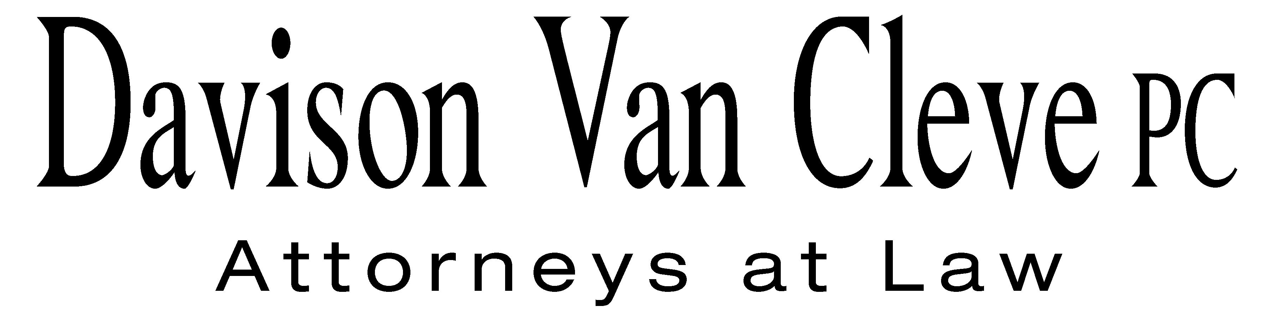
TEL (503) 241-7242 ● FAX (503) 241-8160 ● mail@dvclaw.com
Suite 400
333 SW Taylor
Portland, OR 97204

January 11, 2008

Via Email and Federal Express

Carole J. Washburn
Secretary
Washington Utilities and Transportation Commission
PO Box 47250
1300 S Evergreen Park Drive SW
Olympia, WA 98504-7250

Re: In the matter of the Puget Sound Energy, Inc.’s general rate increase.

Docket No. UE-072300

Dear Ms. Washburn:

Enclosed please find signed confidentiality agreements for Melinda J. Davison, S. Bradley Van Cleve, Irion A. Sanger, Andrew N. Harris, Donald W. Schoenbeck, and Robyn L. Woodbury on behalf of the Industrial Customers of Northwest Utilities in the above-referenced matter.

Thank you for your assistance. If you have any questions, please do not hesitate to give me a call.
Sincerely yours,

Eric G. Shelton

Enclosures

cc: Service List

CERTIFICATE OF SERVICE

I hereby certify that I have this day served the foregoing documents upon all parties of record in this proceeding by mailing a copy thereof in a sealed, first-class postage prepaid envelope to each individual’s last-known address, as listed below.
DATED in Portland, Oregon this 11th day of January, 2008.
Davison Van Cleve, P.C.

Eric G. Shelton

PUGET SOUND ENERGY  TOM DEBOER  PO BOX 97034 PSE-08N  BELLEVUE WA 98009-9734  tom.deboer@pse.com | PERKINS COIE  SHEREE CARSON  JASON KUZMA  10885 N.E. FOURTH STREET STE 700  BELLEVUE WA 98004-5579  scarson@perkinscoie.com  jkuzma@perkinscoie.com
QUALITY FOOD CENTERS, INC.  10116 N.E. 8TH STREET  BELLEVUE WA 98004 | SEATTLE STEAM COMPANY  1325 FOURTH AVE. STE 1440  SEATTLE WA 98101
THE KROGER CO.  ATTN: CORPORATE ENERGY MANAGER (G09)  1014 VINE STREET  CINCINNATI OH 45202  dgeorge@kroger.com | WASHINGTON AND NORTHERN IDAHO DISTRICT  COUNCIL OF LABORERS  PO BOX 12917  MILL CREEK WA 98082-0917
NAVAL FACILITIES ENGINEERING COMMAND-HQ  ACQ-UTILITIES RATES AND STUDIES OFFICE  KAY DAVOODI  1322 PATTERSON AVENUE SE BUILDING # 33  WASHINGTON NAVY YARD DC 20374-5018  khojasteh.davoodi@navy.mil | THE ENERGY PROJECT  CHARLES M EBERDT  1322 N. STATE ST.  BELLINGHAM WA 98225  chuck_eberdt@oppcro.org
NORTHWEST INDUSTRIAL GAS USERS  PAULA E PYRON  4113 WOLF BERRY COURT  LAKE OSWEGO OR 97035-1827  ppyron@nwigu.org | SEATTLE STEAM CO.  ROBERT SHEPPARD  30 GLACIER KEY  BELLEVUE WA 98006
LARKIN AND ASSOCIATES  15728 FARMINGTON ROAD  LIVONIA MI 48154  rsmithLA@gmail.com | BOEHM, KURTZ & LOWRY  KURT J BOEHM  MICHAEL L KURTZ  36 E. SEVENTH ST. STE 1510  CINCINNATI OH 45202  kboehmlaw@aol.com  mkurtz@bkllawfirm.com
BRUBAKER & ASSOCIATES, INC.  MAURICE BRUBAKER  1215 FERN RIDGE PARKWAY STE 208  ST. LOUIS MO 63141  mbrubaker@consultbai.com | CABLE HUSTON BENEDICK HAAGENSEN & LLOYD  EDWARD A FINKLEA  CHAD M STOKES  1001 S.W. 5TH STE 2000  PORTLAND OR 97204  efinklea@chbh.com  cstokes@chbh.com
FEDERAL EXECUTIVE AGENCIES  NORMAN J FURUTA  333 MARKET ST FL 10 MS 1021A  SAN FRANCISCO CA 94105-2195  norman.furuta@navy.mil | DEPARTMENT OF THE NAVY  SCOTT JOHANSEN  1220 PACIFIC HIGHWAY  SAN DIEGO CA 92132  scott.johansen@navy.mil
RONALD L ROSEMAN  2011 - 14TH AVENUE EAST  SEATTLE WA 98112  ronaldroseman@comcast.net | GRAHAM & DUNN  ELAINE SPENCER  PIER 70 STE 300  2801 ALASKAN WAY  SEATTLE WA 98121-1128  espencer@grahamdunn.com
ATTORNEY GENERAL OFFICE  ROBERT D CEDARBAUM  STATE MAIL STOP 40128  bcedarba@wutc.wa.gov | OFFICE OF THE ATTORNEY GENERAL  SIMON FFITCH  800 FIFTH AVENUE STE 2000  SEATTLE WA 98104-3188  simonf@atg.wa.gov
SCHWERIN CAMPBELL BARNARD & IGLITZEN
DMITRI IGLITZIN
18 W MERCER STREET STE 400
SEATTLE WA 98119
iglitzin@workerlaw.com

