EXHIBIT A (ATTORNEY AGREEMENT)
(Amended)

AGREEMENT CONCERNING CONFIDENTIAL INFORMATION
IN DOCKET NO. UE-031389
BEFORE THE
WASHINGTON UTILITIES AND TRANSPORTATION COMMISSION

I, Harvard P. Spigal, as attorney in this proceeding for Microsoft Corporation (party to this proceeding) agree to comply with and be bound by the Protective Order entered by the Washington Utilities and Transportation Commission in Docket No. UE-031389, as amended by Order No. 03 in this docket, and acknowledge that I have reviewed the Protective Order, as amended, and fully understand its terms and conditions.

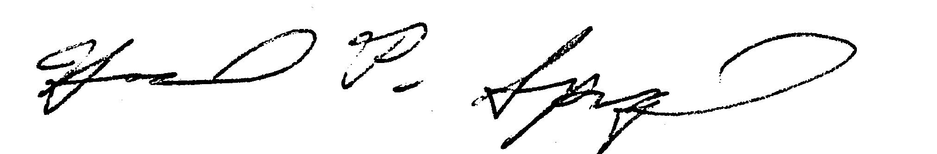
_______________________________________ _________October 22, 2003_______
Signature Date
Harvard P. Spigal
Preston Gates & Ellis LLP
222 SW Columbia Street, #1400
Portland, OR 97035
Ph: 503.228.3200
hspigal@prestongates.com

