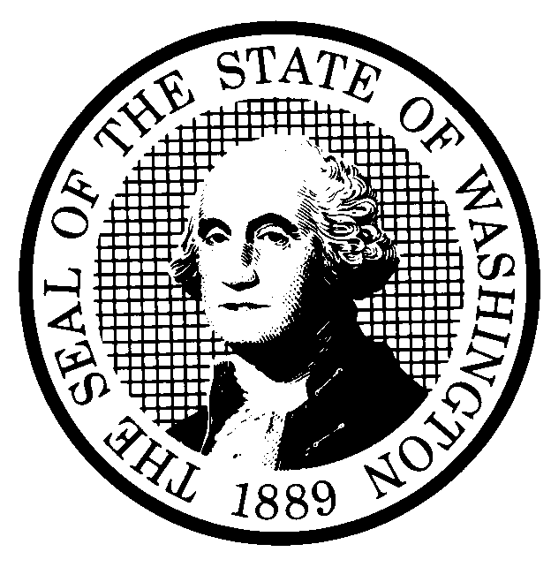 | PROPOSED RULE MAKING  (RCW 34.05.320) |  |  |  |  |  |  |  |  | CR-102 (7/22/01)  Do NOT use for expedited  rule making
Agency: WASHINGTON UTILITIES AND TRANSPORTATION COMMISSION |  |  |  |  |  |  |  |  |  |  | X Original Notice
X Preproposal Statement of Inquiry was filed as WSR 03-18-116; or  Expedited Rule Making -- Proposed notice was filed as WSR ; or  Proposal is exempt under RCW 34.05.310(4). |  |  |  |  |  |  |  |  |  | Supplemental Notice  to WSR  Continuance of WSR
(a) Title of rule: (Describe Subject) The proposed rule revisions would establish the maximum statutory regulatory fee for each industry, the Commission’s process for reducing the maximum statutory regulatory fee, a twenty dollar minimum regulatory fee, and a waiver of the minimum regulatory fee for any company whose annual gross revenues are below the threshold that would generate the twenty dollar minimum regulatory fee.
Purpose: See (j) below.

Other identifying information: Docket No. A-031232.

(b) Statutory authority for adoption: RCW 80.01.040, RCW 80.04.160, RCW 81.04.160, and Chapter 296, Laws of 2003. |  |  |  |  |  |  |  | Statute being implemented: Chapter 296, laws of 2003
(c) Summary: See (j) below.

Reasons supporting proposal:

(d) Name of Agency Personnel Responsible for: |  |  |  |  | Office Location |  |  |  |  |  |  | Telephone
1. Drafting............... Barbara Weigel |  |  |  |  | 1300 Evergreen Park Drive S.W., Olympic WA 98504 |  |  |  |  |  |  | 360-664-1157
2. Implementation....Carole J. Washburn, Secretary |  |  |  |  | 1300 Evergreen Park Drive S.W., Olympic WA 98504 |  |  |  |  |  |  | 360-664-1174
3. Enforcement.........Carole J. Washburn, Secretary |  |  |  |  | 1300 Evergreen Park Drive S.W., Olympic WA 98504 |  |  |  |  |  |  | 360-664-1174
(e) Name of proponent (person or organization):  Washington Utilities and Transportation Commission |  |  |  |  |  |  |  |  |  |  |  | Private  Public  XGovernmental
(f) Agency comments or recommendations, if any, as to statutory language, implementation, enforcement and fiscal matters: None

(g) Is rule necessary because of:  Federal Law?  Federal Court Decision?  State Court Decision? |  | Yes  Yes  Yes |  | X No  X No  X No |  | If yes, ATTACH COPY OF TEXT  Citation:
(h) HEARING LOCATION: |  |  |  |  |  |  | Submit written comments to:
Commission Hearing Room 206  Second Floor, Chandler Plaza Building  1300 S. Evergreen Park Drive S.W.  Olympia, WA 98504 |  |  |  |  |  |  | Carole J. Washburn, Secretary, P.O. Box 47250,  Olympia, WA 98504 or  E-mail to records@wutc.wa.gov. Please include Docket No. A-031232 in your communication.  FAX (360) 586-1150 By December 24, 2003
Date: January 14, 2004 Time: 9:30 a.m. |  |  |  |  |  |  | DATE OF INTENDED ADOPTION: January 14, 2004
Assistance for persons with disabilities: Contact  Mary DeYoung by January 12, 2004. |  |  |  |  |  |  | CODE REVISER USE ONLY
TDD (360) 586-8203 or (360) 664-1133
NAME (TYPE OR PRINT)  CAROLE J. WASHBURN |  |  |  |  |  |  | Filed with the Code Reviser's Office  December 1, 2003, 12:23 p.m.  WSR# 03-24-060
SIGNATURE

TITLE  Executive Secretary |  |  | DATE  December 1, 2003
(COMPLETE REVERSE SIDE)
(j) Short explanation of rule, its purpose, and anticipated effects: The proposal would implement recent amendments to chapters 80.24, 81.24, and 81.77 RCW pursuant to chapter 296, Laws of 2003, that give the Commission authority to set minimum regulatory fees that do not exceed the cost of collecting the fees, and to waive collection of the minimum fee. Existing minimum fees of $1.00 to $5.00 are out-dated and insufficient to cover the cost of collecting and tracking the annual regulatory fees. The proposal would establish the maximum statutory regulatory fee for each industry, the Commission’s process for reducing the maximum statutory regulatory fee, a twenty dollar minimum regulatory fee, and a waiver of the minimum regulatory fee for any company whose annual gross revenues are below the threshold that would generate the twenty dollar minimum regulatory fee. The proposal would amend the following rules:

- WAC 480-30-110, Fees and gross operating revenue, (Auto Transportation Companies)
- WAC 480-51-100, Annual reports – regulatory fees, (Commercial Ferries)
- WAC 480-62-300, Regulatory Fees, (Railroad Companies)
- WAC 480-70-076, Regulatory fees,. (Solid Waste Collection Companies)
- WAC 480-90-208, Financial reporting requirements, (Gas utilities)
- WAC 480-100-208, Financial reporting requirements, (Electric Utilities)
- WAC 480-110-275, Accounting and reporting requirements, and regulatory fees, (Water Utilities)
- WAC 480-120-303, Reporting requirements for competitively classified companies, (Telecommunication Companies)
- WAC 480-120-304, Reporting requirements for companies not classified as competitive, (Telecommunication Companies)

Does proposal change existing rules?  See (j) above. | XYES NO | If yes, describe changes:
(k) Has a small business economic impact statement been prepared under chapter 19.85 RCW?
Yes. Attach copy of small business economic impact statement.
A copy of the statement may be obtained by writing to:

telephoning: ( )
faxing: ( )
X No. Explain why no statement was prepared

The proposed rule revisions will not increase revenue to the agency, nor will they increase the regulatory fee that any company is required to pay. Because there will be no increase in cost resulting from the proposed rules, an SBEIS is not required.

(l) Does RCW 34.05.328 apply to this rule adoption? Yes X No
Please explain: The Commission is not an agency to which RCW 34.05.328 applies. The proposed rules are not significant legislative rules of the sort referenced in RCW 34.05.328(5).

