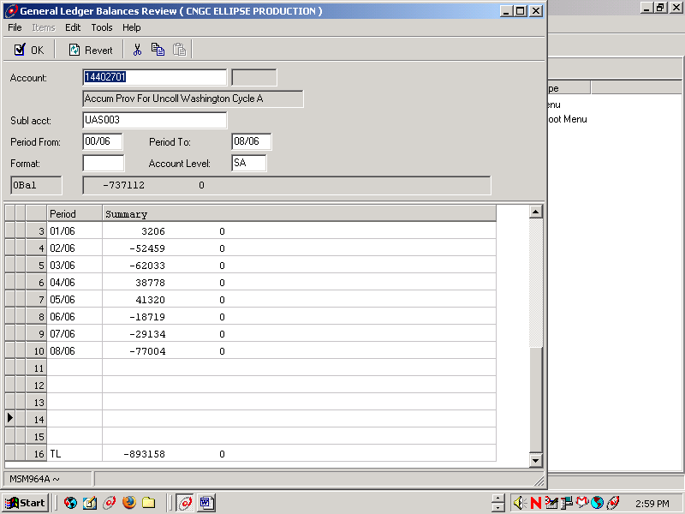
May 06 WA Res & Comm ending balance (June 06 beginning balance)
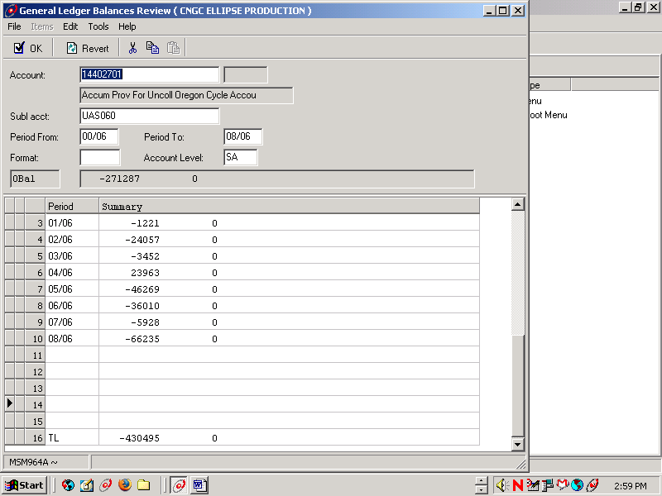
May 06 OR Res & Comm ending balance (June 06 beginning balance)
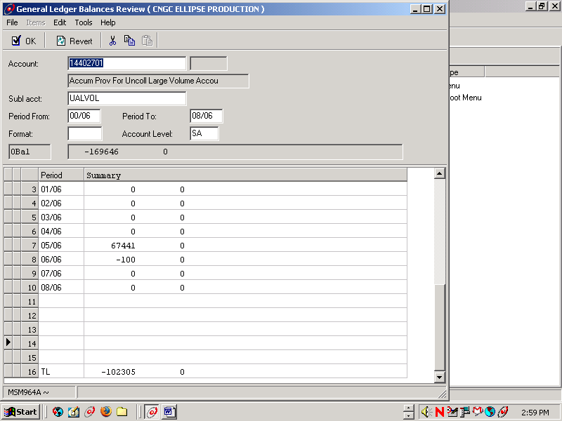
May 06 Large Volume ending balance (June 06 beginning balance)
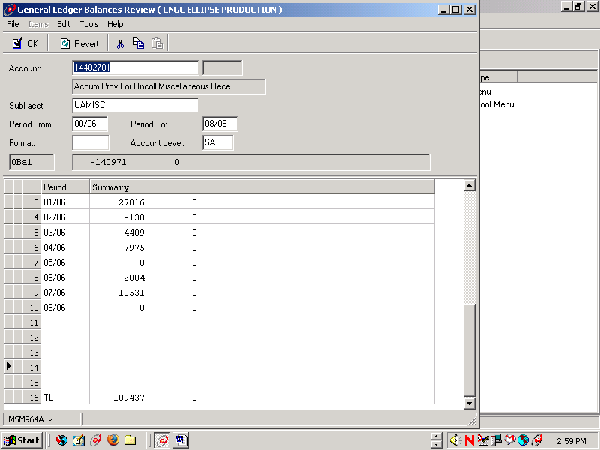
May 06 Misc A/R ending balance (June 06 beginning balance)

