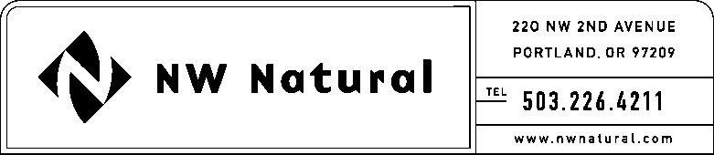
Shawn M. Filippi
Vice President, Chief Compliance Officer
and Corporate Secretary

Tel: 503.220.2435

Fax: 503.220.2584

e-mail: Shawn.Filippi@nwnatural.com

January 13, 2017

Steven V. King, Executive Director and Secretary

Washington Utilities and Transportation Commission
1300 South Evergreen Park Drive SW
Post Office Box 47250
Olympia, Washington 98504-7250

Dear Mr. King:

Re: UG-161164 – Report of Proceeds, Equity Compliance

Pursuant to WAC 480-90-242(6) and the Commission’s Order No. 01, in Docket UG-161164, we enclose herewith the Initial Report of Securities Issued, and Disposition of Proceeds, for the November 2016 issuance and sale of 1,012,000 shares of Common Stock. Please note that the Company is not able to submit a native (WORD) version of Exhibit A (Underwriting Agreement), Exhibit C (Registration Statement) or Exhibit D (Prospectus Supplement) because such documents were filed through the Securities and Exchange Commission’s EDGAR filing system.

Sincerely,

/s/ Shawn M. Filippi

Shawn M. Filippi

SMF:amp
Encl.

