Cristalina
Water Company

November 09, 2010

VIA EMAIL (records@utc.wa.gov)
Utilities & Transportation Commission
ATTN: Records Center
1300 South Evergreen Park Drive SW
Olympia, Washington 98504

RE: Cristalina LLC
Dockets UW-090516 & UW-090839

Dear Sir or Madame:

Attached please find October water use data which is being filed to meet compliance requirements in the above referenced dockets.

If you have any questions or concerns, please feel free to contact our office. Thank you very much.

Sincerely,
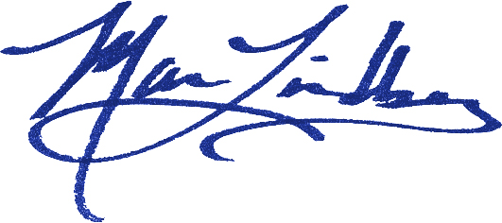
Maria Lindberg
Owner

ML:tc
Attachment

Cristalina Water LLC, PO Box 2626, Bellingham WA 98227

