 Verizon Northwest Inc.

1800 – 41st Street, WA0101RA
P. O. Box 1003
Everett, WA 98206-1003
Fax: 425-261-5262

June 3, 2005

Ms. Carole J. Washburn, Executive Secretary

Washington Utilities and

Transportation Commission

1300 S. Evergreen Park Drive SW

P.O. Box 47250

Olympia, Washington 98504-7250

Dear Ms. Washburn:

Subject: CONTRACT NO. 1303ICB – Request to Extend the Effective Date

Verizon Northwest Inc. filed Contract No. 1303ICB on April 21, 2005, a new customer specific contract to provide Direct Inward Dialing (DID) Numbers for a term of twenty-four (24) months. This filing is currently pending approval in Docket No. UT-050624 with a requested effective date of June 16, 2005. The company requests to extend the effective date for this filing to June 30, 2005 to allow time to respond to Staff’s data requests.

Please contact Rebecca Beaton upon receipt of this request. If there are questions, please contact Lin Fogg at 425.261.6380.

Very truly yours,

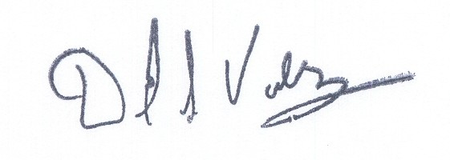

David S. Valdez
Vice President - Public Affairs, Policy and Communications

DSV:lf

(2005-310404)

