CenturyLink
931 14th Street, Suite 1230
Denver, Colorado 80202
303-992-5823

July 18, 2018

Steven King
Executive Director and Secretary
1300 S. Evergreen Park Dr. S.W.
P.O. Box 47250
Olympia, Washington 98504-7250

Re: Advice No. WA 18-04A for United Telephone Company of the Northwest

Dear Mr. King:

United Telephone of the Northwest d/b/a CenturyLink is forwarding for filing the sheets listed on Attachment A.

These two pages were inadvertently left out of CenturyLink’s May 18, 2018 filing to implement the seventh step of Terminating Switched End Office Access Service reductions mandated in the Federal Communications Commission's November 18, 2011 Report and Order and Further Notice of Proposed Rulemaking in WC Docket Nos. 10-90, etc. (FCC 11-161) (Transformation Order). The Terminating – Tandem End Office rates on these two pages reflect the mandated rate reduction to $0.000000.

CenturyLink respectfully requests that this proposed change become effective July 30, 2018.
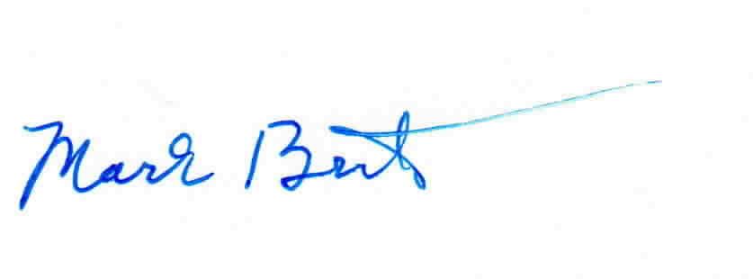
Sincerely,

Mark Brinton
Manager Regulatory Operations
Office: (303) 992-5832
e-mail: Mark.Brinton@CenturyLink.com

Attachment A

Attachment A
Advice No. WA 18-04A

ACCESS SERVICE
Tariff WN U-11

SECTION | SHEET | REVISION
6 | 6-136 | 3rd
6 | 6-136.1 | 1st

