CenturyTel of Washington, Inc. d/b/a CenturyLink
Section 2
WN U-12 1st Revised Sheet 2-34
Access Service Cancels Original Sheet 2-34
Washington

2. General Regulations  2.4 Payment Arrangements and Credit Allowances  2.4.7 Ordering, Rating and Billing of Access Services Where More Than One Exchange Telephone Company is Involved  A. (Cont’d)  1. Treatment of FX/ONAL Type Transport  The transport required to connect closed end FX/ONAL service from one wire center to a dial tone wire center providing the FGA service will be billed via special transport rates. The rates will be those set forth in the special access section of the dial tone company's tariff. Additional charges may apply for the local facilities at the closed end of the service. These charges may be billed by the closed end provider.  B. Meet Point Billing  Meet Point Billing is required when an access service is provided by multiple Telephone Companies for Feature Groups B, C, and D Switched Access Services, and Special Access. It is optional for Feature Group A Switched Access Service.  Each Telephone Company jointly providing the access service will receive an order or a copy of the order from the customer as specified in 5.3.2 following and arrange to provide the service.  For usage rated access services the access minutes of use will generally be determined by the recording company. Where the recording company is not the Bill Rendering Company, the recording company will provide detailed usage records to the Bill Rendering Company to develop the access minutes.  The Bill Rendering Company in a single bill arrangement for Feature Groups B, C, and D Switched Access Services, is normally the end user's end office, for WATS usage the Bill Rendering Company is normally the WATS Serving Office. The name of the Bill Rendering Company will be included in the meet point billing notification provided to the customer by all the telephone companies on all meet point billed services.  The non Bill Rendering Company(s) is any Telephone Company(s) in whose territory a segment of the Local Transport or Channel Mileage is provided and/or where the customer's Point of Termination is located.  (M) Material moved to Page 2-34.18. | (N)  (N)  (M)

Advice No. WA 17-08A
Issued: May 31, 2017 Effective: July 1, 2017
By Phil Grate, Director – Washington (T)
CenturyTel of Washington, Inc. d/b/a CenturyLink
Section 2
WN U-12 Original Sheet 2-34.1
Access Service
Washington

2. General Regulations  2.4 Payment Arrangements and Credit Allowances  2.4.7 Ordering, Rating and Billing of Access Services Where More Than One Exchange Telephone Company is Involved  B. Meet Point Billing (Cont’d)  There are two Meet Point Billing Options, Single Bill and Multiple Bill. These billing options are explained in (1) and (2) following. The Single Bill option is the preferred method. However, when a single bill option can not be agreed to by all telephone companies providing service, the multiple bill option is the default.  Each telephone company must provide meet point billing notification to the customer, in writing, when new service is ordered or thirty days prior to changing an existing meet point arrangement. The notification should include the following:  - The Meet Point Billing Option that will be used,  - The Telephone Company(s) that will render the bill(s),  - The Telephone Company(s) to whom payment(s) should be remitted, and  - The Telephone Company(s) that will provide the bill inquiry function.  A Telephone Company that renders a meet point bill, the Bill Rendering Company, will render the bill in accordance with the industry standards as described in the Multiple Exchange Carrier Access Billing (MECAB) Guidelines and the Multiple Exchange Carrier Ordering and Design (MECOD) Guidelines. The bill will include cross reference(s) to the other telephone Company(s) providing service and common circuit identifiers. Should a billing dispute arise, the terms and conditions of the Bill Rendering company will apply.  1. Single Bill Option  The single bill option allows the customer to receive one bill for access services that are provided by more than one company. The single bill option provides the following two billing alternatives:  - Single Bill/Multiple Tariff  - Single Bill/Single Tariff  These options are described following in (a) and (b) respectively. | (N)  (N)

Advice No. WA 17-08A
Issued: May 31, 2017 Effective: July 1, 2017
By Phil Grate, Director – Washington (T)
CenturyTel of Washington, Inc. d/b/a CenturyLink
Section 2
WN U-12 Original Sheet 2-34.2
Access Service
Washington

2. General Regulations  2.4 Payment Arrangements and Credit Allowances  2.4.7 Ordering, Rating and Billing of Access Services Where More Than One Exchange Telephone Company is Involved  B. Meet Point Billing  1. Single Bill Option (Cont’d)  a. Single Bill/Multiple Tariff  The single bill/multiple tariff bill is prepared by the Bill Rendering Company but reflects all rates and charges for each connecting company's part of the service based on each company's access tariff.  The Bill Rendering Company will:  - determine and include all recurring and nonrecurring rates and charges for each involved Telephone Company;  - identify each involved Telephone Company's rates and charges separately on the bill;  - forward the bill to the customer and provide a copy of the bill or Companies; and  - advise the customer how to remit the payment, either directly to each Telephone Company involved in the provision of this meet point billed service, or, as a single payment made to the Bill Rendering Company. If payments are to be sent directly to the Bill Rendering Company, the non Bill Rendering Company(s) will provide the customer with written authorization for the payment arrangement.  b. Single Bill/Single Tariff  The single bill/single tariff bill provides a meet point bill that is billed completely at the Billing Rendering Company's tariff rates and regulations.  The Bill Rendering Company will:  - determine and include on the access bill all usage data and all other recurring and nonrecurring rates and charges per its access tariff; and  - forward the bill to the customer.  The customer will remit the payment to the Bill Rendering Company. | (N)  (N)

Advice No. WA 17-08A
Issued: May 31, 2017 Effective: July 1, 2017
By Phil Grate, Director – Washington (T)
CenturyTel of Washington, Inc. d/b/a CenturyLink
Section 2
WN U-12 Original Sheet 2-34.3
Access Service
Washington

2. General Regulations  2.4 Payment Arrangements and Credit Allowances  2.4.7 Ordering, Rating and Billing of Access Services Where More Than One Exchange Telephone Company is Involved  B. Meet Point Billing (Cont’d)  2. Multiple Bill Option  Under the Multiple Bill Option each company providing the access service will render an access bill to the customer for its portion of the service based on its access tariff rates and regulations. For switched access Multiple bills, the end office company is generally the Initial Billing Company (IBC).  The IBC is the company that calculates the access minutes to be billed to the customer and provides this data to each connecting company providing service, i.e., the Subsequent Billing Company(s). Each company, IBC and SBC, will:  - prepare its own bill;  - determine its charge(s) for Local Transport, Directory Transport, and/or Channel Mileage as set forth in (3) following;  - determine and include all recurring and nonrecurring rates and charges of its access tariff;  - reflect its Billing Account Reference (BAR) and all connecting company Billing Account Cross Reference (BACR) code(s);  - forward its bill to the customer.  The customer will remit payment directly to each Bill Rendering Company.  3. Determination of Meet Point Billed Local Transport and Channel Mileage Charges  Each Telephone Company's portion of the Local Transport and Channel Mileage will be developed as follows:  a. Determine the appropriate Local Transport or Channel Mileage by computing the number of airline miles between the Telephone Company premises (end office, access tandem or serving wire centers for Switched Access or serving wire centers for Special Access) using the V&H method set forth respectively in 6.4.6 and 7.2.5 following. | (N)  (N)

Advice No. WA 17-08A
Issued: May 31, 2017 Effective: July 1, 2017
By Phil Grate, Director – Washington (T)
CenturyTel of Washington, Inc. d/b/a CenturyLink
Section 2
WN U-12 Original Sheet 2-34.4
Access Service
Washington

2. General Regulations  2.4 Payment Arrangements and Credit Allowances  2.4.7 Ordering, Rating and Billing of Access Services Where More Than One Exchange Telephone Company is Involved  B. Meet Point Billing  3. Determination of Meet Point Billed Local Transport and Channel Mileage Charges (Cont’d)  b. Determine the billing percentage (BP), as set forth in National Exchange Carrier Association, Inc. Tariff F.C.C. No. 4, which represents the portion of the service provided by each Telephone Company.  c. When Terminating Tandem Switched Transport is provided through a CenturyLink Operating Company (CLOC) ILEC Access Tandem and the Terminating End Office is not owned by a any CLOC ILEC or through an ILEC Access Tandem not owned by a CLOC ILEC and the Terminating End Office is owned by a CLOC ILEC, Terminating – Tandem 3rd Party rates are applicable, otherwise Terminating – Tandem End Office rates are applicable. When originating Tandem Switched Transport is provided, Originating rates are applicable. For Feature Groups A, B, C and D Tandem Switched Transport:  - multiply the number of originating and terminating access minutes of use routed over the facility times the number of airline miles, as set forth in (a) preceding, times the BP for each Telephone Company, as set forth in (b) preceding, times the Tandem Switched Facility or Local Transport Facility rate;  - multiply the Tandem Switched Termination rate times the number of originating and terminating access minutes routed over the facility.  - When a tandem office is located within the operating territory of a Telephone Company participating in this tariff, multiply the Tandem Switching rate times the number of originating and terminating access minutes that are switched at the tandem.  The Tandem Switched Termination rate is applied as set forth in 6.1.3(A) following. The Switched Access Nonrecurring Charges are applied as set forth in 6.4.1(B) following. (Note: The BP is not applied to the Switched Access Tandem Switched Termination rate or any Nonrecurring Charge.) | (N)  (N)

Advice No. WA 17-08A
Issued: May 31, 2017 Effective: July 1, 2017
By Phil Grate, Director – Washington (T)
CenturyTel of Washington, Inc. d/b/a CenturyLink
Section 2
WN U-12 Original Sheet 2-34.5
Access Service
Washington

2. General Regulations  2.4 Payment Arrangements and Credit Allowances  2.4.7 Ordering, Rating and Billing of Access Services Where More Than One Exchange Telephone Company is Involved  B. Meet Point Billing  3. Determination of Meet Point Billed Local Transport and Channel Mileage Charges (Cont’d)  d. For Feature Groups A, B, C, and D Direct Trunked Transport:  - multiply the number of airline miles, as set forth in (a) preceding, times the BP for each Telephone Company, as set forth in (b) preceding, times the Direct Trunked Facility rate.  - The Direct Trunked Termination rate is applied as set forth in 6.1.3(A) following. The Switched Access Nonrecurring Charges are applied as set forth in 6.4.1(B) following. (Note: The BP is not applied to either the Switched Access Direct Trunked Termination rate or any Nonrecurring Charge.)  e. For Feature Groups A, B, C, and D.  - When the Entrance Facility and/or Multiplexing equipment is located within the operating territory of a Telephone Company participating in this Tariff, the Entrance Facility and/or Multiplexing charge will apply.  - The Billing Percentage (BP) is not applicable to the Entrance Facility or Multiplexer.  f. For Special Access, multiply the number of airline miles, as set forth in (a) preceding, times the BP for each Telephone Company, as set forth in (b) preceding, times the Channel Mileage Facility rate and add the Channel Mileage Termination rate.  The Special Access Channel Mileage Termination rate and nonrecurring charges are applied as set forth in 7.2.1(B)(2) and 7.2.2(C) following. (Note: The BP is not applied to either the Channel Mileage Termination Recurring Rate or any Nonrecurring Charge.) | (N)  (N)

Advice No. WA 17-08A
Issued: May 31, 2017 Effective: July 1, 2017
By Phil Grate, Director – Washington (T)
CenturyTel of Washington, Inc. d/b/a CenturyLink
Section 2
WN U-12 Original Sheet 2-34.6
Access Service
Washington

2. General Regulations  2.4 Payment Arrangements and Credit Allowances  2.4.7 Ordering, Rating and Billing of Access Services Where More Than One Exchange Telephone Company is Involved  B. Meet Point Billing  3. Determination of Meet Point Billed Local Transport and Channel Mileage Charges (Cont’d)  g. When three or more Telephone Companies are involved in providing an Access Service, the intermediate Telephone Company(s) will determine the charges as set forth in (c) through (f) preceding. Additionally, when a segment of the Tandem Switched Facility, Direct Trunked Facility or Channel Mileage Facility is measured to the intermediate office(s), the Tandem Switched Termination, Direct Trunked Termination or Channel Mileage Termination rates are also applied at the intermediate Telephone Company(s) office(s).  h. Example 1: Originating Switched Access  (See Diagram 1)  - Feature Group D Switched Access is ordered to End Office.  - Originating End Office and Access Tandem are in the operating territory of a Telephone Company (TC-A).  - Customer Designated Premises is in the operating territory of a Telephone Company (TC-B).  - Assumptions:  • TC-A Direct Trunk Transport BP = 40%  • TC-B Direct Trunk Transport BP = 60%  • Direct Trunked Transport mileage = 26 mi.  • Tandem Switched Transport mileage = 23 mi. | (N)  (N)

Advice No. WA 17-08A
Issued: May 31, 2017 Effective: July 1, 2017
By Phil Grate, Director – Washington (T)
CenturyTel of Washington, Inc. d/b/a CenturyLink
Section 2
WN U-12 Original Sheet 2-34.7
Access Service
Washington

2. General Regulations  2.4 Payment Arrangements and Credit Allowances  2.4.7 Ordering, Rating and Billing of Access Services Where More Than One Exchange Telephone Company is Involved  B. Meet Point Billing  3. Determination of Meet Point Billed Local Transport and Channel Mileage Charges  h. Example 1: Originating Switched Access (Cont’d)  (See Diagram 1)  Diagram 1  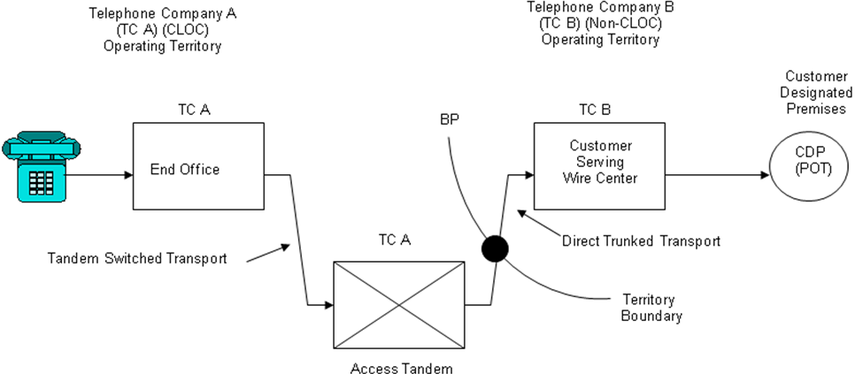 | (N)  (N)

Advice No. WA 17-08A
Issued: May 31, 2017 Effective: July 1, 2017
By Phil Grate, Director – Washington (T)
CenturyTel of Washington, Inc. d/b/a CenturyLink
Section 2
WN U-12 Original Sheet 2-34.8
Access Service
Washington

2. General Regulations  2.4 Payment Arrangements and Credit Allowances  2.4.7 Ordering, Rating and Billing of Access Services Where More Than One Exchange Telephone Company is Involved  B. Meet Point Billing  3. Determination of Meet Point Billed Local Transport and Channel Mileage Charges  h. Example 1: Originating Switched Access  (See Diagram 1) (Cont’d)  Telephone Company A charges are:  End Office charges = 9,000 min. x EO rate  Tandem Switched Facility charge  = 9,000 min. x 23 mi. x TSF rate  Tandem Switched Termination charge  = 2 terminations x 9,000 min. x TST rate  Tandem Switching charge  = 9,000 min x TS rate  Direct Trunked Facility charge  = 26 miles x DTF rate x 40%  Direct Trunked Termination charge  = 1 termination x DTT rate  Shared Multiplexing charge  = 9,000 min x SM rate | (N)  (N)

Advice No. WA 17-08A
Issued: May 31, 2017 Effective: July 1, 2017
By Phil Grate, Director – Washington (T)
CenturyTel of Washington, Inc. d/b/a CenturyLink
Section 2
WN U-12 Original Sheet 2-34.9
Access Service
Washington

2. General Regulations  2.4 Payment Arrangements and Credit Allowances  2.4.7 Ordering, Rating and Billing of Access Services Where More Than One Exchange Telephone Company is Involved  B. Meet Point Billing  3. Determination of Meet Point Billed Local Transport and Channel Mileage Charges (Cont’d)  i. Example 2: Terminating Switched Access – Tandem 3rd Party  (See Diagram 2A and 2B)  Feature Group D Switched Access is ordered to End Office.  Terminating Access Tandem is owned by CLOC ILEC carrier (TC-A) and End Office is owned by a non-CLOC carrier (TC-B)  Assumptions:  • TC-A Direct Trunk Transport BP = 40% (where applicable Diagram 2A)  • TC-B Direct Trunk Transport BP = 60% (where applicable Diagram 2A)  • Direct Trunk Transport mileage = 26 mi.  • TC-A Tandem Switched Transport BP = 20%  • TC-B Tandem Switched Transport BP = 80%  • Tandem Switched Transport mileage = 23 mi. | (N)  (N)

Advice No. WA 17-08A
Issued: May 31, 2017 Effective: July 1, 2017
By Phil Grate, Director – Washington (T)
CenturyTel of Washington, Inc. d/b/a CenturyLink
Section 2
WN U-12 Original Sheet 2-34.10
Access Service
Washington

2. General Regulations  2.4 Payment Arrangements and Credit Allowances  2.4.7 Ordering, Rating and Billing of Access Services Where More Than One Exchange Telephone Company is Involved  B. Meet Point Billing  3. Determination of Meet Point Billed Local Transport and Channel Mileage Charges  i. Example 2: Terminating Switched Access – Tandem 3rd Party  (See Diagram 2A and 2B) (Cont’d)  Diagram 2A  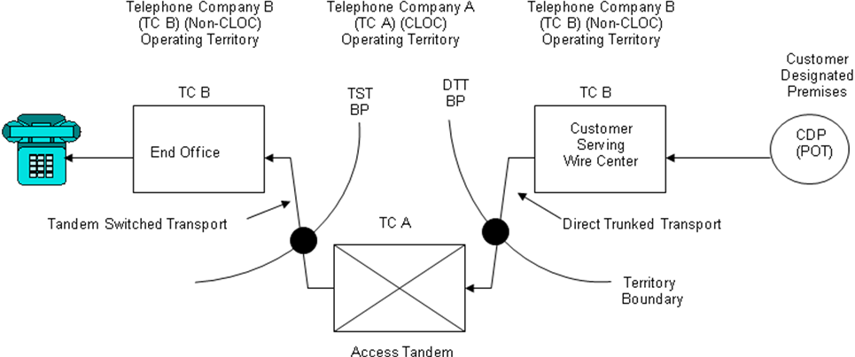  Diagram 2B  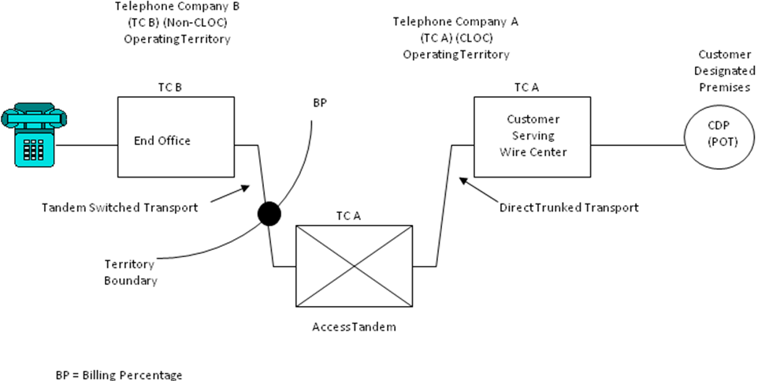 | (N)  (N)

Advice No. WA 17-08A
Issued: May 31, 2017 Effective: July 1, 2017
By Phil Grate, Director – Washington (T)
CenturyTel of Washington, Inc. d/b/a CenturyLink
Section 2
WN U-12 Original Sheet 2-34.11
Access Service
Washington

2. General Regulations  2.4 Payment Arrangements and Credit Allowances  2.4.7 Ordering, Rating and Billing of Access Services Where More Than One Exchange Telephone Company is Involved  B. Meet Point Billing  3. Determination of Meet Point Billed Local Transport and Channel Mileage Charges  i. Example 2: Terminating Switched Access – Tandem 3rd Party  (See Diagram 2A and 2B) (Cont’d)  Example 2 Telephone Company A charges are:  Tandem Switched Facility – 3rd Party charge  = 9,000 min. x 23 mi. x TSF-3rd Party rate x 20%  Tandem Switched Termination – 3rd Party charge  = 1 termination x 9,000 min. x TST-3rd Party rate  Tandem Switching – 3rd Party charge  = 9,000 min. x TS-3rd Party rate  Direct Trunked Facility charge  2A = 26 miles x DTF rate x 40%  2B = 26 miles x DTF rate  Direct Trunked Termination charge  2A = 1 termination x DTT rate  2B = 2 termination x DTT rate  Shared Multiplexing – 3rd Party charge  = 9,000 min x SM-3rd Party rate | (N)  (N)

Advice No. WA 17-08A
Issued: May 31, 2017 Effective: July 1, 2017
By Phil Grate, Director – Washington (T)
CenturyTel of Washington, Inc. d/b/a CenturyLink
Section 2
WN U-12 Original Sheet 2-34.12
Access Service
Washington

2. General Regulations  2.4 Payment Arrangements and Credit Allowances  2.4.7 Ordering, Rating and Billing of Access Services Where More Than One Exchange Telephone Company is Involved  B. Meet Point Billing  3. Determination of Meet Point Billed Local Transport and Channel Mileage Charges (Cont’d)  j. Example 3: Terminating Switched Access – Tandem End Office  (See Diagram 3)  - Feature Group D Switched Access is ordered to End Office.  - Terminating End Office and Access Tandem are both owned by a CLOC ILEC (TC-A)  - Assumptions:  • TC-A Direct Trunk Transport BP = 40%  • TC-B Direct Trunk Transport BP = 60%  • Direct Trunk Transport mileage = 26 mi.  • Tandem Switched Transport mileage = 23 mi.  Diagram 3  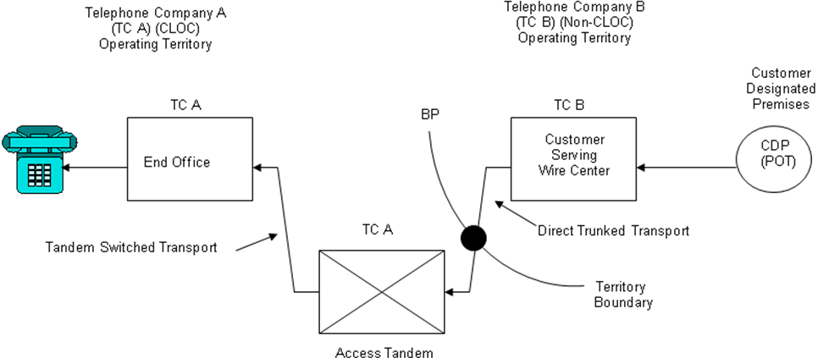 | (N)  (N)

Advice No. WA 17-08A
Issued: May 31, 2017 Effective: July 1, 2017
By Phil Grate, Director – Washington (T)
CenturyTel of Washington, Inc. d/b/a CenturyLink
Section 2
WN U-12 Original Sheet 2-34.13
Access Service
Washington

2. General Regulations  2.4 Payment Arrangements and Credit Allowances  2.4.7 Ordering, Rating and Billing of Access Services Where More Than One Exchange Telephone Company is Involved  B. Meet Point Billing  3. Determination of Meet Point Billed Local Transport and Channel Mileage Charges  j. Example 3: Terminating Switched Access – Tandem End Office  (See Diagram 3) (Cont’d)  - Telephone Company A charges are:  End Office Charges = 9,000 min. x EO rate  Tandem Switched Facility – End Office charge  = 9,000 min. x 23 mi. x TSF-End Office rate  Tandem Switched Termination – End Office charge  = 2 terminations x 9,000 min. x TST-End Office rate  Tandem Switching – End Office charge  = 9,000 min. x TS-End Office rate  Direct Trunked Facility Charge  = 26 miles x DTF rate x 40%  Direct Trunked Termination charge  = 1 termination x DTT rate  Shared Multiplexing – End Office charge  = 9,000 min x SM-End Office rate | (N)  (N)

Advice No. WA 17-08A
Issued: May 31, 2017 Effective: July 1, 2017
By Phil Grate, Director – Washington (T)
CenturyTel of Washington, Inc. d/b/a CenturyLink
Section 2
WN U-12 Original Sheet 2-34.14
Access Service
Washington

2. General Regulations  2.4 Payment Arrangements and Credit Allowances  2.4.7 Ordering, Rating and Billing of Access Services Where More Than One Exchange Telephone Company is Involved  B. Meet Point Billing  3. Determination of Meet Point Billed Local Transport and Channel Mileage Charges (Cont’d)  k. Example 4: Originating Switched Access - CLOC owns only the End Office (See Diagram 4)  - Feature Group D Switched Access is ordered to End Office  - End Office is owned by CLOC (TC-A)  - Access Tandem is owned by a non-CLOC ILEC (TC-B)  - Assumptions:  • Direct Trunk Transport mileage = 26 mi.  • TC-A Tandem Switched Transport BP = 80%  • TC-B Tandem Switched Transport BP = 20%  • Tandem Switched Transport mileage = 23 mi.  Diagram 4  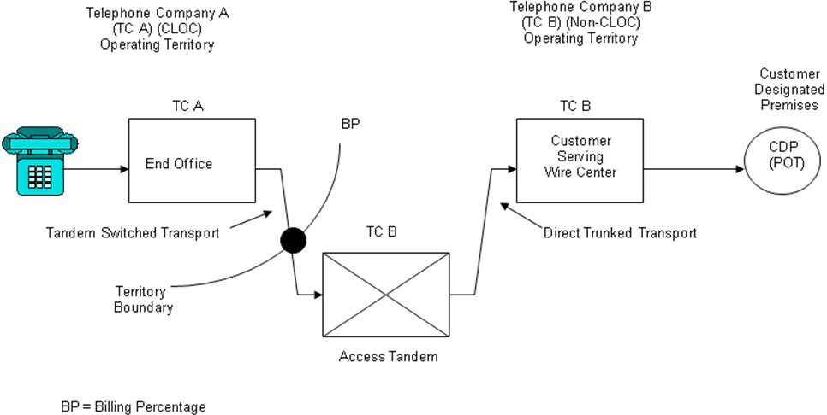 | (N)  (N)

Advice No. WA 17-08A
Issued: May 31, 2017 Effective: July 1, 2017
By Phil Grate, Director – Washington (T)
CenturyTel of Washington, Inc. d/b/a CenturyLink
Section 2
WN U-12 Original Sheet 2-34.15
Access Service
Washington

2. General Regulations  2.4 Payment Arrangements and Credit Allowances  2.4.7 Ordering, Rating and Billing of Access Services Where More Than One Exchange Telephone Company is Involved  B. Meet Point Billing  3. Determination of Meet Point Billed Local Transport and Channel Mileage Charges  k. Example 4: Originating Switched Access - CLOC owns only the End Office  (See Diagram 4) (Cont’d)  - Telephone Company A charges are:  End Office charges = 9,000 min. x EO rate  Tandem Switched Facility charge  =9,000 min. x 23 mi. x TSF rate x 80%  Tandem Switched Termination charge  = 1 termination x 9,000 min. x TST rate | (N)  (N)

Advice No. WA 17-08A
Issued: May 31, 2017 Effective: July 1, 2017
By Phil Grate, Director – Washington (T)
CenturyTel of Washington, Inc. d/b/a CenturyLink
Section 2
WN U-12 Original Sheet 2-34.16
Access Service
Washington

2. General Regulations  2.4 Payment Arrangements and Credit Allowances  2.4.7 Ordering, Rating and Billing of Access Services Where More Than One Exchange Telephone Company is Involved  B. Meet Point Billing  3. Determination of Meet Point Billed Local Transport and Channel Mileage Charges (Cont’d)  l. Example 5: Terminating Switched Access – Tandem 3rd Party  (See Diagram 5)  - Feature Group D Switched Access is ordered to End Office  - End Office is owned by Telephone Company (CLOC) (TC-A)  - Access Tandem is owned by a non-CLOC ILEC (TC-B)  Diagram 5  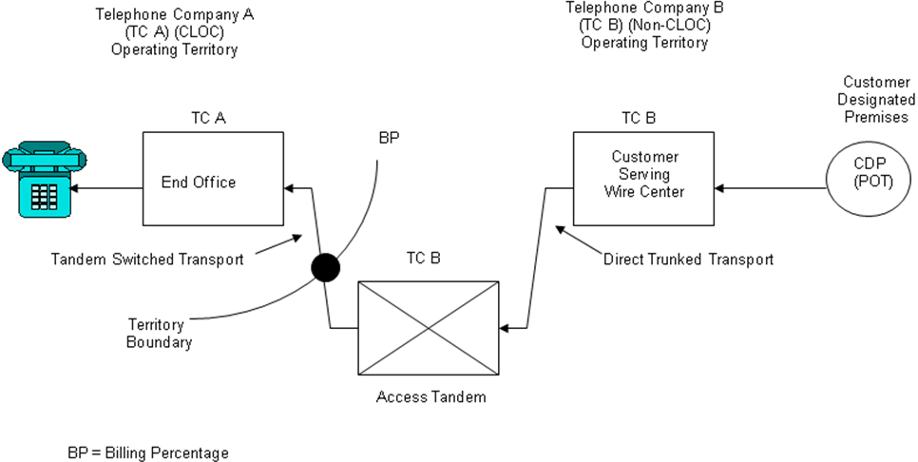 | (N)  (N)

Advice No. WA 17-08A
Issued: May 31, 2017 Effective: July 1, 2017
By Phil Grate, Director – Washington (T)
CenturyTel of Washington, Inc. d/b/a CenturyLink
Section 2
WN U-12 Original Sheet 2-34.17
Access Service
Washington

2. General Regulations  2.4 Payment Arrangements and Credit Allowances  2.4.7 Ordering, Rating and Billing of Access Services Where More Than One Exchange Telephone Company is Involved  B. Meet Point Billing  3. Determination of Meet Point Billed Local Transport and Channel Mileage Charges  l. Example 5: Terminating Switched Access – Tandem 3rd Party  (See Diagram 5) (Cont’d)  - Telephone Company A charges are:  End Office charges = 9,000 min. x EO rate  Tandem Switched Facility 3rd Party charge  = 9,000 min. x 23 mi. x TSF-3rd Party rate x 80%  Tandem Switched Termination 3rd Party charge  = 1 termination x 9,000 min. x TST-3rd Party rate | (N)  (N)

Advice No. WA 17-08A
Issued: May 31, 2017 Effective: July 1, 2017
By Phil Grate, Director – Washington (T)
CenturyTel of Washington, Inc. d/b/a CenturyLink
Section 2
WN U-12 Original Sheet 2-34.18
Access Service
Washington

2. General Regulations  2.4 Payment Arrangements and Credit Allowances  2.4.7 Ordering, Rating and Billing of Access Services Where More Than One Exchange Telephone Company is Involved  2.5 Connections  2.5.1 General  Equipment and Systems (i.e., terminal equipment, multiline terminating systems and communications systems) may be connected with access service (switched and special) furnished by the Telephone Company where such connection is made in accordance with the provisions specified in the following AT&T tariffs: F.C.C. No. 259, Section 2.6; F.C.C. No. 260, Section 2.6; F.C.C. No. 263, Section 2.6; F.C.C. No. 267, Section 2.3; F.C.C. No. 270, Section 2.7; F.C.C. No. 273, Section 2.8, and Technical Publication A.S. No. 1.  (M) Material moved from Page 34. | (M)  (M)

Advice No. WA 17-08A
Issued: May 31, 2017 Effective: July 1, 2017
By Phil Grate, Director – Washington (T)

CenturyTel of Washington, Inc. d/b/a CenturyLink
Section 16
WN U-12 3rd Revised Sheet 16-4
Access Service Cancels 2nd Revised Sheet 16-4
Washington

16. Rates and Charges[1]

16.3 Switched Access Service

Regulations concerning Switched Access are set forth in Section 6 preceding.

16.3.1 Nonrecurring Charges

Nonrecurring Tariff
Charge Reference

A. Local Transport Installation
Per Entrance Facility 6.1.3.A.

Voice Grade Two-Wire $ 56.00

Voice Grade Four-Wire $ 56.00

High Capacity DS1 $400.00

High Capacity DS3 $750.00

B. Trunk Activation
Per 24 Trunks Activated
or Fraction thereof on a
Per Order basis $209.00 6.2

C. FGC and FGD Trunk Conversion
Multifrequency Address Signaling
to SS7 Signaling or SS7 Signaling
to Multifrequency Address
Signaling Per 24 Trunks Converted
Or Fraction thereof on a Per
Order Basis $105.00 (R) 6.2.4

[1] See Sheet 16-1 for applicable exchanges

Advice No. WA 17-08A
Issued: May 31, 2017 Effective: July 1, 2017
By Phil Grate, Director – Washington (T)
CenturyTel of Washington, Inc. d/b/a CenturyLink
Section 16
WN U-12 2nd Revised Sheet 16-8
Access Service Cancels 1st Revised Sheet 16-8
Washington

16. Rates and Charges[1]  16.3 Switched Access Service  16.3.2 Switched Transport  - Premium Access (Cont’d)  Tariff  Rate Reference  3. Tandem Switched Transport 6.1.3.A.3.  Tandem Switched Facility  (Originating)  Per Access Minute Per Mile  - 0 $0.000000  - Over 0 to 8 $0.000020  - Over 8 to 25 $0.000022  - Over 25 to 50 $0.000023  - Over 50 $0.000023  Tandem Switched Termination  (Originating)  Per Access Minute Per Termination  - 0 $0.000000  - Over 0 to 8 $0.000199  - Over 8 to 25 $0.000255  - Over 25 to 50 $0.000263  - Over 50 $0.000265  Tandem Switched Facility  Terminating Terminating  3rd Party End Office  Per Access Minute Per Mile  - 0 $0.000012 $0.000000 (R)  - Over 0 to 8 $0.000012 $0.000000 (R)  - Over 8 to 25 $0.000012 $0.000000 (R)  - Over 25 to 50 $0.000012 $0.000000 (R)  - Over 50 $0.000012 $0.000000 (R)  [1] See Sheet 16-1 for applicable exchanges | (C)  (C)  (C)  (C)

Advice No. WA 17-08A
Issued: May 31, 2017 Effective: July 1, 2017
By Phil Grate, Director – Washington (T)
CenturyTel of Washington, Inc. d/b/a CenturyLink
Section 16
WN U-12 2nd Revised Sheet 16-9
Access Service Cancels 1st Revised Sheet 16-9
Washington

16. Rates and Charges[1]  16.3 Switched Access Service  16.3.2 Switched Transport  - Premium Access  Tariff  Rate Reference  3. Tandem Switched Transport (Cont’d) 6.1.3.A.3.  Tandem Switched Termination  Terminating Terminating  3rd Party End Office  Per Access Minute  Per Termination  - 0 $0.000011 $0.000000 (R)  - Over 0 to 8 $0.000011 $0.000000 (R)  - Over 8 to 25 $0.000011 $0.000000 (R)  - Over 25 to 50 $0.000011 $0.000000 (R)  - Over 50 $0.000011 $0.000000 (R)  Tandem Switching  Per Access Minute Per Tandem  Originating $0.003306  Terminating – 3rd Party $0.006756  Terminating – End Office $0.000700  Common Transport Multiplexing  Per Access Minute  Originating $0.000198  Terminating – 3rd Party $0.000009  Terminating – End Office $0.000000  [1] See Sheet 16-1 for applicable exchanges | (C)  (C)  (C)  (C)  (C)  (N)  (C)  (N)

Advice No. WA 17-08A
Issued: May 31, 2017 Effective: July 1, 2017
By Phil Grate, Director – Washington (T)

CenturyTel of Washington, Inc. d/b/a CenturyLink
Section 16
WN U-12 5th Revised Sheet 16-11
Access Service Cancels 4th Revised Sheet 16-11
Washington

16. Rates and Charges[1]

16.3 Switched Access Service (Cont’d)

16.3.3 End Office

A. Local Switching Rate
Per Access Minute
1. Premium

Local Switching 1
– Originating $0.014441
– Terminating $0.000000 (R)

Local Switching 2
– Originating $0.014441
– Terminating $0.000000 (R)

2. Non-Premium

– Originating $0.000000
– Terminating $0.000000

B. Line Terminations

1. Access Line Termination

Premium N/A
Transitional N/A

C. Intercept
Intercept Charge
Premium N/A
Transitional N/A

D. End Office Shared Port

– Originating $0.000590
– Terminating $0.000000

[1] See Sheet 16-1 for applicable exchanges

Advice No. WA 17-08A
Issued: May 31, 2017 Effective: July 1, 2017
By Phil Grate, Director – Washington (T)
CenturyTel of Washington, Inc. d/b/a CenturyLink
Section 17
WN U-12 3rd Revised Sheet 17-4
Access Service Cancels 2nd Revised Sheet 17-4
Washington

17. Rates and Charges[1]

17.3 Switched Access Service

Regulations concerning Switched Access are set forth in Section 6 preceding.

17.3.1 Nonrecurring Charges

Nonrecurring Tariff
Charge Reference

A. Local Transport Installation
Per Entrance Facility 6.1.3.A.

Voice Grade Two-Wire $ 56.00

Voice Grade Four-Wire $ 56.00

High Capacity DS1 $400.00

High Capacity DS3 $750.00

B. Trunk Activation
Per 24 Trunks Activated
or Fraction thereof on a
Per Order basis $209.00 6.2

C. FGC and FGD Trunk Conversion
Multifrequency Address Signaling
to SS7 Signaling or SS7 Signaling
to Multifrequency Address
Signaling Per 24 Trunks Converted
Or Fraction thereof on a Per
Order Basis $105.00 (R) 6.2.4

[1] See Sheet 17-1 for applicable CenturyTel of Cowiche, Inc. exchanges

Advice No. WA 17-08A
Issued: May 31, 2017 Effective: July 1, 2017
By Phil Grate, Director – Washington (T)

CenturyTel of Washington, Inc. d/b/a CenturyLink
Section 17
WN U-12 2nd Revised Sheet 17-8
Access Service Cancels 1st Revised Sheet 17-8
Washington

17. Rates and Charges[1]  17.3 Switched Access Service  17.3.2 Switched Transport  - Premium Access (Cont’d)  Tariff  Rate Reference  3. Tandem Switched Transport 6.1.3.A.3.  Tandem Switched Facility  (Originating)  Per Access Minute Per Mile  - 0 $0.000000  - Over 0 to 8 $0.000020  - Over 8 to 25 $0.000022  - Over 25 to 50 $0.000023  - Over 50 $0.000023  Tandem Switched Termination  (Originating)  Per Access Minute Per Termination  - 0 $0.000000  - Over 0 to 8 $0.000199  - Over 8 to 25 $0.000255  - Over 25 to 50 $0.000263  - Over 50 $0.000265  Tandem Switched Facility  (Terminating)  Per Access Minute Per Mile  Terminating Terminating  3rd Party End Office  - 0 $0.000012 $0.000000 (R)  - Over 0 to 8 $0.000012 $0.000000 (R)  - Over 8 to 25 $0.000012 $0.000000 (R)  - Over 25 to 50 $0.000012 $0.000000 (R)  - Over 50 $0.000012 $0.000000 (R)  [1] See Sheet 17-1 for applicable CenturyTel of Cowiche, Inc. exchanges | (C)  (C)

Advice No. WA 17-08A
Issued: May 31, 2017 Effective: July 1, 2017
By Phil Grate, Director – Washington (T)

CenturyTel of Washington, Inc. d/b/a CenturyLink
Section 17
WN U-12 2nd Revised Sheet 17-9
Access Service Cancels 1st Revised Sheet 17-9
Washington

17. Rates and Charges[1]  17.3 Switched Access Service  17.3.2 Switched Transport  - Premium Access  Tariff  Rate Reference  3. Tandem Switched Transport (Cont’d) 6.1.3.A.3.  Tandem Switched Termination  (Terminating)  Terminating Terminating  3rd Party End Office  Per Access Minute  Per Termination  - 0 $0.000011 $0.000000 (R)  - Over 0 to 8 $0.000011 $0.000000 (R)  - Over 8 to 25 $0.000011 $0.000000 (R)  - Over 25 to 50 $0.000011 $0.000000 (R)  - Over 50 $0.000011 $0.000000 (R)  Tandem Switching  Per Access Minute Per Tandem  Originating $0.003306  Terminating – 3rd Party $0.006756  Terminating – End Office $0.000700  Common Transport Multiplexing  Per Access Minute  Originating $0.000198  Terminating- 3rd Party $0.000009  Terminating- End Office $0.000000  [1] See Sheet 17-1 for applicable CenturyTel of Cowiche, Inc. exchanges | (C)  (C)  (C)  (C)  (C)  (N)  (C)  (N)

Advice No. WA 17-08A
Issued: May 31, 2017 Effective: July 1, 2017
By Phil Grate, Director – Washington (T)

CenturyTel of Washington, Inc. d/b/a CenturyLink
Section 17
WN U-12 5th Revised Sheet 17-11
Access Service Cancels 4th Revised Sheet 17-11
Washington

17. Rates and Charges[1]

17.3 Switched Access Service (Cont’d)

17.3.3 End Office

A. Local Switching Rate
Per Access Minute
1. Premium

Local Switching 1
– Originating $0.014441
– Terminating $0.000000 (R)

Local Switching 2
– Originating $0.014441
– Terminating $0.000000 (R)

2. Non-Premium

– Originating $0.000000
– Terminating $0.000000

B. Line Terminations

1. Access Line Termination

Premium N/A
Transitional N/A

C. Intercept
Intercept Charge
Premium N/A
Transitional N/A

D. End Office Shared Port

– Originating $0.000590
– Terminating $0.000000

[1] See Sheet 17-1 for applicable CenturyTel of Cowiche, Inc. exchanges

Advice No. WA 17-08A
Issued: May 31, 2017 Effective: July 1, 2017
By Phil Grate, Director – Washington (T)

