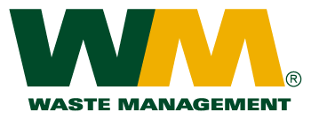

November 29, 2016
Washington Utilities and Transportation Commission
Chandler Plaza Building
1300 S. Evergreen Park Drive SW
P.O. Box 47250
Olympia, WA. 98504-7250
Dear Sirs:
Subject: WM – Healthcare Solutions of Washington, a division of Waste Management of Washington, Inc. (G-237); Tariff # 2
Please find enclosed revised tariff pages 2 and, 7 and new tariff page 8A for the above-referenced company. The principal purpose of these tariff page revisions is to add a new service: the collection, transportation, processing and disposal of reusable sharps containers. In accordance with WAC 480-70-261 we are filing this new service on one-day notice to the commission as this new service is in response to a request by a customer. The proposed effective date of these tariff revisions is November 30, 2016.
If you have any questions or need additional information, please contact me at (425) 814-7840.
Very truly yours,

Michael A. Weinstein
Senior Pricing Manager, Pacific Northwest Market Area

cc: Jeff Norton

