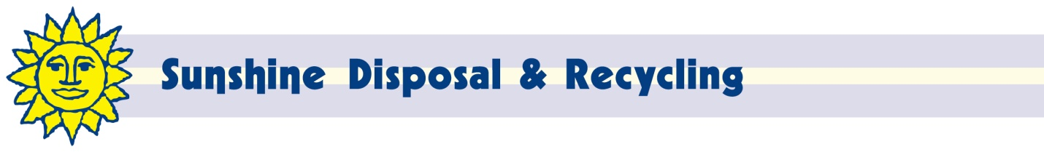

October 20, 2016
Steven V. King, Executive Director and Secretary
Washington Utilities and Transportation Commission
PO Box 47250
Olympia, WA 98504-4720

Dear Mr. King:

Enclosed are proposed revisions to Tariff 5.1 of Ada-Lin Waste Systems, Inc. d/b/a Sunshine Disposal & Recycling (G-104).

The purpose of this filing is to adjust rates to reflect disposal fee changes in Spokane County. Attached are the notifications for the proposed changes. This filing also adjusted Item 18 to reflect the fact that residential customers are now billed on a 3 month cycle. It also adjusted Item 100 to reinforce the fact that Item 240 may be used for residential customers.

The net impact of these changes will decrease revenue approximately $800 or .8% annually. Customers will be notified of the rate change on their next regular billing.

We request waiver from the requirements of WAC 480-07-520 due to the fact that this rate change only covers changes in disposal fees and non-revenue related items.

If I can be of any further assistance, please contact me at 509-924-5678 x217 or 509-252-3500 (fax) or at johnl@sunshinedisposal.com.

Respectfully,

John Lloyd
Chief Financial Officer

