s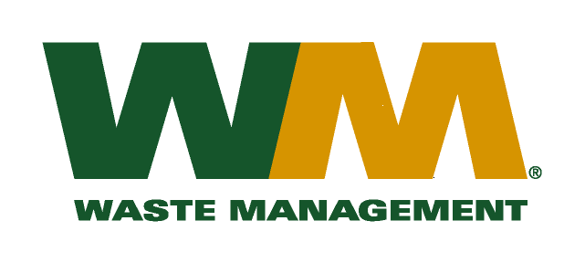
July 30, 2026
Washington Utilities and Transportation Commission
Chandler Plaza Building
1300 S. Evergreen Park Drive SW
P.O. Box 47250
Olympia, WA 98504-7250
Subject: Waste Management–South Sound and Waste Management of Seattle, divisions of Waste Management of Washington, Inc. (G-237); Tariff # 23
Enclosed are revised pages 2, 21-25, 25A, 27, 29, and 34-37 to the above-referenced tariff. The purpose of these tariff revisions is twofold. First, residential and commercial rates are being adjusted due to the increase in the King County disposal fees. Second, the revisions also reflect the change in the commodity credits for residential and multi-family customers receiving recycling collection services.
The King County Council approved the increase in disposal fees from $120.17 to $134.59 per ton as reflected in King County Ordinance No.2016-0386, a copy of which is included with this filing. The increased rates, if approved by the Commission, would approximately increase Company revenue by $449,000, and residential and commercial garbage rates by approximately 5.3%. The effective date of these proposed tariff revisions is January 1, 2017.
As mentioned above, the tariff revisions also to reflect the change in the commodity credits for residential and multi-family customers receiving recycling collection services. These tariff revisions reflect a decrease of the current commodity credit from $0.87 to $0.49 per month for residential customers. Multi-family commodity credits are decreasing proportionately to the decreases to residential customers. As a result, this filing also seeks approval to implement an increase in customers’ solid waste collection rates in addition to the disposal fee increase.
This decrease in the commodity credit is due to the overall changes in commodity values and tonnages since our last commodity credit adjustment on January 1, 2016. The proposed effective date of the revised recycling commodity credits is January 1, 2017.
As a reminder of context, the change in commodity credits are being submitted mid-way through the two-year Revenue Sharing Plan with King County for 2016 - 2017. It only reflects the changes to the commodity rebates due to actual prices and quantities over the past 12 months. It does not make other adjustments that will be required upon completion of the Plan. In accordance with RCW 81.77.185 and the approved Plan, the Company will continue to retain up to 47.5% of recycling commodity revenues to be spent on program activities. At the end of the two-year period, the revised commodity credit will be subject to additional adjustments to reflect any incentives earned by the Company, and amounts of retained revenue over or under spent to comply with the tasks in the Revenue Sharing plan. This filing includes a report on expenditures to date, but does not indicate any amounts over or under spent because the Plan activities are still ongoing. Along with any changes attributable to commodity values and tonnages during the next 12-month period, retained revenue adjustments will be addressed in our filing in 2017 at the completion of the two-year plan period.
Enclosed for your review are our accounting work papers. Customers will be notified of the change in their collection rates and their commodity credit adjustment on their next regularly scheduled billing after the approval of the Commission. In addition, the counties have been notified of these proposed tariff changes.
If you have any questions or need additional information, please contact me at (425) 814-7840.
Very truly yours,

Mike Weinstein
Senior Pricing Manager, Pacific Northwest Market Area
cc: Jeff McMahon & Carlton Paulmier, Waste Management
Pat McLaughlin & Jeff Gaisford, King County Solid Waste Division

