AFFIDAVIT CONTAINING CERTIFICATIONS
PURSUANT TO WAC 480-123-060 AND WAC 480-123-070

I, Mark R. Martell, being of lawful age, state that I am the Administrative Manager of Pend Oreille Telephone Company (“Company”), that I am authorized to execute this Affidavit on behalf of the Company, and that the facts set forth in this Affidavit are true to the best of my knowledge, information and belief. On this basis, I hereby certify to the Washington Utilities and Transportation Commission (“Commission”) for use by the Commission in providing the certification to the Federal Communications Commission and Universal Service Administrative Company required by 47 C.F.R. §54.314, as follows:

(1) That all federal high-cost support provided to the Company within the State of Washington has been used in the preceding calendar year and will be used in the coming calendar year only for the provision, maintenance and upgrading of facilities and services for which the support is intended;

(2) That during the 2013 calendar year, the Company met substantially the applicable service quality standard found in WAC 480-123-030(1)(h);

(3) That during the 2013 calendar year, the Company maintained the ability to function in emergency situations under the standard found in WAC 480-123-030(1)(g), as such standard relates to functionality of wireline carriers in emergency situations; and

(4) That during the 2013 calendar year, the Company publicized the availability of its applicable telephone assistance programs, such as Lifeline, in a manner reasonably designed to reach those likely to qualify for service, including residents of federally-recognized Indian reservations within the Company’s designated service area.

I certify under penalty of perjury under the laws of the State of Washington that the foregoing is true and correct.

Dated this __21st__ day of July, 2014, at Glenns Ferry, Idaho.

Company: Pend Oreille Telephone Company
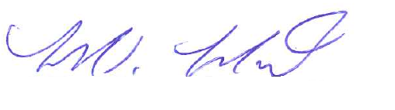

By:
Mark R. Martell

Its: Administrative Manager

