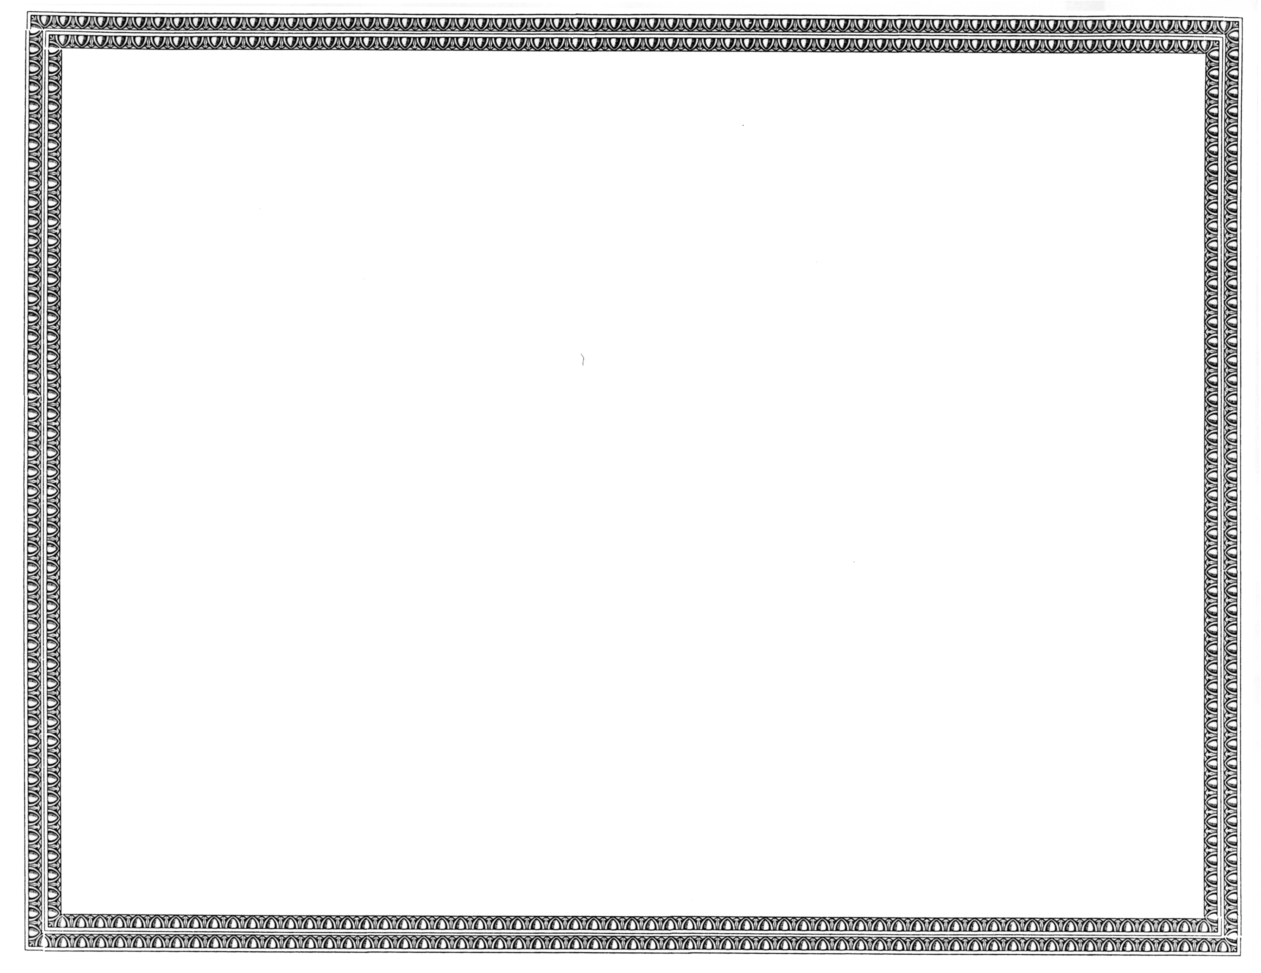



REGISTRATION
OF

Network Billing Systems, LLC

AS A COMPETITIVE
TELECOMMUNICATIONS COMPANY

Docket Number UT-140808 June 6, 2014
Effective Date

STEVEN V. KING

Executive Director and Secretary

CERTIFICATE IS NOT TRANSFERABLE

