Steven King, Executive Secretary 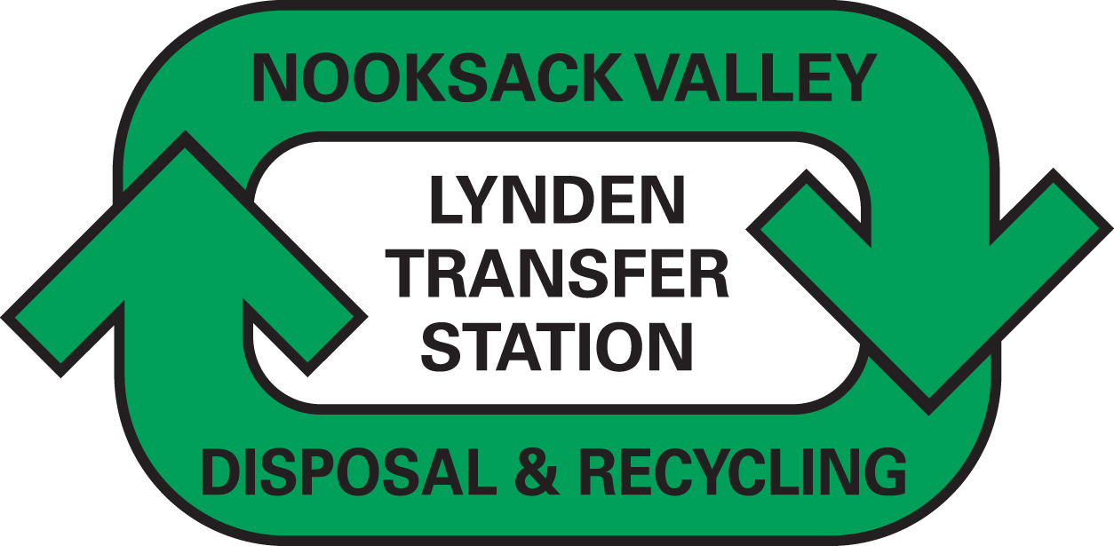
Washington Utilities and Transportation Commission
1300 South Evergreen Park Drive SW
P.O. Box 47250
Olympia, WA 98504-7250 October 15, 2013

Dear Secretary King,

Enclosed please find revised tariff pages and worksheets for Nooksack Valley Disposal, Inc., permit G-166. This is an adjustment to the recycling credit as detailed in WAC 480-70-351.

We have made the annual review to the Recycling Credit portion of Item 100. This adjustment is a decrease of the credit to residential recycling customers as a result of a calculation of the recycling tracker using the last twelve months of recycling commodity values. The current credit is $.56 per customer per month. The proposed credit is $.21 per customer per month. The expected impact to the company is an increase in revenue of $9,362. We have requested an effective date of December 1, 2013, the date the old rates expire.

Notice will be given to our customers and to the Whatcom County Council at the time of our next billing, after rates have been approved.

.

The contact person for this submittal is: Calvin Den Hartog
P.O. Box 267
Lynden, WA 98264
Phone: (360) 354-3400
Fax: (360) 354-3288
Calvin_NVD@msn.com

Sincerely,

Calvin Den Hartog
General Manager

CC: Whatcom County

