Shawn M. Filippi
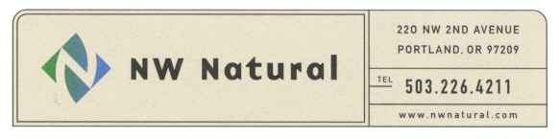
Senior Legal Counsel & Assistant Corporate Secretary
Tel: 503.220.2435
Fax: 503.721.2516
Toll Free: 1.800.422.4012
e-mail: shawn.filippi@nwnatural.com

December 14, 2012

Via Electronic Filing
Dave Danner, Secretary and Executive Director
Washington Utilities and
Transportation Commission
1300 S. Evergreen Park Drive, S.W.
P. O. Box 47250
Olympia, WA 98504-7250

Re: UG ___________. Northwest Natural Gas Company’s Revolving Line of Credit with a Syndication of Banks and the borrowing of up to $450,000,000 in Connection therewith Primarily to Back-Up the Company’s Commercial Paper Program

Dear Mr. Danner:

Submitted herewith for filing with the Commission is the Statement and Application of Northwest Natural Gas Company Establishing Compliance with RCW 80.08.040 with Respect to a Revolving Line of Credit with a Syndication of Banks and the Borrowing of up to $450,000,000 in Connection therewith Primarily to Back-Up the Company’s Commercial Paper Program. If you have any questions regarding this matter or require any additional information, please contact me at 503-220-2435, or Stephen Feltz at 503-220-2345.

Sincerely,

/s/ Shawn M. Filippi

Shawn M. Filippi

SMF:nkb
Encl.

