October 6, 2011

Mr. David Danner
Executive Director & Secretary
Washington Utilities and Transportation Commission
1300 S. Evergreen Park Drive SW
P. O. Box 47250
Olympia, Washington 98504-7250

RE: Avista Corporation Affiliated Interest Filing (Advantage IQ, Inc.) pursuant to RCW 80.16.020.

Dear Mr. Danner:
Pursuant to RCW 80.16.020 and WAC 480-90-245, please find enclosed for filing an original and three copies of the “Master Promissory Note” between Avista Corporation and Advantage IQ, Inc., an Affiliated Interest, for the Promissory Note by and between Avista and Advantage IQ Inc., an affiliate of Avista. The Promissory Note, is attached hereto as Attachment A.
Avista Corporation is seeking Commission approval of intercompany debt, an affiliated interest transaction.

Affiliated Interest
Avista Capital, Inc., is a wholly owned subsidiary of Avista Corporation, and is the parent corporation of Avista Corporation’s non-regulated subsidiary investments and operations. As reported in the Company’s 2010 Affiliated Interest and Subsidiary Transactions Report, Avista Capital had a non-utility subsidiary investment in Advantage IQ, Inc. (75.74% ownership). Advantage IQ, Inc., is an Affiliated Interest pursuant to RCW 80.16.020 and WAC 480-90-245.

Intercompany Debt - Subsidiary Promissory Note

Avista Corporation filed the “Avista Corporation Cash Management Guidelines and Procedures” dated April 2011 with the Washington Commission on May 23, 2011. These guidelines are in place in order to efficiently manage cash at the corporate and subsidiary levels, minimize borrowing costs and maximize investment returns. These guidelines exclude Advantage IQ as they manage their cash in accordance with their cash management investment guidelines. Advantage IQ currently has excess funds.

Avista Corp would like to enter into a note agreement between Avista Corporation and Advantage IQ. The note agreement is structured so that Avista Corporation would pay the same rate as would have been incurred under the credit facility (i.e. Avista Corporation’s avoided short-term borrowing rate). The avoided short-term borrowing rate is currently 130 bps plus LIBOR. Avista Corporation may borrow up to $50 million in principal under the note agreement. The unpaid principal balance along with accrued interest is required to be paid the last day of each quarter end (March, June, September and December) and sooner upon demand by Advantage IQ. Additionally, Avista Corporation will be required to retain liquidity under its credit facility to repay the outstanding principal balance in whole at any time. The note is structured to mirror the “Avista Corporation Cash Management Guidelines and Procedures” dated April 2011 that was previously filed with the commission.

Please direct any questions regarding this filing to Liz Andrews at (509) 495-8601.

Sincerely,
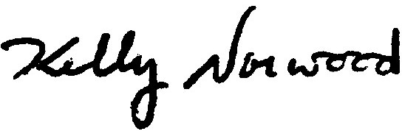
Kelly O. Norwood
Vice President, State and Federal Regulation
Enclosure

