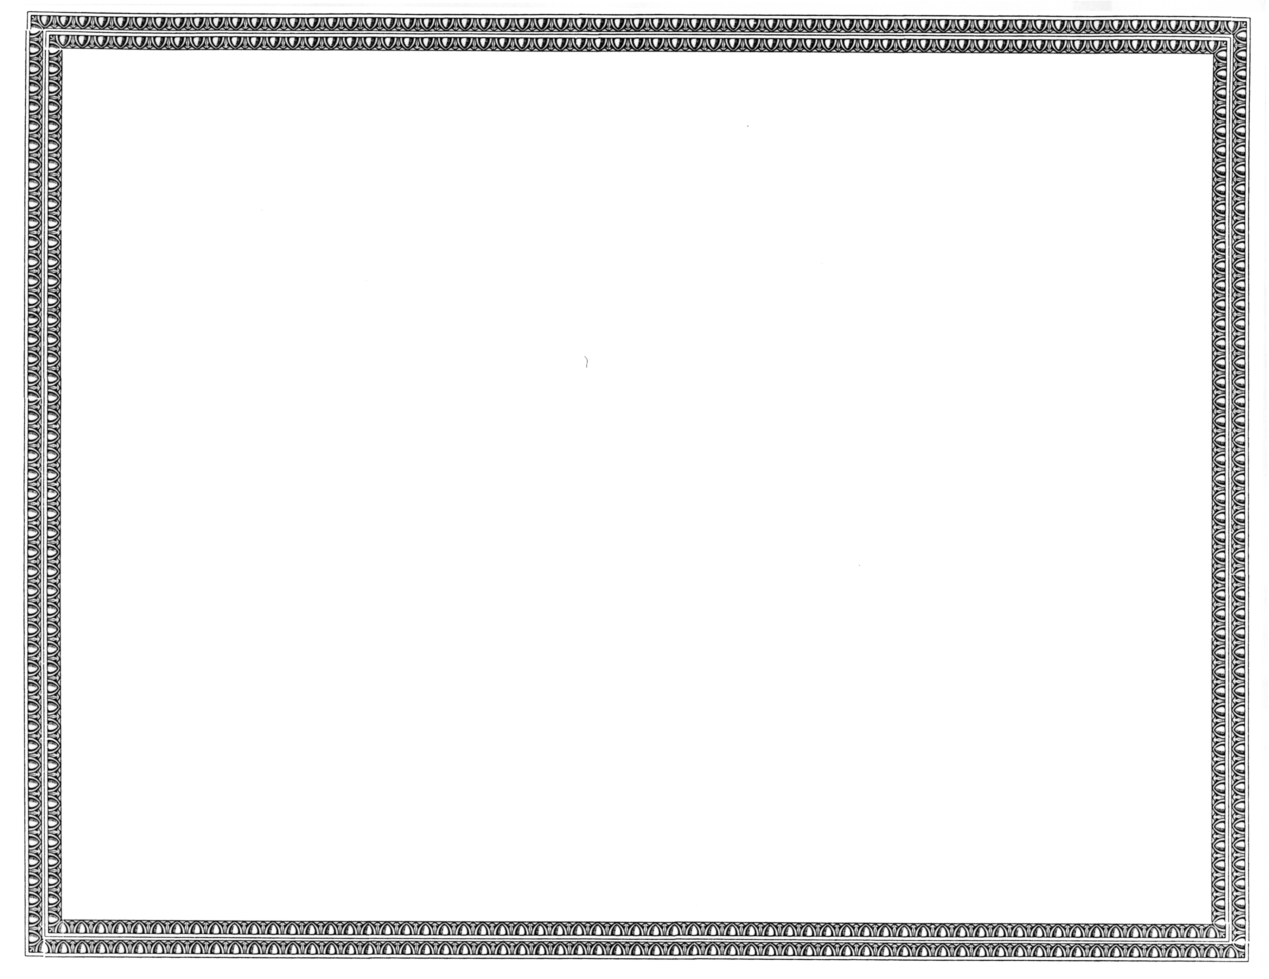



REGISTRATION
OF

Zayo Group, LLC

AS A COMPETITIVE
TELECOMMUNICATIONS COMPANY

Docket Number UT-110349 March 26, 2011
Effective Date

DAVID W. DANNER

Executive Director and Secretary

CERTIFICATE IS NOT TRANSFERABLE

