

Calvin K. Simshaw 805 Broadway
Senior Regulatory Counsel Vancouver, WA 98660
calvin.simshaw@centurylink.com 360-905-5958

May 13, 2010 Via E-mail and
Legal Messenger

Mr. Dave Danner
Secretary and Executive Director
Washington Utilities and Transportation Commission
P.O. Box 47250
1300 S. Evergreen Park Dr. SW
Olympia, WA 98504-7250

Re: Joint Application of Qwest Communications International Inc. and CenturyTel, Inc. for Approval of Indirect Transfer of Control

Dear Mr. Danner,

Enclosed for filing are an original and twelve copies of the Application of Qwest Communications International Inc. (“QCII”) and CenturyTel, Inc. (“CenturyLink”) for approval of an Indirect Transfer of Control of QCII’s operating subsidiaries to CenturyLink.

Please note that included in the Joint Application is a request that, pursuant to WAC 480-07-440 and RCW 34.05.434, the Commission shorten the notice period for scheduling of a prehearing conference from 20 to 14 days. The Joint Applicants intend to submit pre-filed testimony in support of the Joint Application some time next week.

Thank you in advance for your assistance with this filing. If you have any questions, please do not hesitate to contact me.

Sincerely,

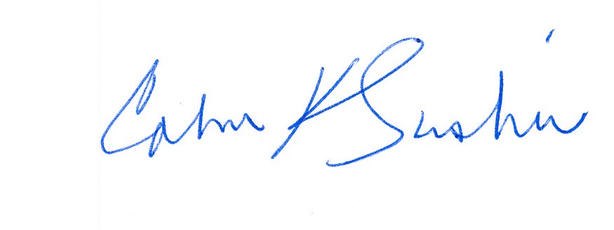

Calvin K. Simshaw
Senior Regulatory Counsel

