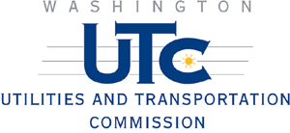
PUBLIC NOTICE

2nd Avenue
Highway-Rail Grade Crossing

The City of Ferndale has filed a petition with the Utilities and Transportation Commission to close this railroad crossing. If you would like to comment on this petition, e-mail your comments to comments@utc.wa.gov or send your written comments to:

David Danner, Director and Executive Secretary
Utilities & Transportation Commission
PO Box 47250, Olympia, WA 98504-7250

Please include our reference number, TR-090434. You must submit your comments by May 5, 2009. If you have questions about the proposed petition, call John Cupp at (360) 664-1113 or send him an e-mail at jcupp@utc.wa.gov

