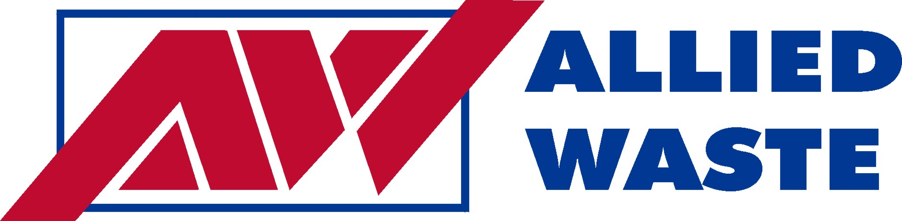

January 16, 2009

VIA EMAIL AND FIRST CLASS MAIL

David Danner, Executive Director & Secretary
Washington Utilities and Transportation Commission
P.O. Box 47250
1300 S. Evergreen Park Dr. SW
Olympia, WA 98504 – 7250

Re: Notice Pursuant to WAC 480-70-096 of Acquisition of Control of Allied Waste Industries, Inc. by Republic Services, Inc.

Dear Mr. Danner,
This is to formally notify the Commission, pursuant to the above rule, of the stock acquisition effective December 5, 2008 of Fiorito Enterprises and Rabanco LTD., holder of Certificate No. G- 60, by Republic Services, Inc., the parent company of Rabanco LTD.,Kent Meridian Disposal, which are also regulated solid waste collection companies in the State of Washington.

Republic Services, Inc. is a publicy – traded company (NYSE: RSG) with numerous shareholders, the largest of which is CASCADE INVESTMENT LLC.

The name, address and contact information for the person within Rabanco LTD and Republic Services, Inc. who can answer any further question on this matter is as follows:

Timothy Stuart, Area President
Rabanco Ltd.
1600 127th Ave NE
Bellevue, WA 98005

Tel: 425.646.2430
Fax: 425.646.2451
Email: timothy.stuart@awin.com

Please contact us with any further questions you might have on this matter and thank you for you attention on the above.

Yours truly,
Joseph Garza
Sr. Market Analyst
425.646.2426
joe.garza@awin.com

