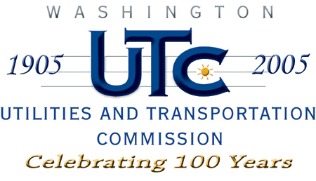
Memorandum
February 8, 2008

To: Records Center

From: Kathy Hunter, Transportation Safety Compliance Manager

Subject: TR-080133, Continuation of Pre-Rule Quiet Zone
City of Spokane

On January 17, 2008, the City of Spokane sent the Utilities and Transportation Commission (UTC) a copy of its January 14, 2008, letter to the Federal Railroad Administration (FRA) regarding its intent to continue a quiet zone with the city as provided under the Code of Federal Regulations (CFR) 222.41. A quiet zone is a designated area of railroad track over which a train travels and does not sound its whistle or horn at a public crossing.

CFR 222.41 allows a local jurisdiction to continue a quiet zone if it was in effect before December 9, 1996; was still in effect on December 18, 2003; and it meets criteria set out in the CFR. The City of Spokane had a quiet zone in effect before December 9, 1996. (See UTC Docket TR-951218.) The quiet zone was still in effect on December 18, 2003.

As a condition of continuing a quiet zone, local jurisdictions are required to provide notice to a number of organizations of its intent to continue the quiet zone, including the state regulatory agency. The federal rule preempts states from approving or prohibiting any quiet zones within the state.

The City of Spokane previously notified UTC of its intent to continue this quiet zone in Docket TR-052055. This most recent notification of continuance of the quiet zone omits two crossings that were previously included in this corridor, 8th Avenue/Dishman-Mica and the Vista Road railroad crossings. The City of Spokane reports that the 8th Avenue/Dishman-Mica and Vista Road railroad crossings are now included within the City of Spokane Valley quiet zone and not subject to the City of Spokane’s jurisdiction.

UTC docketed the city’s letter as a means of documenting the city’s intent under the federal rules to continue its quiet zone. We have no standing to take any action regarding the quiet zone.

Please close this docket with no further action.

