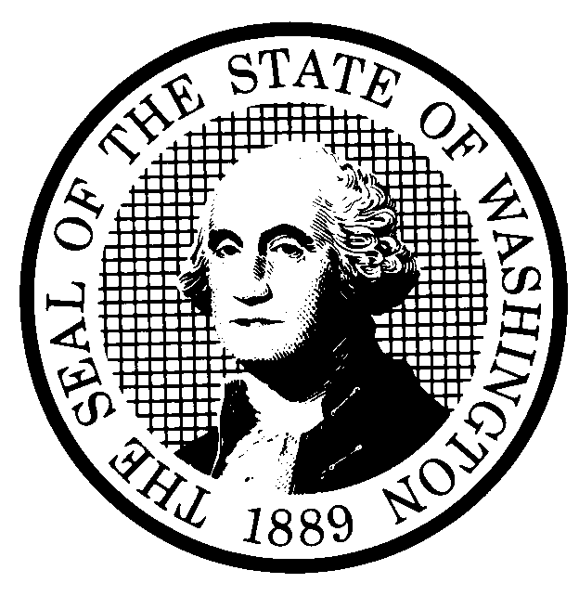 | PREPROPOSAL STATEMENT OF INQUIRY |  | CR-101 (June 2004)  (Implements RCW 34.05.310)  Do NOT use for expedited rule making
Agency: Washington Utilities and Transportation Commission
Subject of possible rule making: The subject of this inquiry is to consider whether the Utilities and Transportation Commission (UTC) should propose new or revised regulations to implement RCW 80.36.090 and RCW 80.36.300. Those statutes are implemented, in part, by the telecommunications service extension rule, WAC 480-120-071 (often referred to as the “line extension” rule). In addition to exploring changes to the requirements, definitions and exemptions in WAC 480-120-071, this inquiry may also address service extensions by telecommunications carriers the commission has designated as eligible telecommunications carriers pursuant to 47 U.S.C. § 214(e). This inquiry may lead to proposed amendments to existing rules including, without limitations, WAC 480-120 and WAC 480-123. The inquiry could also lead to new sections, including a section addressing extension of service to homes outside of existing telephone exchange areas. Finally, the inquiry could lead to rules related to the obligations of wireless eligible telecommunications carriers for service to households without telecommunications service. In addition, amendments or new rules may address service extension issues raised for the first time in this rulemaking. The rulemaking is assigned Docket UT-073014.

.
Statutes authorizing the agency to adopt rules on this subject: RCW 80.01.040 and RCW 80.04.160.
Reasons why rules on this subject may be needed and what they might accomplish: The Commission is interested in determining if the rule provides the correct balance of obligations among customers, local service providers, and interexchange carriers. The Commission is also interested in examining whether the Commission or local service providers should establish limits on distance or cost to circumscribe the obligations of local service providers to extend service. In addition, the rule is not specific about the circumstances when telecommunications carriers should seek waivers under subsection (7). The UTC has received several requests for waivers concerning extensions with estimated costs that vary considerably. Multiple requests for waivers may be an indication the rule may need to be revised. The UTC has also received comments that the rule does not serve the needs of people who live in homes outside the boundaries of telephone exchanges.

Identify other federal and state agencies that regulate this subject and the process coordinating the rule with these agencies: Federal and state laws and rules apply. The agency other than the UTC that has authority concerning extensions of service is the Federal Communications Commission. See 47 U.S.C. § 214(e)(3).
Process for developing new rule (check all that apply):
Negotiated rule making
Pilot rule making
Agency study
Other (describe) The UTC’s official notice of this inquiry will indicate the date by which the UTC wishes to receive initial written comments and the date, time and location of an initial workshop. The UTC may provide the opportunity for additional written comments and/or for participation in additional workshops, if needed.

How interested parties can participate in the decision to adopt the new rule and formulation of the proposed rule before publication: (List names, addresses, telephone, fax numbers, and e-mail of persons to contact; describe meetings, other exchanges of information, etc.)
Interested persons may file comments with the Executive Secretary, Washington Utilities and Transportation Commission, P.O. Box 47250, 1300 S. Evergreen Park Drive S.W., Olympia, Washington, 98504-7250; Telephone (360) 664-1174; Fax (360) 586-1150, by 5:00 p.m., Friday, September 14, 2007.

For specific information regarding opportunities for written comments and to ensure receipt of further information concerning this rulemaking, including notices of any workshops, please see the attachment to this form.

DATE  August 10, 2007 |  | CODE REVISER USE ONLY
NAME (TYPE OR PRINT)  Carole J. Washburn |  | Filed with the Code Reviser’s Office  August 10, 2007, 9:53 a.m.  WSR 07-17-054
SIGNATURE
TITLE
Executive Secretary

WASHINGTON UTILITIES AND TRANSPORTATION COMMISSION
CR-101 - ATTACHMENT
DOCKET UT-073014

Interested persons may contact the Secretary, Washington Utilities and Transportation Commission, P.O. Box 47250, Olympia, Washington, 98504-7250, 360-664-1174 (Fax: 360-586-1150).

WRITTEN COMMENTS
Written comments may be submitted to the Commission at the address given above and should be filed with the Commission no later than Friday, September 14, 2007.
Electronic copies. The commission requests that comments be provided in electronic format to enhance public access, for ease of providing comments, to reduce the need for paper copies, and to facilitate quotations from the comments. Comments may be submitted by e-mail to the commission’s Records Center at records@utc.wa.gov. Please include:

- The docket number of this proceeding (UT-073014)
- The commenting party’s name
- The title and date of the comment or comments

An alternative method for submitting comments may be by mailing/delivering an electronic copy on a 3 ½ inch, IBM-formatted, high-density disk, in .pdf Adobe Acrobat format or in Word 97 or later. Include all of the information requested above. The commission will post on the commission’s Web site all comments that are provided in electronic format. The Web site is located at www.utc.wa.gov/073014. If you are unable to file your comments electronically or to submit them on a disk, the commission will always accept a paper document.

Opportunity for further comment is anticipated. Information about the schedule and other aspects of the rulemaking, including comments, will be posted on the commission’s Web site as it becomes available. If you wish to receive further information on this rulemaking you may (1) call the Commission’s Records Center at 360-664-1234, (2) e-mail the commission at <records@utc.wa.gov>, or (3) mail written comments to the address above to the attention of Carole J. Washburn, Secretary. When contacting the Commission, please refer to Docket UT-073014 to ensure that you are placed on the appropriate service list. Questions may be addressed to Bob Shirley (360) 664-1292 or e-mail at bshirley@utc.wa.gov.

TO CONTINUE RECEIVING NOTICES AND INFORMATION ABOUT THIS RULEMAKING -- The commission wants to ensure its mailings are sent to persons who are interested in the topic and want to receive that information. ANY PERSON WHO COMMENTS will continue to receive notices and information. If you do not submit comments but wish to remain on the mailing list for this rulemaking, please advise the Records Center by any one of the following methods: (1) send a note with your name, address (or a copy of your mailing label), and telephone and fax numbers referencing Docket UT-073014, and the words "Please keep me on the mailing list"; or (2) e-mail your name, address, telephone and fax numbers, referencing Docket UT-073014, and the words "Please keep me on the mailing list" to <records@utc.wa.gov>. Please note that all information in the mailings will be accessible through the commission's Internet Web site at http://www.utc.wa.gov/073014. THOSE PARTIES WHO DO NOT RESPOND MAY NOT RECEIVE FURTHER MAILINGS OR INFORMATION ON THE RULEMAKING.
NOTICE

