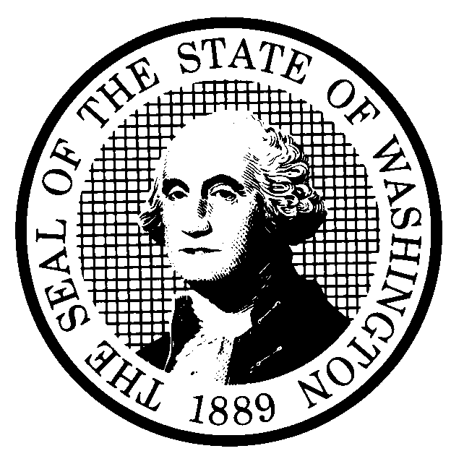 | PREPROPOSAL STATEMENT OF INQUIRY |  | CR-101 (June 2004)  (Implements RCW 34.05.310)  Do NOT use for expedited rule making
Agency: Washington Utilities and Transportation Commission

Subject of possible rule making: Examine the need to revise and clarify rules to selected sections of WAC 480-07 – Procedural Rules, specifically WAC 480-07-110, WAC 480-07-125, WAC 480-07-140, WAC 480-07-160, WAC 480-07-307, WAC 480-07-395, WAC 480-07-510, WAC 480-07-710, WAC 480-07-900, WAC 480-07-903, WAC 480-07-904, and WAC 480-07-905. The rulemaking has been assigned Docket A-072162.
Statutes authorizing the agency to adopt rules on this subject: RCW 80.01.040(4), RCW 80.04.160, and RCW 34.05.020.
Reasons why rules on this subject may be needed and what they might accomplish: Since the Commission adopted rules related to delegation of certain Commission decisions in WAC 480-07, Procedural Rules, effective September 21, 2006, Commission Staff have identified a variety of issues that suggest the Commission should review the delegation rules to promote efficiency in the conduct of business before the Commission. At the same time, Commission Staff have also identified issues with other procedural rules in WAC 480-07.
Identify other federal and state agencies that regulate this subject and the process coordinating the rule with these agencies:
None
Process for developing new rule (check all that apply):
Negotiated rule making
Pilot rule making
Agency study
Other (describe)
The Commission will ask for initial written comments, and will provide the opportunity for additional comments.
How interested parties can participate in the decision to adopt the new rule and formulation of the proposed rule before publication:
(List names, addresses, telephone, fax numbers, and e-mail of persons to contact; describe meetings, other exchanges of information, etc.)
Interested persons may contact the Executive Secretary, Washington Utilities and Transportation Commission, P.O. Box 47250, 1300 S. Evergreen Park Drive S.W., Olympia, Washington, 98504-7250; Telephone (360) 664-1174; Facsimile (360) 586-1150.

Interested persons may file written comments on the CR-101 by January 8, 2008.

For specific information regarding opportunities for written comment and to ensure receipt of further information concerning this rulemaking, please see the attachment to this form.

DATE  December 5, 2007 |  | CODE REVISER USE ONLY
NAME (TYPE OR PRINT)  Carole J. Washburn |  | Filed with the Code Reviser’s Office  December 5, 2007, 9:20 a.m.  WSR 07-24-081
SIGNATURE
TITLE
Executive Secretary

WASHINGTON UTILITIES AND TRANSPORTATION COMMISSION
CR-101 - ATTACHMENT
DOCKET A-072162

Interested persons may contact the Secretary, Washington Utilities and Transportation Commission, P. O. Box 47250, Olympia, Washington, 98504-7250, 360-664-1174 (Fax: 360-586-1150).

WRITTEN COMMENTS
Written comments may be submitted to the Commission at the address given above and should be filed with the Commission no later than Tuesday, January 8, 2008.

Electronic copies. The Commission requests that comments be provided in electronic format to enhance public access, for ease of providing comments, to reduce the need for paper copies, and to facilitate quotations from the comments. Comments may be submitted by electronic mail to the Commission’s Records Center at records@utc.wa.gov. Please include:

- The docket number of this proceeding (A-072162)
- The commenting party’s name
- The title and date of the comment or comments

An alternative method for submitting comments may be by mailing/delivering an electronic copy on a 3 ½ inch, IBM-formatted, high-density disk, in .pdf Adobe Acrobat format or in Word 97 or later. Include all of the information requested above. The Commission will post on the Commission’s web site all comments that are provided in electronic format. The web site is located at http://www.utc.wa.gov/072162. If you are unable to file your comments electronically or to submit them on a disk, the Commission will always accept a paper document.

Opportunity for further comment is anticipated. Information about the schedule and other aspects of the rulemaking, including comments, will be posted on the Commission’s web site as it becomes available. If you wish to receive further information on this rulemaking you may (1) call the Commission’s Records Center at 360-664-1234, (2) e-mail the Commission at <records@utc.wa.gov>, or (3) mail written comments to the address above to the attention of Carole J. Washburn, Executive Secretary. When contacting the Commission, please refer to Docket A-072162 to ensure that you are placed on the appropriate service list. Questions may be addressed to Ann Rendahl (360) 664-1144 or e-mail at arendahl@utc.wa.gov.

TO CONTINUE RECEIVING NOTICES AND INFORMATION ABOUT THIS RULEMAKING -- The Commission wants to ensure its mailings are sent to persons who are interested in the topic and want to receive that information. ANY PERSON WHO COMMENTS will continue to receive notices and information. If you do not submit comments but wish to remain on the mailing list for this rulemaking, please advise the Records Center by any one of the following methods: (1) send a note with your name, address (or a copy of your mailing label), and telephone and fax numbers referencing Docket A-072162, and the words "Please keep me on the mailing list"; or (2) E-mail your name, address, telephone and fax numbers, referencing Docket A-072162, and the words "Please keep me on the mailing list" to <records@utc.wa.gov>. Please note that all information in the mailings will be accessible through the Commission's Internet web site at <http://www.utc.wa.gov/072162>. THOSE PARTIES WHO DO NOT RESPOND MAY NOT RECEIVE FURTHER MAILINGS OR INFORMATION ON THE RULEMAKING.
NOTICE

