Qwest
1801 California St.
Suite 4700
Denver, Colorado 80202

November 6, 2007

Basic Contract Number: OMR #Q9322

Ms. Carole Washburn,
Executive Secretary
Washington Utilities and
Transportation Commission
1300 S. Evergreen Park Drive S. W.
Olympia, Washington 98504

Re: Docket No. UT-072089 – Change of Effective Date – Filing Less Than Statutory

Dear Ms. Washburn:

Pursuant to WAC 480-80-142, Qwest Corporation (Qwest) is forwarding a copy of a twelve (12) month Agreement for LAN Switching Service (LSS) that will become effective upon the Washington Utilities and Transportation Commission’s approval on November 20, 2007.

This Agreement was originally filed with an effective date of November 25, 2007. Upon discovery that the customer’s current Agreement is expiring on November 20, 2007, Qwest is now requesting an earlier effective date. Because this notice of a change in the effective date comes less than 30 days prior to the now requested effective date, Qwest is also filing a request for Commission approval with less than statutory notice.

This contract is not subject to federal competitive bid. Pursuant to the requirements of the Telecommunications Act of 1996, and RCW 80.36.170 and 80.36.180, where those statutes are applicable, Qwest offers the local exchange service in this contract for resale under the same terms and conditions set forth in this contract and at the discounted rate where applicable as established by the Commission in Docket No. UT-960369.

Attached is a non-proprietary statement of the essential terms and conditions of this contract. Also attached is the associated Contract Analysis. Some of this information is considered confidential by Qwest and should be protected under the provisions of WAC 480-07-160.

Sincerely,
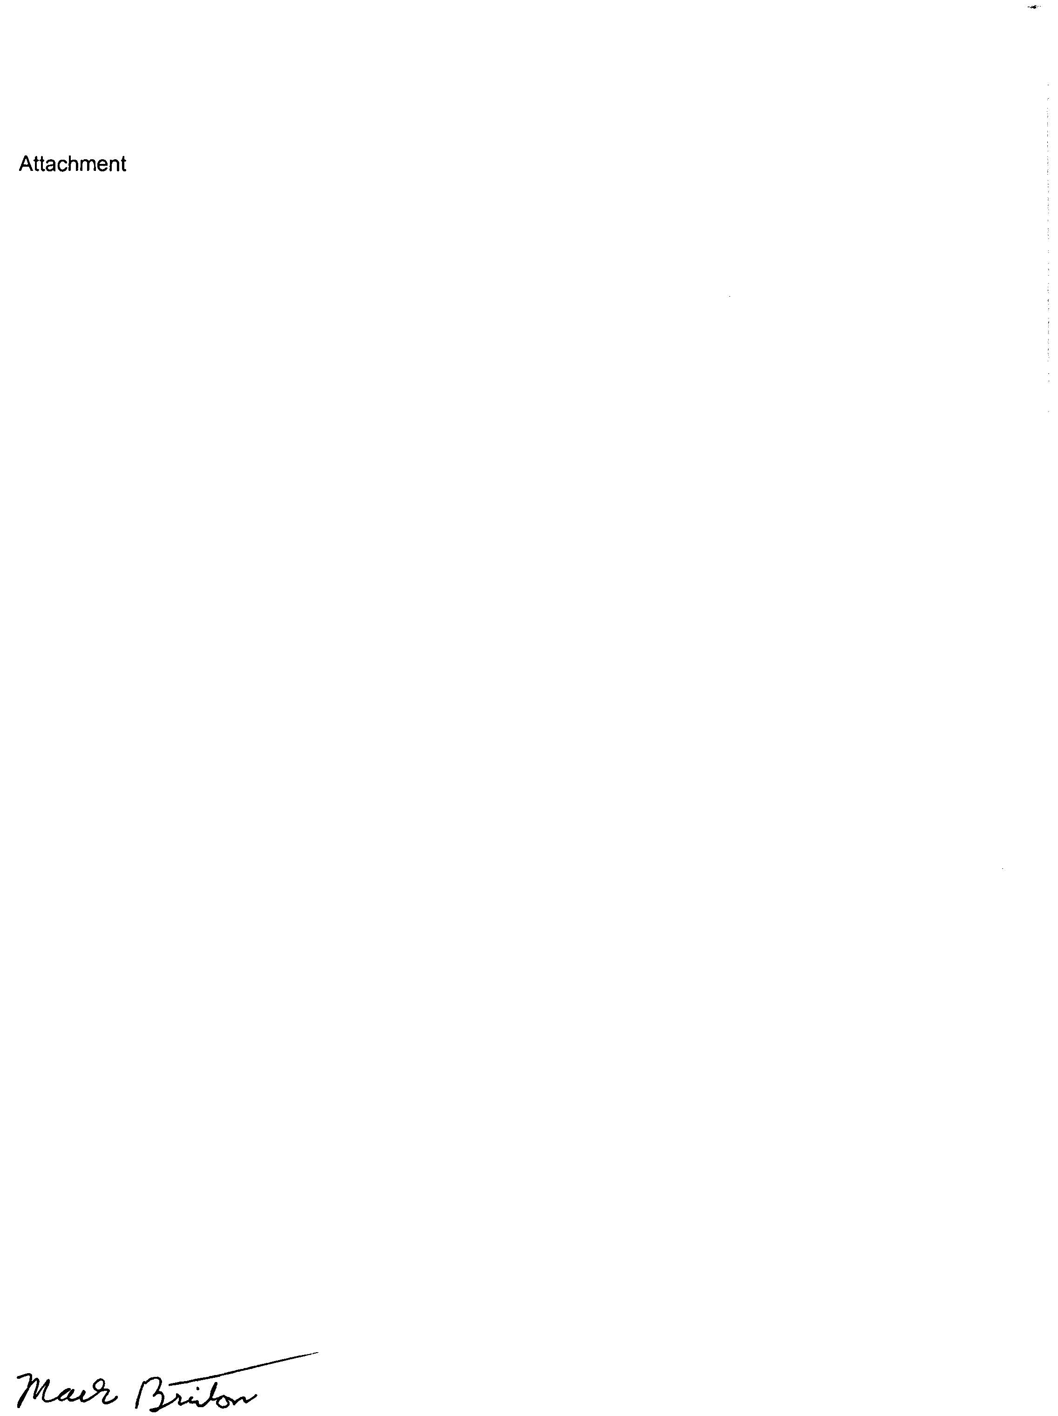

Mark Brinton
Regulatory Support Manager
Office: (303) 896-5123
Fax: (303) 896-9994
e-mail: mark.brinton@qwest.com

Attachments

ESSENTIAL TERMS AND CONDITIONS

Basic Contract Number: OMR #Q9322

New______X________Modified__________Renewal__________

Duration of Basic Contract: 12 months

Effective Date: On November 20, 2007

This Agreement will expire 12 months from the date Service is available to DOT, as evidenced by Qwest records (“Term”) and all mandatory filing requirements are met and approved by the Washington Utilities and Transport Commission (“WUTC”).

Description of Service:

LAN Switching Service (LSS) is a metropolitan-area LAN interconnection service, which utilizes Asynchronous Transfer Mode (ATM) technology to provide customers with native LAN interconnection. LSS provides a specific amount of bandwidth, and supports both point-to-point and multi-point connectivity at 10 Mbps, 45 Mbps, and 100 Mbps.

Monthly Recurring Charge: $3,136.00

Nonrecurring Charge: $0

Service Location(s): Shoreline, Bellingham

Number of Circuits: 2

TELECOMMUNICATIONS CONTRACTS: 480-80-142 (7)

1. Documentation: Standard filing requirements and effective dates. Contracts must be filed with the commission not less than 30 days before the proposed effective date of the contract. Each application filed for commission approval of a contract must include a complete copy of the proposed contract. Documentation must show that the contract does not result in undue or unreasonable discrimination between customers receiving like and contemporaneous service under substantially similar circumstances; and demonstrate, at a minimum, that the contract charges cover the company's cost of providing the service. In addition, the company must summarize the following information with each contract submitted:

(A) Summarize the basis of the charge(s) proposed in the contract and explain the derivation of the proposed charge(s) including all cost computations involved.
Answer: Pricing of this service considers the pricing relationship to similar LAN arrangements, the volume being ordered and the length of the agreement. The underlying costs of the individual components were identified in current cost studies. Attachment A provides a summary of the costs and a contribution analysis.

(B) Indicate the basis for using a contract rather than a filed tariff for the specific service involved.
Answer: This contract represents custom specific pricing (recurring charge). Qwest is responding to the competitive marketplace. The Nonrecurring charge will be recovered by the Monthly Recurring Charge during the second month of service.

