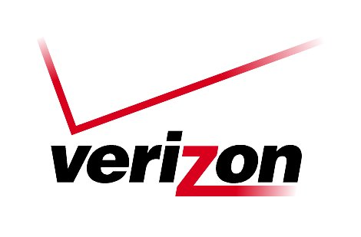 Verizon Northwest Inc.

1800 – 41st Street
WA0105RA
P. O. Box 1003
Everett, WA 98206-1003

August 28, 2007

Ms. Carole J. Washburn, Executive Secretary
Washington Utilities and
Transportation Commission
Chandler Plaza Building
1300 S. Evergreen Park Drive SW
Olympia, Washington 98504

Subject: REQUEST TO EXTEND EFFECTIVE DATE – UT-071717

Dear Ms. Washburn:
Verizon Northwest Inc. (Verizon) filed a request on August 20, 2007 with the Washington Utilities and Transportation Commission to direct the Pooling Administrator (PA) to provide Verizon with one ten thousand number code to satisfy the requirement for additional numbers from Microsoft Corporation, Redmond, WA in the Kirkland Rate Center, NPA 425, LATA 674, OCN 4324. This request is currently pending in Docket No. UT-071717 with a requested effective date of September 13, 2007. At the request of Commission Staff, the company extends the requested effective date to September 27, 2007 to allow more time for review.

Please notify Deborah Reynolds and Rebecca Beaton upon receipt of this letter.

If there are questions concerning this request, please contact Lin Fogg at (425) 261-6380.

Very truly yours,
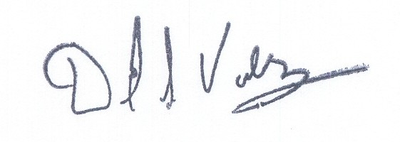

David S. Valdez
Senior Vice President - West
Public Affairs, Policy and Communications

DSV/LF/lf

