Agenda Date: May 9, 2007
Item Number: B2

Docket: TS-070651
Mosquito Fleet, LLC

Staff: Bob Colbo, Transportation Program Staff

Recommendation:

Take no action on this filing at this time.

Background:

Today’s presentation allows customers or other interested parties to comment on the proposed request for a discontinuance of passenger ferry operations in Docket TS-070651. No action is required by the commission. Staff will make its recommendation to the commission at the open meeting on May 23, 2007.

On April 4, 2007, Mosquito Fleet, LLC, BC-125, (Mosquito or company) filed a petition with the commission requesting a one full-year (July 1, 2007 to June 30, 2008) temporary discontinuance of operations on its runs between Everett and Friday Harbor, and serving Rosario and Roche Harbor as flag stops, by reservation only. The company normally operates seasonally during the warm summer months each year.

Last year in Dockets TS-060996 and TS-061301 the commission allowed partial reductions in scheduled service due to decreased patronage and high operating costs. Overall the company experienced heavy operating losses last year. The company anticipates even higher operating expenses and losses due to current fuel costs this year.

The Washington State Ferry (WSF) provides service to Friday Harbor and Orcas Island from its terminal in Anacortes (see Figure 1). Customers whose final destinations are either Roche Harbor (via Friday Harbor terminal) or Rosario (via Orcas Island terminal) have access to transportation other than their personal vehicles.

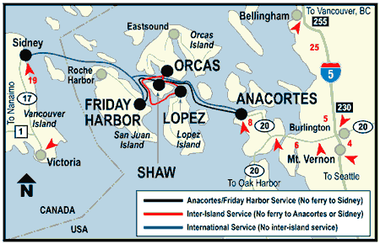
Figure 1; WSF Service Map for San Juan Islands

The company has posted notices at the ports of Everett and Friday Harbor. The company also sent a notice to the Everett Herald. As of May 7, no party has filed comments with the commission.

Conclusion:

Staff recommends that the commission take no action on this filing at this time.

