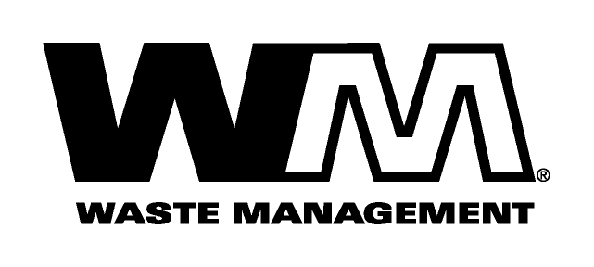

March 31, 2007

Dear Valued Customer,

Our goal at Waste Management is to provide you with the highest quality solid waste service. We value your business.

Like all of us, the garbage industry is faced with many challenges today. Rising costs for labor, disposal, fuel and other general operating expenses have resulted in increased costs for us to provide collection services.

These costs have risen considerably since our last general rate increase, over five years ago. Accordingly, we have applied for an increase in rates, subject to the review and approval of the Washington Utilities and Transportation Commission (W.U.T.C.). The W.U.T.C. regulates the rates and services of Solid Waste companies operating in the unincorporated areas of Washington. The W.U.T.C., upon completing its investigation, could approve rates that may vary from the proposed rates shown on the back of this letter. If approved, the new rates would become effective May 1, 2007.

If you would like to comment on this proposal, you may do so anytime prior to final approval by the W.U.T.C. Comments may be submitted in writing or presented at the commission’s public meeting on this rate proposal. If you have questions, or you would like to be added to the mailing list for this case, you may contact the W.U.T.C. in writing at P.O. Box 47250, Olympia, WA 98504-7250 or by calling toll-free 1 (800) 562-6150 or by e-mailing comments@wutc.wa.gov or faxing (360)-664-3604.

At Waste Management, we are committed to finding new and innovative ways to provide high quality solid waste services at the most cost effective rates. As the industry leader, we will continue to work diligently to develop and implement the most efficient collection systems available and whenever possible, pass any recognized cost savings on to our customers.

As always, we are dedicated to responsive customer service. Should you have any questions, please give us a call at 1(800) 572-4559. Thank you for your understanding and support. We appreciate your business and look forward to providing you with the best possible service.

Respectfully,

Waste Management of Greater Wenatchee

