 |  |  |  |  |  |  |  | Commission Docket No.
 |  |  |  |  |  |  |  | Agenda Date Assigned
BEFORE THE WASHINGTON UTILITIES AND TRANSPORTATION COMMISSION

LESS THAN STATUTORY NOTICE AND WAIVER OF CUSTOMER NOTICE RULES REQUESTED BY:
(Utility Name) Verizon Northwest Inc. |  |  |  |  |  |  |  |  |  |  |  |  |  | (Utility UBI Number) 313-013-420
(Utility d/b/a if different than registered name)
Utility proposes to change |  |  | Tariff Language |  |  |  |  |  |  |  |  |  |  | Number |  | Advice No. 3229
 | (tariff title, price list title, etc.)
Present provisions are: WN U-20 tariff contains a Note: throughout that states, “The changes to the terms and conditions approved by the Commission in Advice No. 3110 effective January 15, 2004 in Docket No. UT-031731 remain in effect until March 1, 2007.”
Proposed changes are: Remove the above Note from each tariff sheet where it appears.

Indicate below, or attach, an explanation of the reason the company requests permission to file the proposed provisions with less than statutory notice and to provide notification to customers on less than required notice.
On 2/5/07 Verizon filed a petition with the Commission for a permanent waiver of WAC 480-120-560(2) and (3) regarding implementation intervals for requests for collocation. Commission approved this waiver in UT-070268 effective 2/28/07. The waiver exemption is effective after 2/28/07. The Note referenced above in the WN U-20 is obsolete.
 |  |  |  | is authorized to issue and file tariffs on behalf of
(Name and title of issuing agent)  David S. Valdez-Senior VP PAPC |  |  |  |  |  |  |  |  |  |  |  |  |  |  | (Name of Utility)  Verizon Northwest Inc.
Signature and Title of Company Officer
I request these provisions become effective on |  |  |  |  | March 15, 2007
 |  |  |  |  |  |  |  |  |  | (Date)
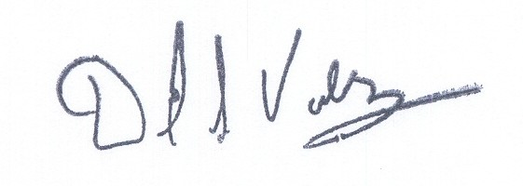  (Signature of Authorized Agent) |  |  |  |  |  |  |  |  |  | (Title) Senior Vice President-West, Public Affairs, Policy and Communications
(Print Name)
David S. Valdez
( 425 ) 261-5691 |  |  |  |  |  | ( 425 ) 261-5262 |  |  |  |  |  |  | David.s.valdez@verizon.com
(Telephone Number) |  |  |  |  |  | (Fax Number) |  |  |  |  |  |  | (E-Mail Address)
1800 41st St. MC: WA0105RA |  |  |  |  |  | Everett |  |  |  |  |  |  | WA |  |  |  | 98203
(Mailing Address) |  |  |  |  |  | (City) |  |  |  |  |  |  | (State) |  |  |  | (Zip Code)
WASHINGTON UTILITIES AND TRANSPORTATION COMMISSION

O R D E R
The Commissioners, having determined this order is consistent with the public interest, directed the Secretary to enter this order granting the provisions requested above.
DATED and signed at Olympia, Washington, this |  |  |  |  |  |  |  |  | Day of
 |  |  |  |  |  |  |  |  |  | (Month and Year)
 |  |  |  |  |  |  |  |  |  | Secretary
Util LSN Form 02/24/04

