 Verizon Northwest Inc.

1800 – 41st Street
WA0105RA
P. O. Box 1003
Everett, WA 98206-1003
Fax: 425-261-5262

December 15, 2006

Ms. Carole J. Washburn, Executive Secretary
Washington Utilities and
Transportation Commission
Chandler Plaza Building
1300 S. Evergreen Park Drive SW
Olympia, Washington 98504

Subject: REQUEST TO EXTEND EFFECTIVE DATE IN UT-061789

Dear Ms. Washburn:
Verizon Northwest Inc. (Verizon) filed a waiver request with the Commission on November 30, 2006 to direct the Pooling Administrator (PA) to provide Verizon with one ten thousand number code to satisfy the requirement for additional numbers from T-Mobile located in Bothell, WA.
This request is currently pending in Docket No.UT-061789 with a requested effective date of December 30, 2006. The company requests to extend the effective date for this waiver to January 30, 2007. Commission Staff has requested additional information regarding the customer’s need for a full code.

Please notify Rebecca Beaton upon receipt. Additional questions should be directed to Richard Potter at 425.261.5006.

Very truly yours,
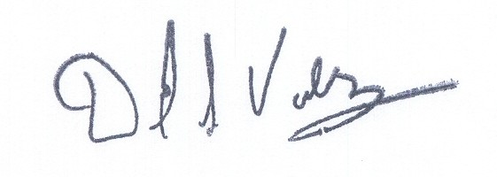

David S. Valdez
Senior Vice President - West
Public Affairs, Policy and Communications

DSV/LF/lf

